Jacqueline Ludorf 505 Park Avenue, Suite
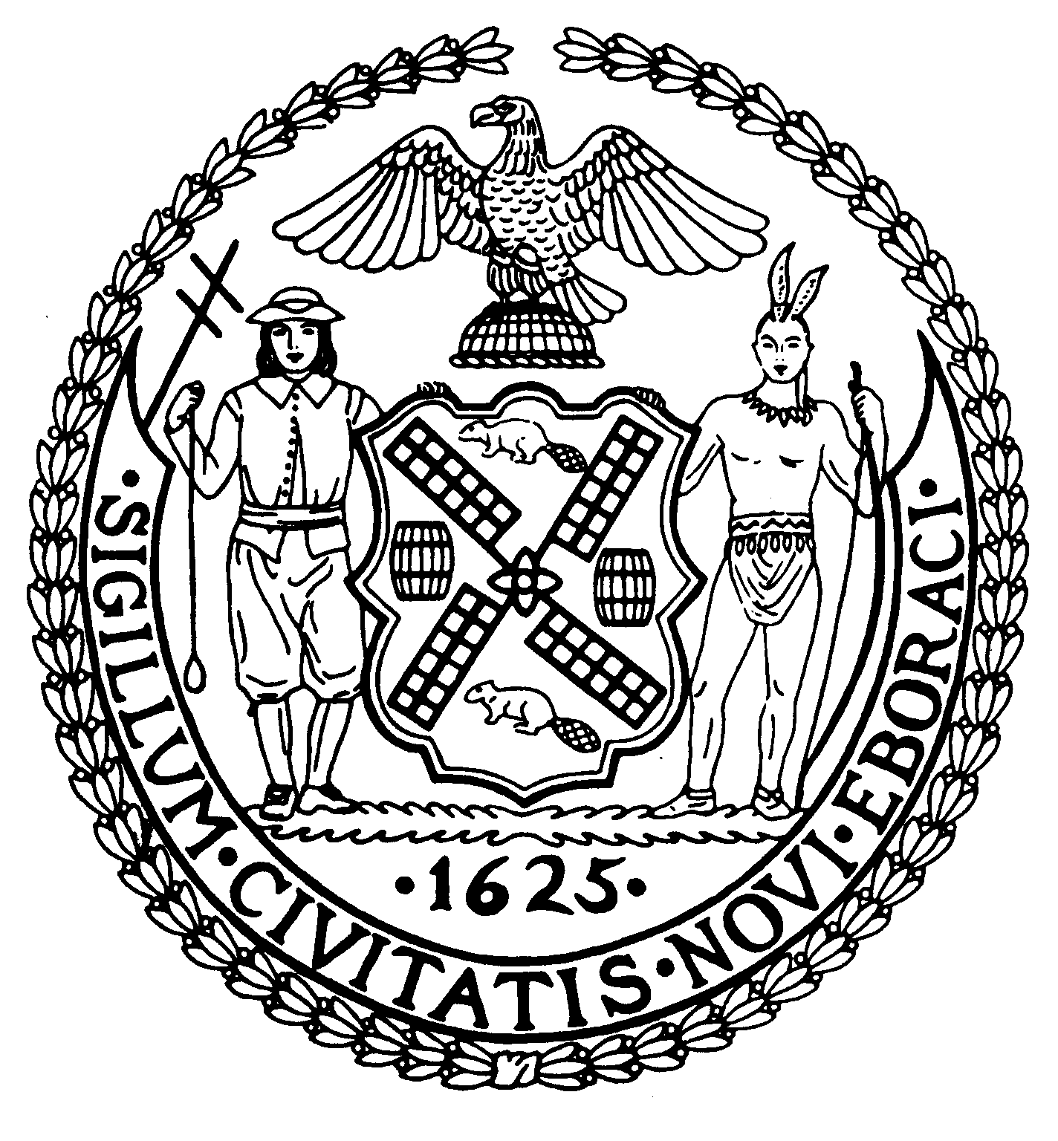

Chair New York, N.Y. 10022-1106

(212) 758-4340
Latha Thompson (212) 758-4616 (Fax)
District Manager www.cb8m.com - Website
info@cb8m.com - E-Mail

The City of New York
Manhattan Community Board 8

Environment and Sanitation Committee

Tuesday, September 28th , 2010
Hunter College School of Social Work
129 East 79th Street
Room 1010
6:30PM

Agenda

- Discussion of NYS legislative proposals A.10490A/S.7592A that would establish a moratorium
on hydraulic fracturing until 120 days after the U.S. EPA issues its study on hydraulic
fracturing’s potential impact on drinking water, human health and the environment.

2. Old Business

3. New Business

David Kleckner and Debra Teitelbaum, Co-Chairs

