Jacqueline Ludorf 505 Park Avenue
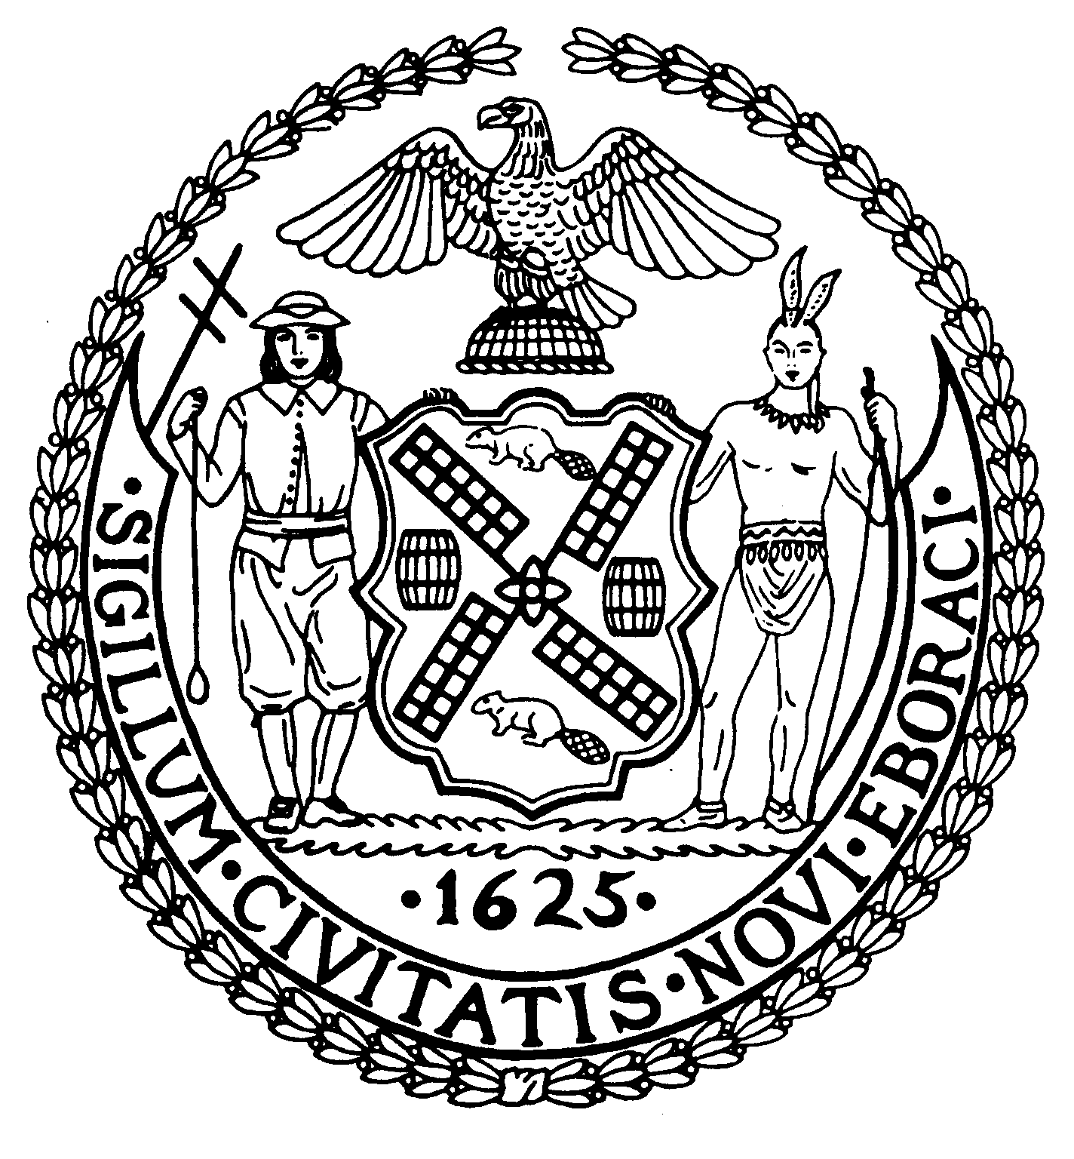
Chair Suite 620
New York, N.Y. 10022

Latha Thompson (212) 758-4340
District Manager (212) 758-4616 (Fax)
www.cb8m.com Website
info@cb8m.com - E-Mail

The City of New York

Manhattan Community Board 8

Transportation Committee Meeting
New York Blood Center
310 East 67th Street, Conference Room 1

Wednesday, September 1, 2010
6:30PM

Agenda

- Update on Roosevelt Island Tram Station Design (joint item with Roosevelt Island & Parks Committees)

- Update from TLC on Wall Street shared ride taxi stands, Wall Street vans and other group ride stands

- Update on Bolt Bus stop locations in CB8.

- Update from DOT on the installation of pedestrian crosswalk timers in CB8

- Old Business

- New Business

Jonathan Horn and Charles Warren, Co-Chairs

