Jacqueline Ludorf 505 Park Avenue, Suite 620
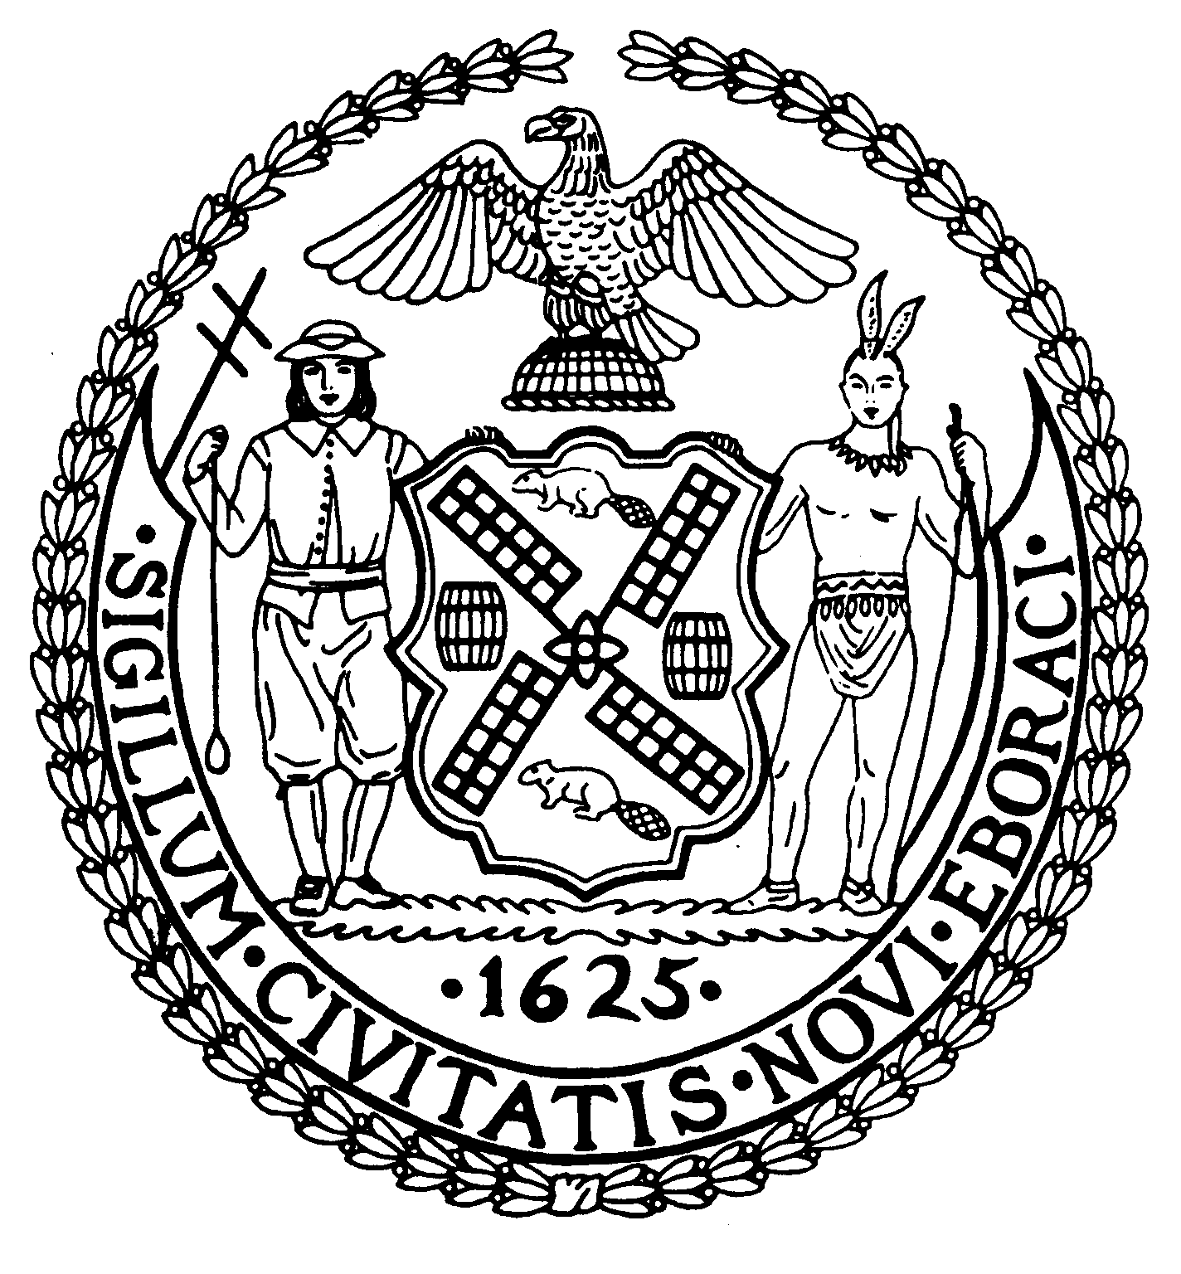
Chair New York, N.Y. 10022-1106
(212) 758-4340
Latha Thompson (212) 758-4616 (Fax)
District Manager www.cb8m.com - Website

info@cb8m.com - E-Mail

The City of New York
Manhattan Community Board 8

RULES AND BY-LAWS COMMITTEE
July 13, 2011
Community Board Office
505 Park Avenue, New York, N.Y. 10022

Present: Helene Simon, Hedi White, Co-Chairs; Jackie Ludorf, Board Chair.
Elizabeth Ashby, Michele Birnbaum, Barbara Chocky, Jonathan Horn, Ellen Polivy, Barry Schneider, Judy Schneider, Terry Slater, Marco Tamayo, Nick Viest, Chuck Warren

The meeting began with a discussion to clarify the agenda and the items to be considered by this meeting of the Rules and By Laws committee. Jonathan Horn stated he understood that the purpose of the meeting, as referred to the Committee by the Executive Committee at its May 11, 2011 meeting, was to consider revising the by-laws to remove “the regular Land Use Meeting” from the Attendance requirement of Board Members, and not the “scope of the Zoning and Development committee” as the meeting notice stated.

Several members reviewed the historical background of this by-laws provision:
During the 1970’s and 1980’s our community district was the site of extensive development, much of which required Community Board review as part of the ULURP and/or Board of Standards & Appeals procedures. Often, several projects were a part of the monthly Board Meeting Agenda, with meetings therefore running late at night. To ease this problem, a second “required” full Board Meeting was established by the By-Laws to hear such items, hence the title “Land Use Meeting”. Later, the Street Life committee report was added to that meeting to further balance the two monthly agendas.
In the intervening years, a general slow-down of development in our district has meant our Board does not have the same agenda pressures. Hence, the present question as to the necessity of a 2nd regular required monthly meeting.

Lively discussion of this ensued, including questions as to where the items that were heard at the Land Use Meeting would be re assigned. It was determined that this was an issue for the Chair of the Board. The merits of assuring that the full Board have the opportunity to hear these full applications by requiring attendance at the initial presentation and public hearings was also debated.

A motion was made by Jonathan Horn and seconded, to amend Article I Section B 1a to remove the words “and the regular Land Use Meeting”

During discussion, it was noted that while the Land Use Meeting is presently not called every month, there has been no sustained period without one to ascertain whether its elimination would be a prudent move.

There was consideration of an opportunity for a trial period.

Judy Schneider offered a substitute motion, which was seconded, as follows:

“To table the motion to change the Board’s by-laws for a period of six (6) months at the end which time the committee would reconsider the motion to amend the by-laws”

Motion passed: 8-6-0. In favor: Simon, Viest, White, Ludorf, Schneider, B., Schneider, J., Polivy, Warren; Against: Birnbaum, Horn, Chocky, Tamayo, Slater, Ashby.
(The motion to table is not debatable; its passage at the committee requires no further action.)

