Jacqueline Ludorf 505 Park Avenue
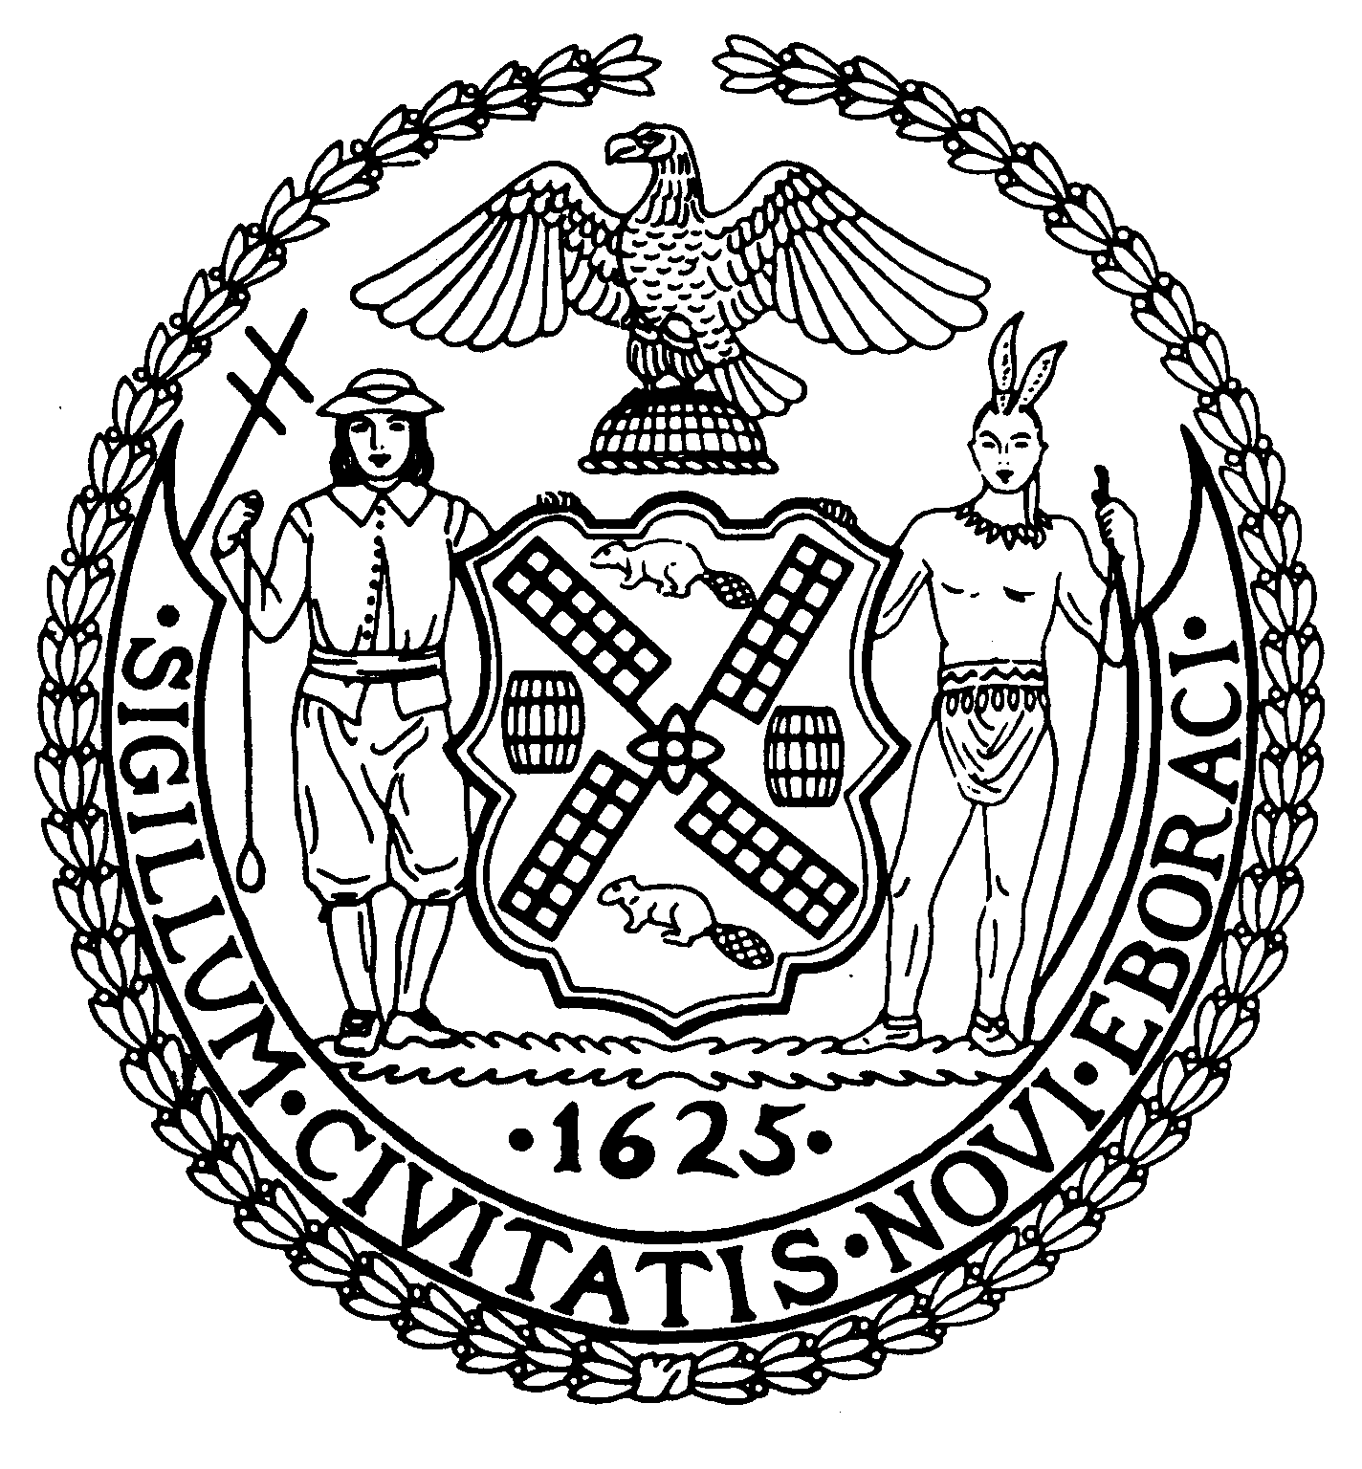
Chairman Suite 620
New York, N.Y. 10022

Latha Thompson (212) 758-4340
District Manager (212) 758-4616 (Fax)
www.cb8m.com Website
info@cb8m.com - E-Mail

The City of New York
Manhattan Community Board 8

The City of New York

Manhattan Community Board 8
Parks Committee meeting

Thursday, July 7, 2011, 6:30 PM
New York Blood Center, 310 E. 67th St.
Conference Room One

CB8M Members present: Elizabeth Ashby, Molly Blayney, Michele Birnbaum, Susan Evans, Scott Falk, Rita Popper, Peggy Price, Barbara Rudder, Barry Schneider, Judy Schneider, Teri Slater, Marco Tamayo.

Absent excused: Jane Parshall, David Helpern, Helene Simon
1.Review of the Central Park Conservancy’s Plan to Reconstruct Central Park’s East 69th St. Entrance and Redesign the Surrounding Landscaping—a joint issue with the Landmarks Committee.
Lane Addonizio and Marie Warsh, of the Central Park Conservancy, presented the Conservancy’s plans to reconstruct the East 69th St. entrance to Central Park. The proposal includes installing a new irrigation system; realigning the entrance path; moving area benches farther into the park; and, adding to the local landscaping. In addition, the Conservancy plans to install a low black pipe rail fence to protect the entrance plantings and a granite threshold stone at the entrance wall opening.

Ms. Addonizio detailed the Conservancy’s reasons for these proposals:
--The sharpness of the curve of the path leading from the E. 69th St. entrance to the nearby flagpole;
--Increased pedestrian congestion at the E. 69th St. park entrance caused by benches positioned too close to the entranceway;
--The need for storm drainage in the area to curb erosion;
--The desire to replace existing wood-and-concrete benches with the now-regulation wood-and-cast iron “World’s Fair”-style benches.

According to Ms. Addonizio, a “modest” realignment of the path would smooth its sharp turn, which is not only “awkward” but also “blocks the view of the East Green.” To ease the sharpness of the turn, the Conservancy proposes to curve a 48-foot portion of the path that is currently straight. As a result, the path will move between 0 and 13 feet south of its existing route.

To curb congestion at the E. 69th St. park entrance, she said the Conservancy wants to move the rows of benches, which straddle both sides of the path, away from the entrance. Instead, the rows of benches would begin some 20 feet farther into the park.
No trees would be removed for the project. But new area plantings would include small trees, shrubs, evergreens and perennials on both sides of the entranceway, Ms. Addonizio said.
She asserted that the proposed pathway adjustment is not part of a plan to allow dual pedestrian-bicycling use of the path.
According to Ms. Addonizio, this overall $900,000 project would begin as soon as final approvals are obtained, and construction would take about 4-to-6 months.
CB8M members generally approved of the plan to install a new drainage system and relocate the area’s benches.
Instead, debate centered on proposed changes to the pathway: Although some CB8M members agreed with that redesign plan, others favored the current pathway’s structure, including its unusual geometry. According to some CB8M members, a change in the path’s alignment would likely disrupt the area’s current symmetry and sense of the flagpole as the area’s focal point and center. In addition, some felt that the pathway’s crook helps block views of the park’s entrance and the street—thereby enhancing users’ park experience.
Other reasons for opposing the path’s change included: a member’s concern that a straighter path would spur bike usage; and, disagreement that the path’s current design is “awkward.”
Some CB8M members asked the Conservancy representatives if the irrigation and bench relocation aspects of the plan could be done without changing the path. Ms. Addonizio replied that such a plan would be possible but not advisable. Again citing the path’s currently “awkward” curve, she added that somewhat smoothing it would also help with the storm drainage issue.
CB9M members proposed voting on this issue in two parts: Part “a” would entail a resolution to support a new irrigation system, along with changes to the location of area benches and new plantings for the area around the E. 69th St. Central Park entrance. Part “b” would be a resolution involving only the path’s realignment.
The part “A” resolution passed unanimously. But after a vote favoring path realignment at the E. 69th St. entrance failed, members passed a resolution opposing the pathway change.

RESOLUTIONS
Part A:
WHEREAS the East 69th St. entrance to Central Park would benefit from an irrigation system to address area drainage problems and prevent soil erosion; and
WHEREAS the plan to relocate park benches from the park’s East 69th St. entrance area to about 20 feet farther into the park would reduce congestion at the park’s E. 60th St. entrance; and
WHEREAS the use of World’s Fair-style wood-and-cast iron benches—replacing wood-and-concrete benches--would enable seating near the park’s 69th St. entrance to conform to current regulations for benches at park entrances; therefore,

BE IT RESOLVED that Community Board 8, Manhattan, approves of the Central Park Conservancy’s plans to install an irrigation system at Central Park’s East 69th St. entrance and to relocate area benches some 20 feet farther into the park. As part of this project, the Board also approves of replacing local wood and concrete benches with regulation World’s Fair-style benches and expanding on the plantings around the park’s east 69th St. entrance.

VOTE:
12-0-0
In favor: Ashby, Birnbaum, Blayney, Evans, Falk, Popper, Price, Rudder, Slater, B. Schneider, J. Schneider, Tamayo.
Part B:
WHEREAS the existing shape of the path from Central Park’s E. 69th St. entrance into the park helps block street views and noise for those inside the park, thereby enhancing users’ park experience; and
WHEREAS somewhat smoothing the path’s existing curve would alter the path’s geometry and dislocate the nearby flagpole as the focal point and center of the area; and
WHEREAS a less angular design to the path potentially could spur biking on this pedestrian path; therefore,
BE IT RESOLVED that Community Board 8, Manhattan, opposes the Central Park Conservancy’s plan to change the alignment of the path leading from Central Park’s East 69th St. entrance into the park.

VOTE:
8-4-0
In favor: Ashby, Birnbaum, Blayney, Evans, Popper, Rudder, Slater, Tamayo.
Opposed: Falk, Price, B. Schneider, J. Schneider.

2. Proposal by the Lachaise Foundation to Exhibit the Gaston Lachaise Sculpture, LaMontagne, in Tramway Plaza.
Paula Hornbostel, curator and trustee of the Lachaise Foundation, presented a proposal to display Gaston Lachaise’s La Montagne sculpture in Tramway Plaza.
The plan, has received approval of the Parks Dept., and is awaiting a verdict from the Mayor’s office. If fully approved, the sculpture would be shown in the Plaza for about a year, starting possibly as soon as August.
This abstract sculpture, of a nude, is made of bronze, with a silver nitrate patina. In size, the display--including its base--is 44 inches by 104 inches.
Placed on pillars, it would stand some five feet high, with total weight, including pillars, of about 2,000 pounds. According to the Parks Dept., because of its hefty weight, the display won’t need any anchors into the ground to hold it in place and prevent any movement by it.
The sculpture would be placed at a 45-degree angle in Tramway Plaza, and stand near the Plaza’s southeast corner at 59th St. and 2nd Ave.
CBM8 members differed on the appropriateness of the sculpture in the relatively small Tramway Plaza. On one hand, various meeting attendees said they enjoy seeing art in parks, generally, and, and in particular, art in Tramway Plaza, which would benefit from the Lachaise sculpture. According to one CB8M member, it would be a shame “to deprive citizens of the East 60s” of the ability to see a Lachaise work.

However, some CB8M members also questioned the appropriateness of displaying La Montagne at Tramway Plaza. Given the limited space in that park, one member held, “you can’t walk around the sculpture and see it” as it should be seen.
Members questioned the sculpture’s effect on pedestrian traffic flow in this busy area. According to some CB8 members, a schematic plan was needed, since materials being presented lacked enough detail to determine whether the sculpture would disrupt pedestrian traffic.
Members also questioned whether the sculpture would be lighted at night to help prevent accidents around it, and whether the pillars could attract climbers.
In addition, one CB8M member cited the difficulty viewing an artwork on a 5-foot platform. She suggested placing the sculpture on a lower base to make it more visible.

RESOLUTION
WHEREAS the Gaston Lachaise sculpture, La Montagne, would add an artistic element to Tramway Plaza; and
WHEREAS this addition to the plaza is intended to be temporary, lasting approximately one year; and
WHEREAS CB8M members assume that placement of the sculpture near E.59th St. and 2nd Ave. in Tramway Plaza would not hinder pedestrian traffic in the Plaza from any direction; therefore,
BE IT RESOLVED that CB8M approves of the plan to install the Gaston Lachaise sculpture, La Montagne, at Tramway Plaza, provided that this display be adequately lighted from sundown to sunrise to prevent accidents.

VOTE:
10-2-0
In favor: Ashby, Birnbaum, Blayney, Evans, Falk, Popper, Rudder, B. Schneider, J. Schneider, Tamayo.
Opposed: Price, Slater.

3.Report on the City's 2012 Budget Allocations for Parks in the CB8M District.
Taina Prado, of Council Member Jessica Lapin’s office, reported on City’s 2012 budget allocations for parks in the CB8M district.
- Close to $1 million for structural repairs at 12 sites along the East River Esplanade;
- $2 million earmarked by the Mayor for the East River Esplanade; (No details were available the use of these funds.)
- No additional funding for the planned Older Adults Recreation Area in John Jay Park. (Council Member Lapin’s office will suggest other avenues to explore for additional funding beyond last year’s initial $250,000 allocation.)
- $8,000 for senior fitness training at John Jay Park and at either Carl Schurz Park or St. Catherine’s Park.
- $6,000 to Civitas for a contest to produce a design for the reconstruction of the East River Esplanade.
The Parks Committee expressed concern over the underfunding for parks in the CB8M district.

4.New Business.
The Parks Committee co-chairs reported on their meeting with the Parks Committee chairs/co-chairs of Community Boards 5, 7and 11 to discuss Central Park issues. CB8’s Parks Committee plans, on a regular basis, to continue reaching out to these community boards on areas of interest and concern about Central Park.

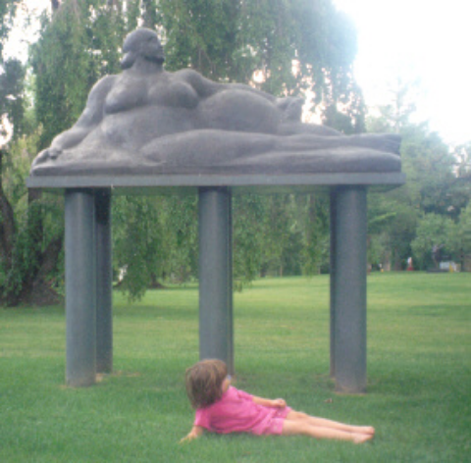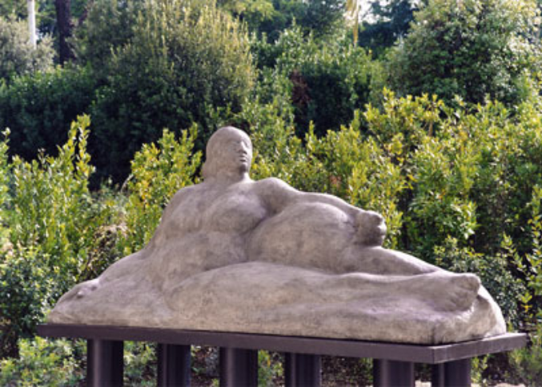
Views of Gaston Lachaise’s sculpture, La Montagne, proposed to be displayed temporarily in Tramway Plaza.

