Jacqueline Ludorf 505 Park Avenue, Suite 620
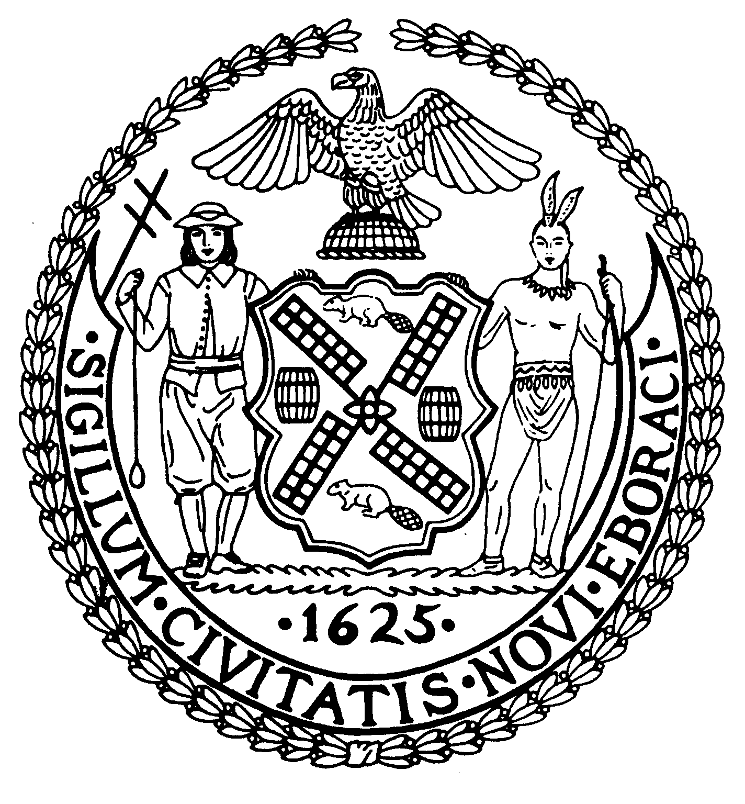
Chair New York, N.Y. 10022-1106
(212) 758-4340
Latha Thompson (212) 758-4616 (Fax)
District Manager www.cb8m.com - Website

info@cb8m.com - E-Mail

The City of New York
Manhattan Community Board 8

Youth and Education Committee Meeting
New York Blood Center
310 East 67th Street, Conference Rm. 1
July 12, 2010 7:00 pm

Agenda

- Discussion of Department Of Education position on bake sales at schools

- Update on Waitlist and Gifted and Talented

- Update on PS 267

- New/Old Business-September agenda

Jim Clynes and Judith Schneider, Co-Chairs

