Jacqueline Ludorf 505 Park Avenue
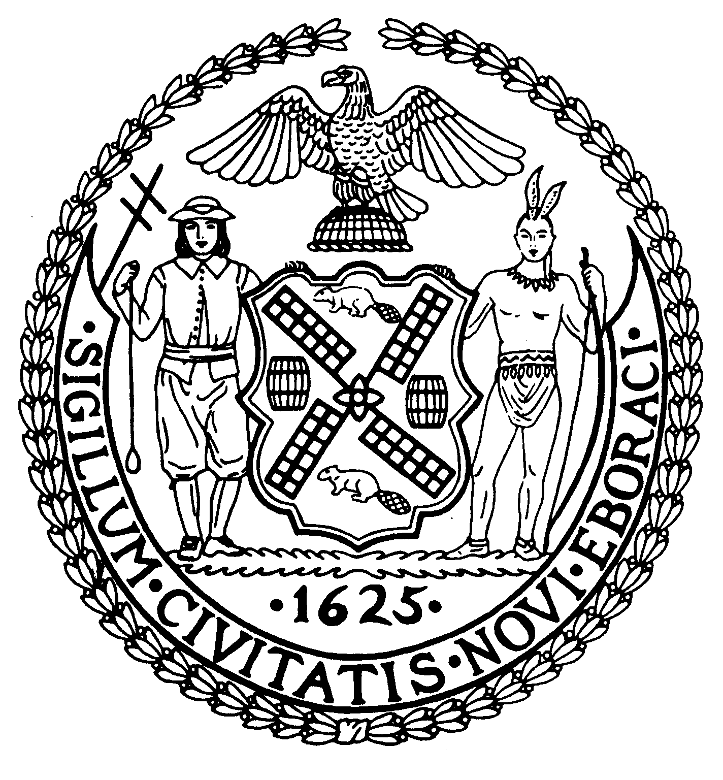
Chairman Suite 620
New York, N.Y. 10022

Latha Thompson (212) 758-4340
District Manager (212) 758-4616 (Fax)
www.cb8m.com Website
info@cb8m.com - E-Mail

The City of New York
Manhattan Community Board 8
Transportation Committee
Wednesday, July 7, 2010
NY Blood Center
310 East 67th Street, Conference Room 1

Present: Michael Auerbach, Michele Birnbaum, Scott Falk, Lorance Hockert, Jonathan Horn, David Kleckner, Barry Schneider, Judy Schneider, Charles Warren
Absent (excused): Jim Clynes, Rita Popper, Betty Wallerstein
Absent (unexcused): Helene Simon, Alex Tisch, Hedi White

The meeting was called to order by co chair Jonathan Horn at 6:35 pm.
- Presentation by DOT of a planned Queensboro Bridge Bus Priority Study (joint item with Landmarks Committee)

Will Carey of DOT presented plans for a study by DOT of possible ways to improve bus travel times across the Queensboro Bridge for both local and express buses. Some preliminary data has already been collected and DOT expects to present the study’s findings to the affected community boards in October. Following public comment, any proposed changes will be finalized by the end of 2010 and scheduled for implementation in Summer 2011. Acopy of his presentation will be posted to the CB8 website.

The committee raised some initial concerns about what types of changes might be made to the bridge approaches on First and Second Avenue. There was also a question raised as to how DOT planned to coordinate any changes with the Third Water Tunnel construction project on 59th Street, which will have an impact on the bridge and its approaches. Mr. Carey indicated that DOT might be able to make changes on the Queens side of the bridge until the Water Tunnel project is completed in 3 years.

- Update on Third Water Tunnel Construction Work by DDC (joint item with Environment and Sanitation Committee)

Shane Ojar from DDC provided a status report on the planned start of construction work. While the contract has still not been registered,, the contractor is planning to start utility work with Con Ed and drilling “test pits” around July 19th. The results of this work will allow them to confirm exactly what utility relocations will be needed and the precise path of the pipe under 59th Street. It will take approximately 6 months to fabricate the tunnel pipe, so significant street excavation will likely not begin until early 2011. The project is still projected to take 3 years from initial start date (7/19/10). Contact information for the project’s community liaison will be available from the board office.

One committee member raised a concern over DDC’s use of space in 12 Honey Locust Park during the project. The DDC representatives indicated that they currently do not plan to use any space beyond what is currently occupied by DOT and DEP and that DEP and DOT would be responsible for restoring the Park.

- Update on Roosevelt Island Tram renovations (joint item with Roosevelt Island & Parks Committee)

Steve Chironis, Acting President of RIOC and Marie Dauphinais of POMA provided the committee with an update on the RI Tram reconstruction. Due to difficulties in obtaining a crane, work on replacing the two tower heads in Manhattan was delayed. That work, originally scheduled to be completed by early July, will begin this weekend. It will now be completed by early August. As a result, the re-opening date for tram service has been pushed back from early September to the first week in October. The board office will remain in touch with POMA and RIOC regarding any further possible delays.

- Update on SBS Service Plans and Street Design

Joseph Barr and Kate Mikuliak of DOT addressed the change in plans for a protected bike lane on First Avenue. Due to time constraints, they would be unable to complete the necessary infrastructure work to create a protected bicycle lane the full length of First Avenue, as originally planned, by the October start of Select Bus Service. The revised plan includes a protected lane south of 34th Street only by October. In CB8, the existing bike lane on First Avenue will be slightly widened and have a protective painted buffer placed between the bike land and traffic lane. During Phase 2 (spring 2011) and Phase 3 (Fall 2011) of the project, the protected lane will be extended from 34th Street all the way to 125th Street.

Milling and paving work has begun on First Avenue and will continue throughout the summer, followed by lane markings and installation of the fare machines. The start-up date of 10/10/10 remains fixed. Copies of the outreach flyers being distributed to all business, institutions and residential buildings along the route were provided to the committee and will be posted to the CB8 website.

- Request from DOT for a Bolt Bus stop on Lexington Avenue between 59th and 60th Streets..

This was the second location presented to the committee for a Bolt Bus stop in our district. While the committee members remain supportive of allowing Bolt Bus to run its service to Boston from a location in CB8, a variety of concerns were raised over this location that made it unfeasible. The committee agreed to work with DOT and Bolt in the coming weeks to locate possible sites along Third Avenue in the 60’s for discussion in September or October.
- Old Business
There was no old business.
- New Business
Arlene Klene, a new community resident, raised several concerns over traffic backups and pedestrian safety on York Avenue in the low 70’s around Hospital for Special Surgery and the other nearby medical facilities. Committee members explained the history of our work with the local institutions and the city to address traffic problems in that area. While it was felt that the situation might be better than in the past, it was perhaps time to take another look. It was agreed to ask the various medical facilities and other neighborhood institutions to a meeting in the fall for an update.

The meeting was adjourned at 8:55 pm
Respectfully submitted,
Jonathan Horn and Charles Warren, Co-chairs

