Jacqueline Ludorf 505 Park Avenue, Suite 620
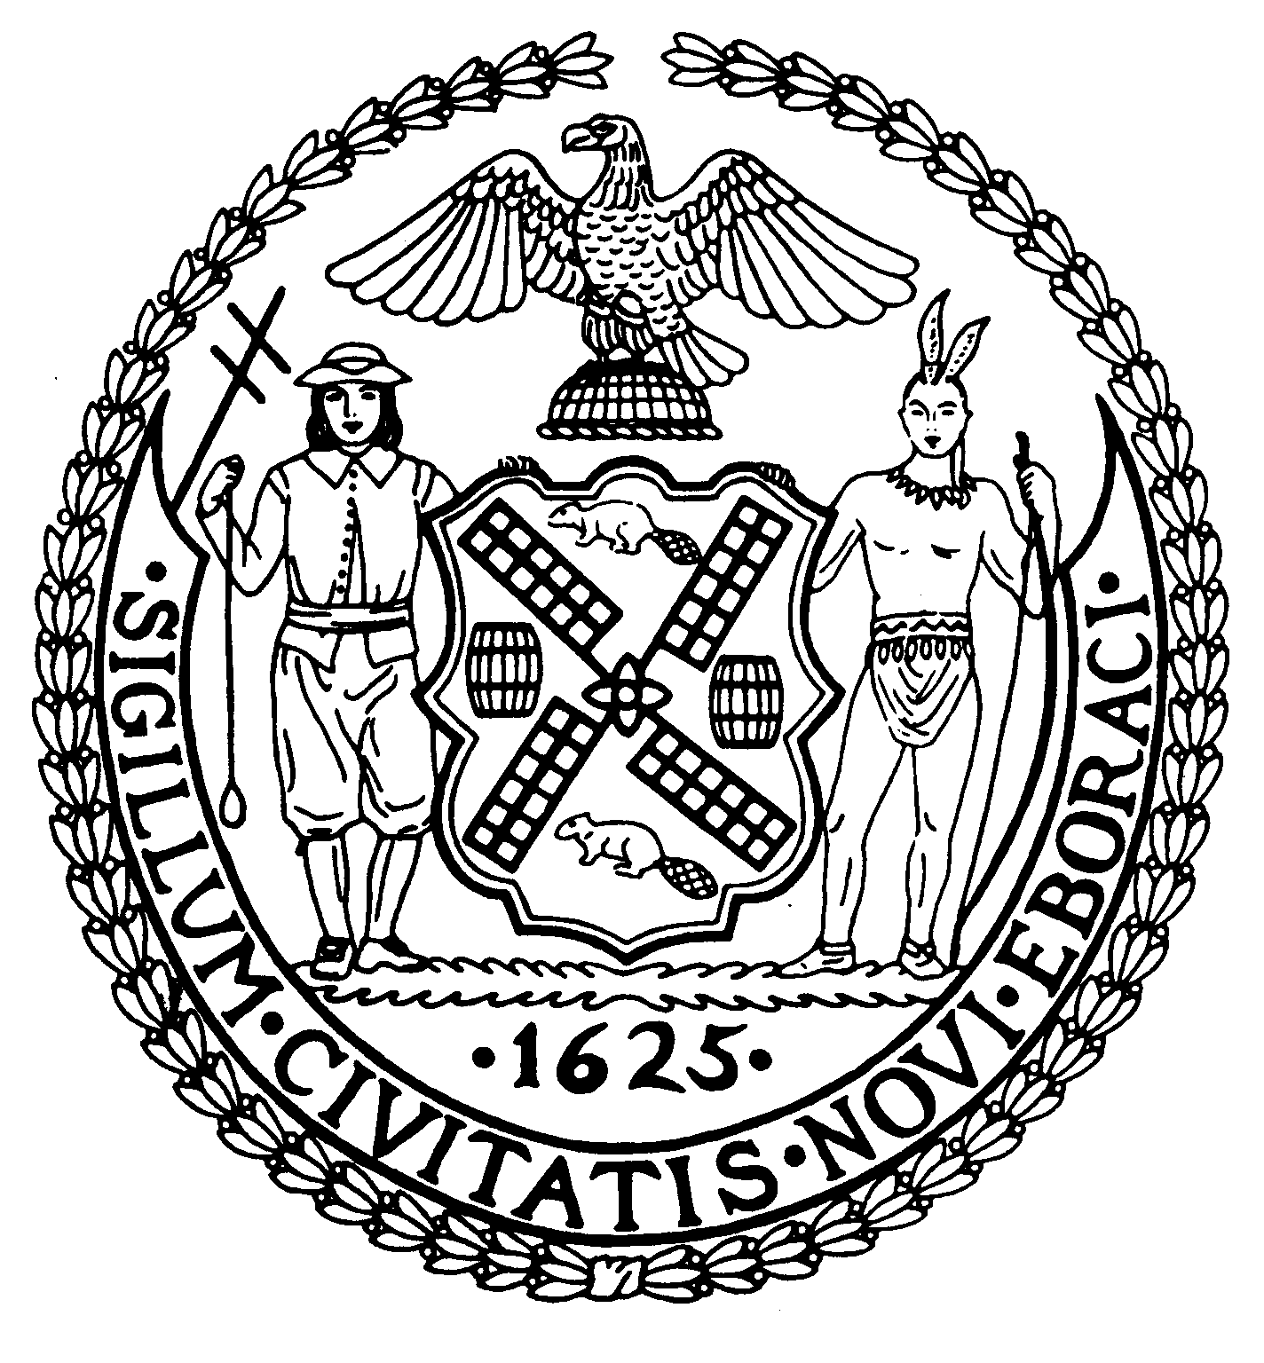
Chair New York, N.Y. 10022-1106
(212) 758-4340
Latha Thompson (212) 758-4616 (Fax)
District Manager www.cb8m.com - Website

info@cb8m.com - E-Mail

The City of New York
Manhattan Community Board 8
Parks Committee meeting
Thursday, July 8, 2010, 6:30 PM
New York Blood Center
310 East 67th St., Conference Room 1

CB8M members present: Elizabeth Ashby, Michele Birnbaum, Susan Evans, Scott Falk, Jackie Ludorf, Rita Popper, Peggy Price, Barbara Rudder, Judy Schneider, Barry Schneider, Teri Slater.
Absent-excused: Public member Laura Mayer
1.Review of the Parks Dept.'s plan for up to 4 specialty food carts and bicycle vendor at or around Central Park's Tavern on the Green at 67th St. and Central Park West--a joint issue with the Landmarks Committee.
Charlotte Hall and Joel Metlen, members of the Parks Dept.’s concessions division, presented the city’s plan for an RFP for temporary use of the Tavern on the Green site for high end food and beverage specialty carts. These vendors would be located on the terrace of the Tavern on the Green restaurant. At the end of this month, the Parks Dept. plans to issue an RFP, for a one-year term for the vendors with a one year renewable contract.
In addition, the Parks Dept. plans to extend its contract for an existing bike rental concession, also located in the Tavern on the Green area. Inside the Tavern on the Green building, the Central Park Conservancy will manage a visitor’s information station and a gift shop, and public restrooms will be available. The Parks Dept. will alter the landscaping of the area to provide access to the carts.
Parks Dept. officials attending the joint Parks-Landmarks meeting were unable to provide site plans or any other details about these concessions. As a result, Committee members agreed not approve these plans until the Parks Dept. provides CB8M with more information about the vendors.
RESOLUTION:
WHEREAS the Parks Dept. has informed the CB8M Parks and Landmarks Committees in a timely manner about plans for up to 4 specialty food/beverage carts on the terrace of Central Park’s Tavern on the Green, and about extending the contract on a bicycle rental concession near Tavern on the Green; and
WHEREAS few details of these plans were available to be considered at CB8M’s July Parks-Landmarks Committee meeting; and
WHEREAS this lack of information prevented CB8M Committee members from being able to vote on the proposals; and
WHEREAS Community Board 8 believes that it is vitally important to be able to discuss and vote on proposed concessions in CB8M-district parks; therefore,
BE IT RESOLVED that Community Board 8M urges the Parks Dept. to postpone issuing any RFPs for vendors of specialty food and beverage carts in and around the terrace of Tavern on the Green restaurant in Central Park until the Parks Dept. presents CB8M with detailed plans for these concessions.
BE IT FURTHER RESOLVED that Community Board 8M urges the Parks Dept. not to extend a contract for bicycle rentals in the area near Tavern on the Green restaurant until the Parks Dept. presents CB8M with detailed plans for this concession.
VOTE: 11-0-0: In favor: Elizabeth Ashby, Michele Birnbaum, Susan Evans, Scott Falk, Jackie Ludorf, Rita Popper, Peggy Price, Barbara Rudder, Barry Schneider, Judy Schneider, Teri Slater.
2. Plan for a Public Art Display on the Park Avenue Mall at 67th St. and at 70th St.
Jennifer Lantzas, the Parks Dept.’s public art coordinator, introduced a proposal for two temporary sculptures on the Park Avenue Mall.
As planned, the two large white sculptures, designed by the Japanese artist Yoshimoto Nara, would each depict a child and a dog. The art works would stand 14 feet high, base included, and face each other from their locations at Park Ave. and 67th St. in front of the Armory, and at Park Ave. and 70th St, in front of The Asia Society. The sculptures will be made of marine grad epoxy/fiberglass constructed over a welded steel armature.
These displays would run from August 28th to November 6th, 2010.
This public art presentation would coincide with Nara’s first retrospective in the United States, opening at the Asia Society in early September. During this summer, the Park Avenue Armory will host Nara for an open studio residency.
The program would be presented by the Art Production Fund, producers of public art projects, in association with The Asia Society.
In a letter to the Parks Committee, The Fund for Park Avenue expressed its “full support” for the temporary art installation.
One CB8M member voiced concern about the possibility of the art works obstructing the visibility of drivers along Park Avenue, potentially creating accidents. Jennifer Lantzas responded that the Nara art installations would comply with the DOT’s specifications on driver visibility when art works appear on the Park Ave. Mall. In addition, she said that the Parks Dept. requires that these public art projects be insured.
Another CB8M member aired concerns about the use of public space for commercial activity.
RESOLUTION:
WHEREAS the NYC Parks Dept. has presented a plan for the display of two large sculptures designed by Yoshimoto Nara on the Park Avenue Mall, installed at 67th St. and at 70th St., in recognition of the artist’s first retrospective in the United States; and
WHEREAS these installations would be temporarily on display on the Park Ave. Mall, from August 28 to November 6, 2010; and
WHEREAS The Fund for Park Avenue has expressed its support for this public art display; therefore,
BE IT RESOLVED that Community Board 8, Manhattan approves of the plan for a temporary display of two sculptures designed by Yoshimoto Nara on the Park Avenue Mall, at 67th St. and at 70th St.
VOTE: 11-0-0; In favor: Elizabeth Ashby, Michele Birnbaum, Susan Evans, Scott Falk, Jackie Ludorf; Rita Popper, Peggy Price, Barbara Rudder, Barry Schneider, Judy Schneider, Teri Slater.
3. Discussion of the Need to Repair and Beautify the East River Esplanade in the CB8M District
Barbara Rudder gave an update on the Park committee’s progress to secure funding for the repair and redesign of the East River esplanade from E63rd Street to E. 96th Street. The esplanade is in horrendous condition, the foundation is crumbling, there are patchwork repairs, and the esplanade is increasingly getting worse. More and more garbage pails cover holes that cannot be fixed.
Since CB8M passed resolutions asking for city, state and federal money to repair our waterway, members of the Parks committee have attended several forums dealing with the city’s waterfront.
- The Metropolitan Waterways Alliance sponsored several discussions about improving the City’s waterfront, but the area within CB8M was ignored in the presentations. We testified at the meetings, but worry that we have not been heard.
- The City Planning department held several forums on Vision 2020, the city’s comprehensive waterfront plan. City Planning will be submitting their suggestions by the end of the year. Again, Peggy and I testified. At the last forum, we broke up into small groups by location. Our Community Board, as well as Jane Swanson representing Councilmember Jessica Lappin, stressed the need for repairs in our area.
- There was another forum discussing the waterfront in CB6M. At this time, there is no access to the waterway for a stretch from E38 to E59 Street. Because of a deal that is possible with the UN, there is a proposal to create an esplanade to close this gap. In addition, temporary caissons were constructed near E63 Street when the FDR Drive was repaired. CB6 and the elected representatives are very excited about the potential of using the caissons to build a road to connect to the esplanade for better access for bicyclists as well as pedestrians. Our Environmental Committee jointly with the 197-a Committee will be meeting to discuss the environmental impacts.
- Peggy Price and Barbara Rudder met with Kristen Ellis, our liaison from Borough President’s Scott Stringer’s office. We walked along the esplanade to show her the its deteriorating condition. She informed us that the BP has received funding to do a study of the waterfront from the Battery to the E30s. Jane Swanson said this proves that there is money available.
Jane Swanson gave us an update on Jessica Lappin’s work. The Councilmember will be sponsoring a task force cosponsored by our other elected officials to discuss how to obtain funding. They have been diligently working with the Parks department to determine who has jurisdiction over the esplanade, State DOT, City DOT, and/or Parks. The various departments will be meeting with the elected officials at the end of the month, and then with the task force, which will include CB8 members as well as other interested parties Jane announced the Councilmember Lappin was able to secure $500,000 for the esplanade in our district. Jane is very optimistic that we are finally being heard and real progress has been made.
Our Community Board all thanked Jessica fro her strong voice, dedication, and dogged determination. We need a powerful force to fight for our esplanade. There was concern noted that a comprehensive design is needed. Jane is certain that if the Marine Transfer Station is built, it will not interfere with the esplanade. Congress member Carolyn Maloney has not secured federal money yet, but will work on it.
4. Plans for a CB8M-Sponsored Forum on Renovating and Beautifying the East River Forum in Our Area
This session focused on collecting ideas for a CB8M-sponsored forum on repairing and beautifying the East River Esplanade in our district. The forum will be held on Thursday night, September 23, 2010.
Meeting attendees discussed an array of ideas for structuring and focusing the forum. It was decided that the forum’s format will consist of a panel of speakers representing key components of an effort to repair and beautify the East River Esplanade. Invited panelists will include Rep. Carolyn Maloney and City Council Member Jessica Lappin, who are coordinating a Waterfront Task Force focused on our district; Joshua Laird, the Parks Dept.’s assistant commissioner for planning and natural resources; an official of the NYC Planning Dept.; and an official of the Waterfront Alliance.
Meeting attendees noted a continuing problem: the lack of a clear plan for renovating and beautifying the East River Esplanade in our district. It’s hoped that public input at this forum will help produce ideas for what could be done with the Esplanade.
In conjunction with the forum, meeting attendees suggested that the Parks Committee create a mission statement about Esplanade repair and visual improvement. Broadly, such a document would spell out what we are seeking: a repaired seawall, an Esplanade in good condition; and beautified landscape in this waterfront area.
It was agreed that the forum needs to be widely publicized to attract, hopefully, a broad cross-section of the public The Parks Committee will ensure that civic/community groups throughout our area learn of the forum—and how they can best participate in it.
It was suggested that, during the forum, attendees write their questions on index cards, which would be collected. This process would help eliminate duplication of questions.
Among other suggestions: During the event, writing comments and ideas aired by the public on a large board; and giving each forum attendee a sheet of paper for providing feedback on the forum and for jotting down any additional questions/comments they have as the forum winds up. CB8M could later post answers to such questions on its website.

