Jacqueline Ludorf 505 Park Avenue, Suite 620
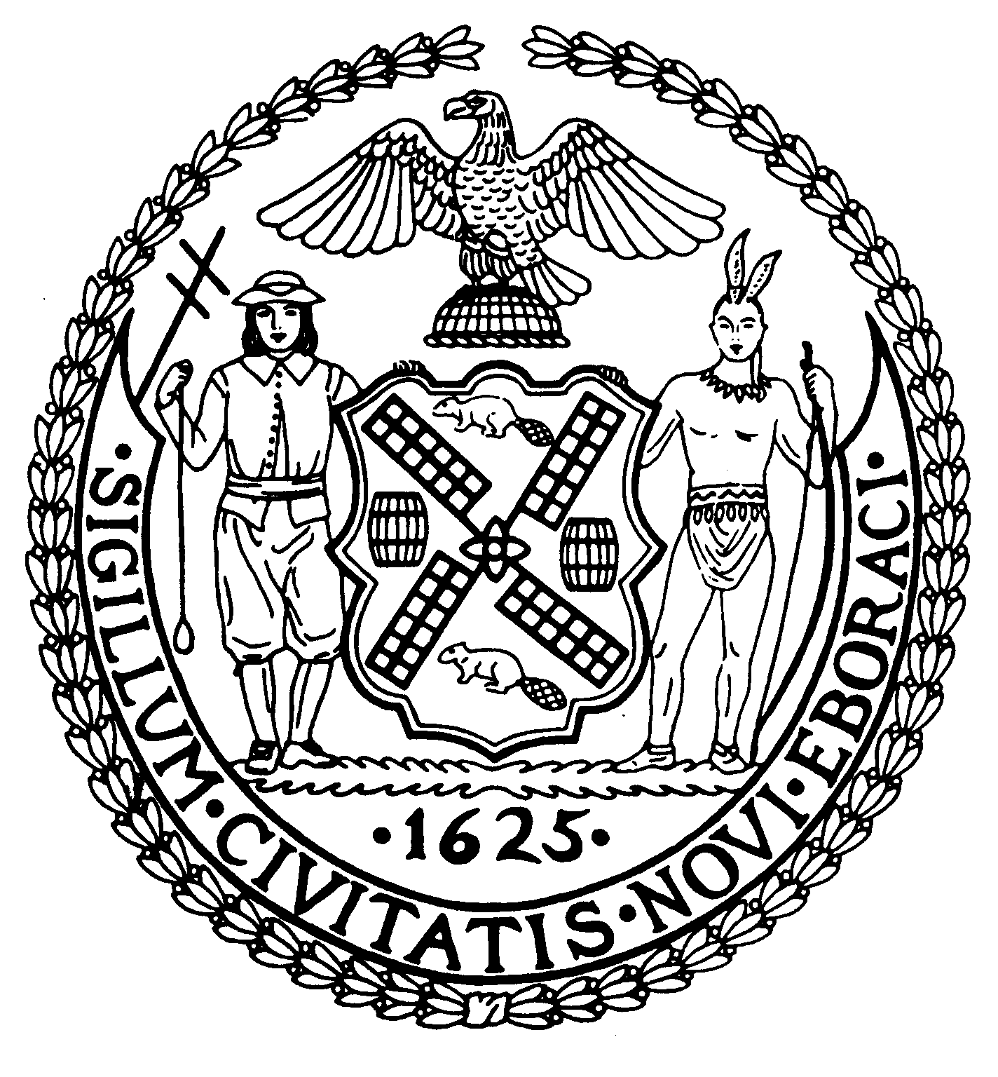
Chair New York, N.Y. 10022-1106

(212) 758-4340
Latha Thompson (212) 758-4616 (Fax)
District Manager www.cb8m.com - Website
info@cb8m.com - E-Mail

The City of New York
Manhattan Community Board 8

Parks Committee
Thursday, July 8, 2010 @ 6:30 PM

New York Blood Center
310 East 67th Street, Conference Room 1

Agenda

- Review of the Parks Dept.'s plan for including 4 specialty food carts and bicycle vendor at or around Central Park's Tavern on the Green at 67th St. and Central Park West--a joint issue with the Landmarks Committee.

- Review of a plan, by the Asia Society and Art Production Fund, to install 2 sculptures by artist Yoshimo Nara on the Park Avenue Mall from September to November of this year. According to the plan, to be presented by the Parks Dept., the two proposed sites would be Park Ave. at 70th St., in front of the Asia Society, and Park Ave. at 67th St., in front of the Armory. The plan coincides with Nara's first U.S. retrospective, opening in September at the Asia Society.

- Update on the status of redevelopment of the Waterfront in CB8M.

- Planning for a Parks Committee-sponsored forum on Waterfront redevelopment in our district. This event is likely to be held in late September.

Margaret Price and Barbara Rudder, Parks Committee Co-Chairs

