Jacqueline Ludorf 505 Park Avenue, Suite
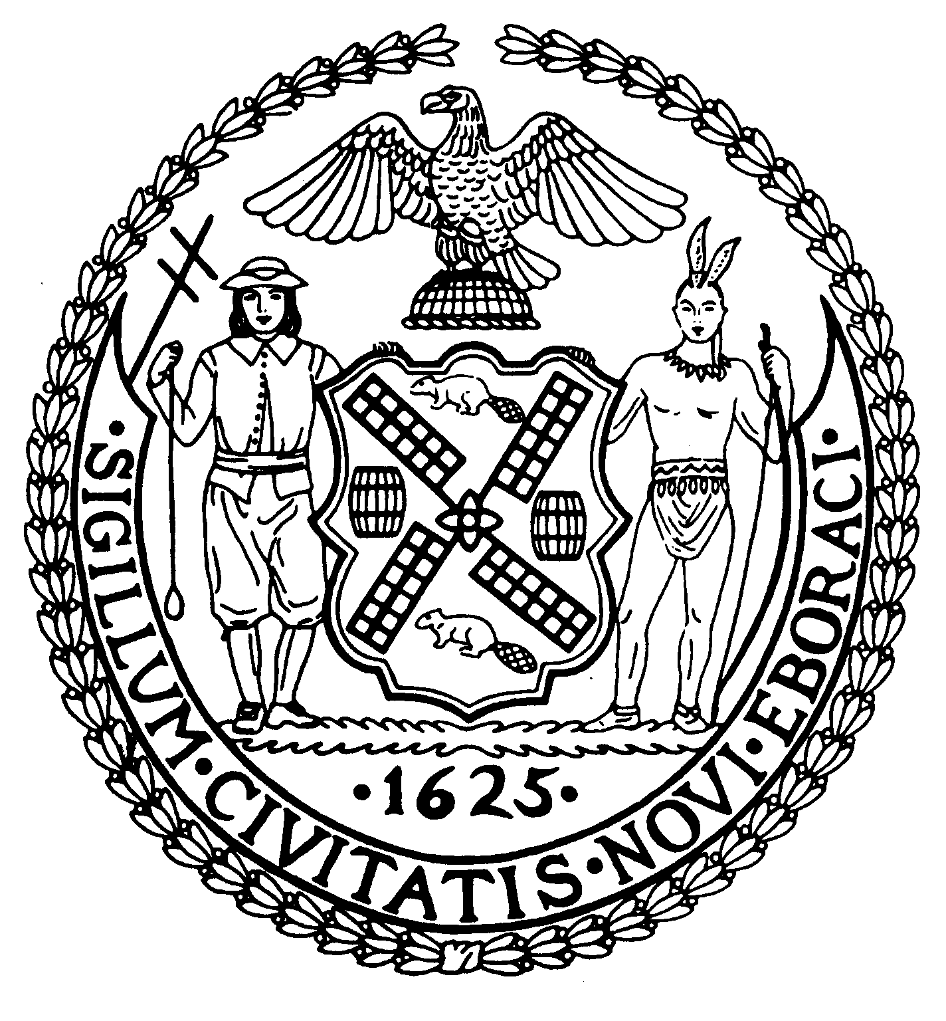

Chair New York, N.Y. 10022-1106

(212) 758-4340
Latha Thompson (212) 758-4616 (Fax)
District Manager www.cb8m.com - Website
info@cb8m.com - E-Mail

The City of New York
Manhattan Community Board 8

Environment and Sanitation Committee

Thursday, July 21, 2010
New York Blood Center
310 East 67th Street
Conference Room 1
6:30PM

Agenda

- Discussion of retention of existing caissons installed in the East River, for FDR Drive reconstruction, to complete the Greenway. (joint with 197-a Committee)

David Kleckner and Debra Teitelbaum, Co-Chairs

