Jacqueline Ludorf 505 Park Avenue
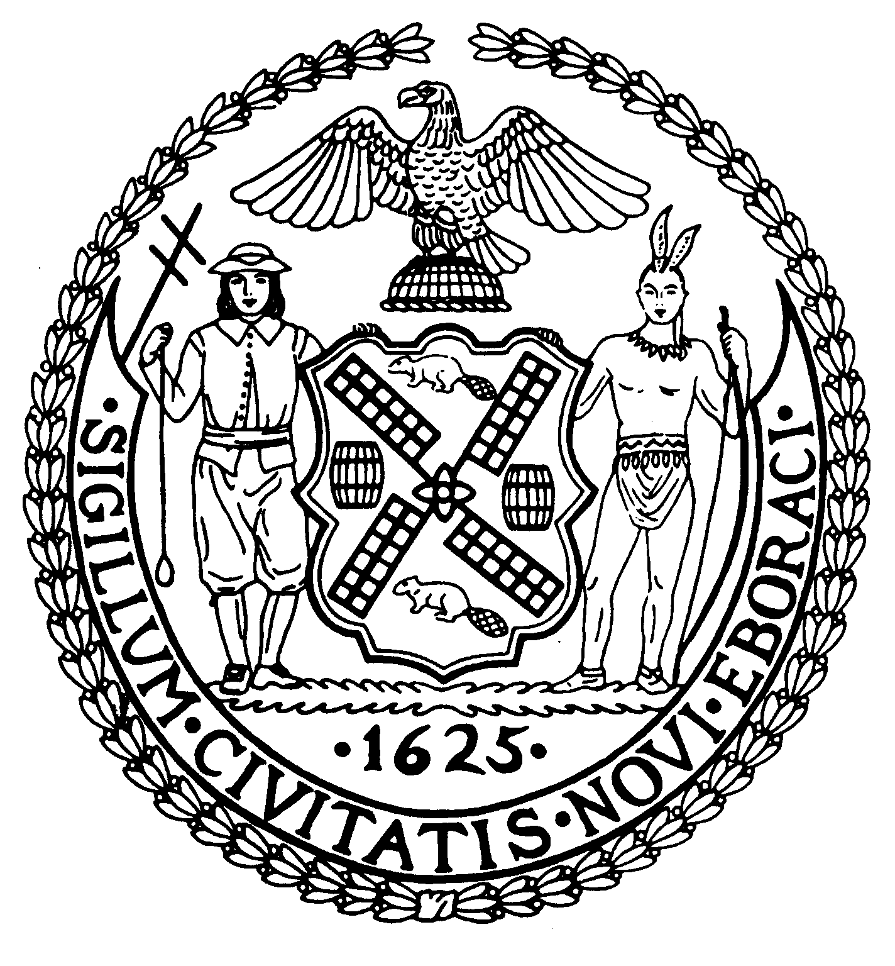
Chairman Suite 620
New York, N.Y. 10022

Latha Thompson (212) 758-4340
District Manager (212) 758-4616 (Fax)
www.cb8m.com Website
info@cb8m.com - E-Mail

The City of New York
Manhattan Community Board 8
Transportation Committee
Wednesday, June 1, 2011
New York Blood Center, 310 East 67th Street, Conference Room 1

Present: Michele Birnbaum, Molly Blayney, Susan Evans, Scott Falk, Lorance Hockert, Jonathan Horn, Jacqueline Ludorf, Rita Popper, Margaret Price, Barbara Rudder, Barry Schneider, Judy Schneider, Helene Simon, Teri Slater, Alex Tisch, Charles Warren, Hedi White

The meeting was called to order by co-chair Jonathan Horn at 6:30 pm.

- Discussion of DOT’s proposed traffic signal changes at 73rd Street and York Avenue, including a request to remove one parking spot at the SE corner.

Following a site visit by the committee co-chairs and DOT representatives to the location, DOT has agreed to the committee’s suggested solution. The signal for traffic heading West across York Avenue will be delayed 15 seconds during which time pedestrians will be allowed to cross 73rd Street with no vehicles turning into East 73rd Street heading towards the FDR Drive entrance. If DOT determines that there is a sightline issue, they will possibly change a single parking spot on York Avenue at the SE corner of 73rd Street and York Avenue to “No Parking Anytime”.

- MTA Service review
Alissa Kosowsky and other representatives from the MTA updated the committee and responded to questions on Select Bus Service issues, M15 local service and various bus stop changes caused by the Second Avenue Subway construction. Also addressed were questions on bus bunching and waiting time on several of the crosstown routes.

- Discussion of Community Board 7’s proposal for a Trial Period of Motor Vehicle-Free Central Park (Joint item with the Parks and Landmarks Committees)

The committee held an extensive and wide-ranging discussion on the proposal for a trial period to test the impact of banning motor vehicles from the Central Park Loop. Ken Coughlin of Community Board 7 explained the rationale behind the resolution passed jointly by their Parks and Transportation Committee last month. Although the overall sense was that a car-free Central Park was a laudable goal, various concerns over the current proposal were raised by different members. Among these concerns were how the study of the trial period’s effects were be conducted, what the criteria for success or failure would be, whether the SE corner of the Park would be included in the trial, the possibility of an open-ended trial period and existing problems with other stakeholders sharing the loop even when cars are currently banned. The committee ultimately decided to vote and approve the following resolution, which is a modified version of the proposed Borough Board resolution

WHEREAS, Central Park was designed as a refuge within the city; its loop drive was intended for uses that integrate seamlessly into the pastoral ambiance of the park (by contrast, the East-West transverses, located several feet below grade, were designed to accommodate vehicular traffic with minimum impact on park users); and

WHEREAS, private motor vehicles on the loop drive impede the healthy environment, peaceful enjoyment, and use patterns of pedestrians, runners, cyclists, carriages, and pedicabs; and

WHEREAS, the presence of private motor vehicles necessitates traffic management tools that do not necessarily provide for safe, shared use of the loop drive by pedestrians, cyclists, runners, carriages, and pedicabs; and

WHEREAS, recent measures that restrict the use of private motor vehicles on the loop drive have not resulted in noticeable negative impacts on surrounding streets; and

WHEREAS, private motor vehicles are still permitted on the loop drive during weekday periods when, outside of weekends, visitors and local residents most use the park (early mornings and early evenings, before and after business hours); and

WHEREAS, more than 100,000 people have signed petitions asking for a car-free Central Park; and

WHEREAS, serious consideration of any proposal to prohibit private motor vehicle traffic warrants an objective study of duration sufficient to observe adaptive shifts in traffic behavior and their impacts during both low- and high-volume periods of traffic;

THEREFORE, BE IT RESOLVED that the New York City Department of Transportation, in conjunction with the Department of Parks and Recreation, prohibit the use of private motor vehicles on the loop drive of Central Park (including taxis, but excepting vehicles necessary for park maintenance, concessions, and emergencies) in order to allow for car-free enjoyment of the park during the summer months through Labor Day 2011; and

BE IT FURTHER RESOLVED that while the loop drive of Central Park is free of private motor vehicles, the New York City Department of Transportation study traffic impacts and, if necessary, extend the prohibition beyond Labor Day 2011 no later than the day after the 2011 New York City Marathon to accurately measure and assess the potential impact of permanent prohibition of private motor vehicles on the loop drive of Central Park; and

BE IT FURTHER RESOLVED that while the loop drive of Central Park is free of private motor vehicles, the Central Park Conservancy and the Department of Parks and Recreation study and begin to implement measures that enhance safety and optimize shared use of the loop drive by pedestrians, runners, cyclists, horse-drawn carriages and pedicabs in the absence of private motor vehicles.

Approved 14-1
Yes: Blayney, Evans, Falk, Hockert, Horn, Ludorf, Popper, Price, Rudder, Simon, Slater, Tisch, Warren, White
No: Birnbaum

- Continued discussion of proposed pedestrian safety improvements around 96th Street, the FDR Drive. and the Esplanade (Joint item with Parks Committee)

This item was returned to the committee by the Full Board because of reported discrepancies in the wording of the resolution recorded in the May 2011 minutes. Following a brief discussion, the committee approved the resolution with one change.

WHEREAS, pedestrians have difficulty crossing the access roads at 96th Street and the FDR Drive because of a lack of painted crosswalks and pedestrian signals, and
WHEREAS, there is no signage indicating access to the esplanade in this area,

RESOLVED, that Community Board 8 recommends the installation or repainting of crosswalks at all of the pedestrian crossings at 96th Street and the FDR Drive;

FURTHER RESOLVED, that pedestrian walk signals be installed at all existing traffic lights at the 96th Street and FDR Drive crossings without changing the timing of the lights; and

FURTHER RESOLVED, that two signs be installed in the most appropriate places to inform drivers and pedestrians of access to the East River esplanade.

Approved 15-0
Yes: Birnbaum, Blayney, Evans, Falk, Hockert, Horn, Ludorf, Popper, Price, Rudder, Simon, Slater, Tisch, Warren, White

- Discussion of noise complaints resulting from Fresh Direct delivery vehicles parked on 61st Street between First and Second Avenues

This discussion was continued from the May meeting. Fresh Direct again failed to send a representative, but did email the board office that they would be relocating their vehicles to 61st Street between York and First Avenue. According to residents present at the meeting, they have not noticed Fresh Direct trucks between First and Second Avenues in recent days, so this relocation may have taken place. Concern was expressed that this simply moved the problem to another block. Several individuals suggested that 60th Street between York and First Avenue might be a viable location for their trucks to layover. A number of possible issues with this block were also raised and Josh Orzeck from DOT offered to look into the situation. The committee decided that this is actually a district-wide issue concerning the Fresh Direct refrigeration units. The decision was made to have a joint Environment and Sanitation/Transportation Committee meeting in September and try to get Fresh Direct and other interested parties to attend and work on possible solutions.

- Old Business

Russ Novack, a resident of East 67th Street asked the committee to address the problem of Fox 5 trucks and cars abusing the special parking areas the committee has previously granted them. Specifically, they are once again double parking in front of their facility on East 67th Street and blocking through traffic, including buses and ambulances. The committee will have the board office inform Fox 5 of the latest concerns and ask them to attend our September meeting to address the communities’ concerns. The general feeling was that if they do not abide by their previous commitments, we will consider taking back some of the “Press Parking” areas previously assigned to them.

A question was raised on why the restored meters on Lexington Avenue from 85th to 86th Street are in effect until 10pm, instead of the 7pm that all other blocks in that area. Josh Orzeck said he would look into the matter.

- New Business

The issue of trucks improperly using Park and Fifth Avenues was raised by a committee member. DOT, NYPD and Traffic Enforcement all offered to try and increase enforcement of these violations.

A proposed City Council bill to require delivery bicycles to be registered and have license plates was briefly discussed and will be added to our September agenda.

The question was raised as to whether congestion pricing might be getting resurrected. As of now, nothing seems imminent.

The meeting was adjourned at 8:45 pm
Respectfully submitted,
Jonathan Horn and Charles Warren, Co-chairs

