Jacqueline Ludorf 505 Park Avenue
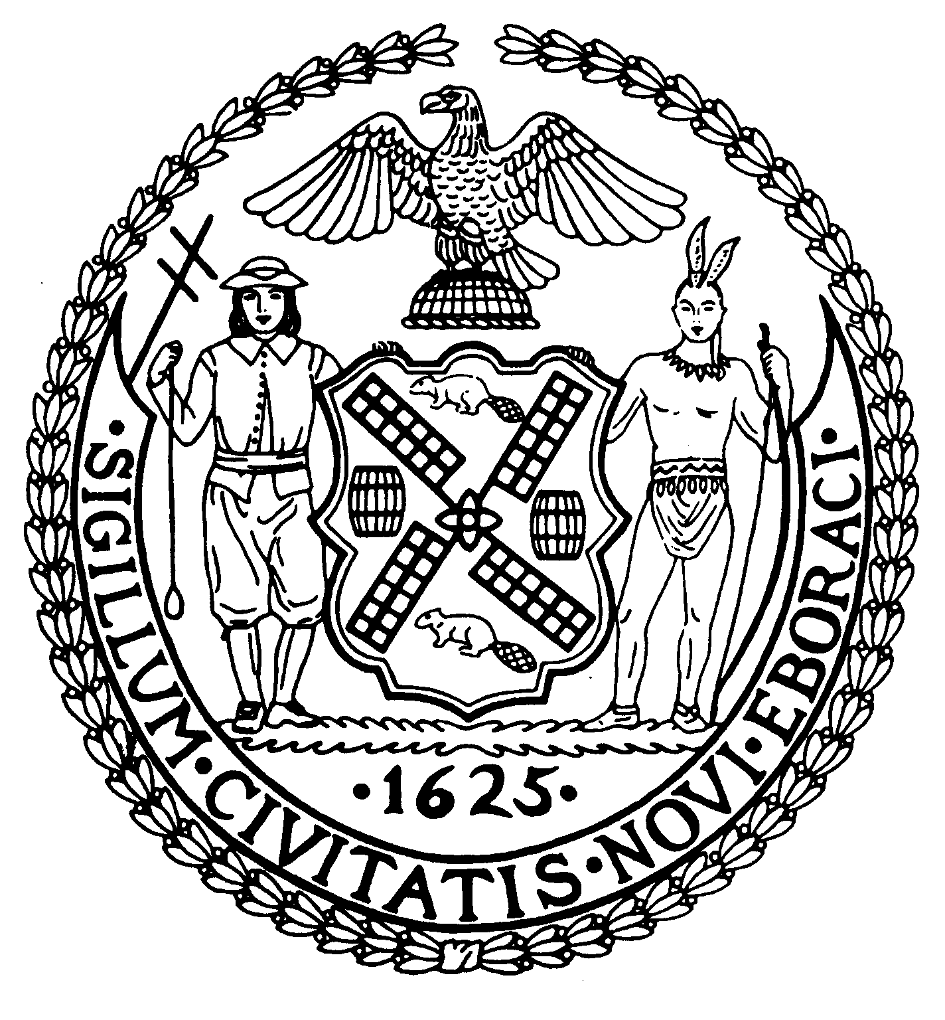
Chairman Suite 620
New York, N.Y. 10022

Latha Thompson (212) 758-4340
District Manager (212) 758-4616 (Fax)
www.cb8m.com Website
info@cb8m.com - E-Mail

The City of New York
Manhattan Community Board 8

SECOND AVENUE SUBWAY TASK FORCE
Manhattan Community Board 8
Wednesday, June 22, 2011

Hunter College, 695 Park Avenue, West Building, Lecture Hall, 6th Floor

6:30 PM

Present: Rita Popper, Margaret Price, David Rosenstein, Barry Schneider, Judith Schneider, H. Patrick Stewart, Marco Tamayo

Excused:

The meeting was called to order at 6:35 PM

- Construction Update

Construction work zone progress – 96th Street Station, 86th Street Station, 72nd Street Station and Lexington/63rd Street Stations - presented Tom Peyton. construction program director. The complete PowerPoint presentation is available http://www.mta.info/capconstr/sas/pdf/2011_June%2022_Final.pdf.

2 Fence Wrapping

Bill Goodrich, Vice President for Capital Construction, presented the proposed construction fence wrapping to enhance the visual experience along the sidewalks of the project. See slides 32 – 35 of the PowerPoint presentation referenced in 1, above.

Mr. Goodrich was followed by Rita Popper and Tara Reddi with an alternate graphic suggestion for the construction zone. In coordination with the Manhattan Chamber of Commerce, who has partnered with the MTA in marketing Second Avenue, Ms. Reddi proposed to create a fun, whimsical construction
camouflage that lessens the unattractive appearance of the construction sites, calls attention to the obstructed businesses and supports the “Shop 2nd Avenue…it’s Worth it” PR campaign. The PowerPoint presentation can be viewed at http://www.cb8m.com/updates/second-avenue-subway-corridor-construction-scrim-camouflage-business-name-recognition.

3. Executive Session

Following the MTA's presentation and the questions and comments from the public, the Committee went into Executive Session and had the following discussion:

A. Mr. Rosenstein raised the issue of the MTA, along with the City Department of Transportation, extending the use of section of 2nd Avenue at E. 91st Street beyond the limited use originally presented to the community. Specifically, the MTA is continuing to use the "freeze zone" as a staging area for ongoing work after the stated purpose was completed. He also argued that there was no notice to the community. Mr. Goodrich explained that it was the goal of the MTA to reduce the size of the work zones in the project and to relocate, where possible, work areas from the narrower side streets to the boarder avenues. He also stated that the MTA could do a better job of commutating its plans to the community and that they would make every effort to get to the word out in the future, in advance of site relocations.

. B. Ms. Price brought up the condition of traffic on Second Avenue within CD #8. She noted that traveling down the avenue at all times of the day and night was a nightmare. She asked, rhetorically, if something can be done to improve travel time. Her thoughts were echoed by other members of the committee and extended to First Avenue as well. Ms. Alissa Kosowsky, Assistant Director Government & Community Relations, noted that the issue is one of enforcement of the existing traffic regulations. She pointed out that the new Select Buses have cameras to record and identify vehicles in the bus lanes and that summonses are issued. Mr. Schneider suggested that the committee coordinate with the Transportation Committee to work with the MTA, NYC Transit, the City Department of Transportation, the NYPD and especially the Traffic Enforcement Division. He offered to reach out to his colleagues on the Board to set up a meeting of the concerned agencies in the next few weeks.

Respectfully submitted, M. Barry Schneider and Patrick Stewart, SAS TF Co-Chairs

