Jacqueline Ludorf 505 Park Avenue
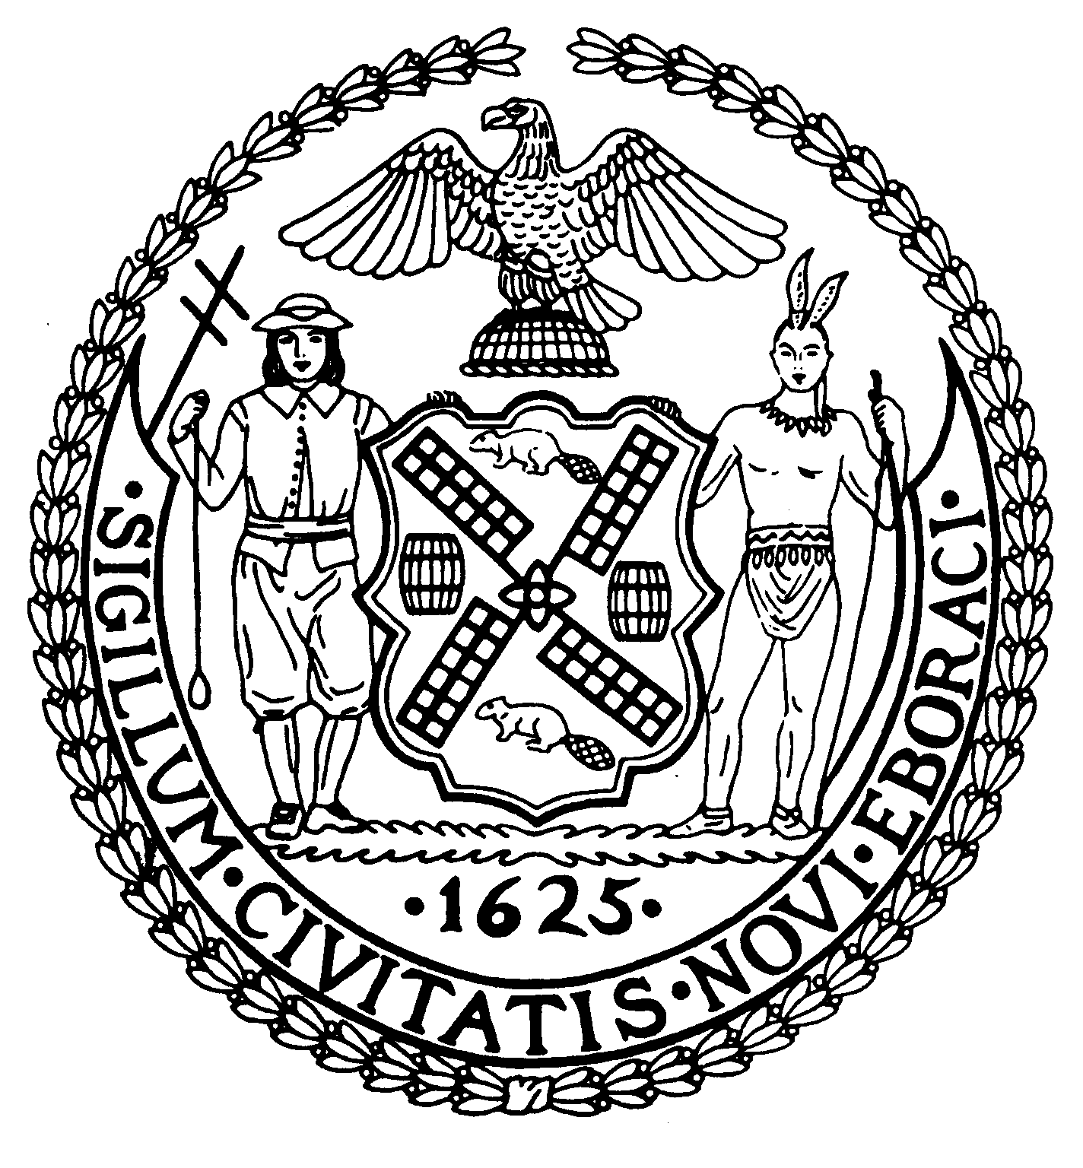
Chairman Suite 620
New York, N.Y. 10022

Latha Thompson (212) 758-4340
District Manager (212) 758-4616 (Fax)
www.cb8m.com Website
info@cb8m.com - E-Mail

The City of New York
Manhattan Community Board 8

Parks Committee Meeting

Thursday, June 2, 2011, 6:30 PM
New York Blood Center, 310 East 67th St., Conference Room 1

CB8M Members in attendance: Elizabeth Ashby, Michele Birnbaum, Molly Blayney, Susan Evans, Scott Falk, Jane Parshall, Rita Popper, Peggy Price, Barbara Rudder, Judy Schneider, Helene Simon, Teri Slater, Marco Tamayo

Excused Absence: Barry Schneider
1 Discussion of the Parks Dept.’s plans for a horseback riding concession at the North Meadow Recreation Center in Central Park—a joint item with the Landmarks Committee.
Charles Kloth and Charlotte Hall of the Parks Dept.’s revenue unit, presented the City’s plans for a new horseback riding concession to be operated at the North Meadow Recreation Center in Central Park. The Parks Dept. will be receiving Request for Proposals for this concession until June 13.
After a vendor is chosen, Mr. Kloth and Ms. Hall plan to review plans again for the project with CB8M’s Parks and Landmarks committees.
As envisioned, the winning concessionaire will receive a 7-year license to operate the riding facility at the operating site and on Central Park’s bridal paths. In addition to renting horses, the vendor could offer such activities as: riding lessons, guided rides, community programs and therapeutic riding.
No new stable will be created. Instead, the Parks Dept. is proposing to contain up to 12 horses at the Recreation Center in a 30 feet by 90 feet area, enclosed by a chain-link fence and covered by a tent to provide shade for the horses.
No horses would remain in the park overnight. As currently planned, the vendor would daily transport the horses via trailer in and out of Central Park. During the day, trailers could be kept in a parking area just of the 95th St. transverse at the Recreation Center exit or at the parking area at the 102 St. transverse. The vendor would create a kiosk at the Recreation Center for such administrative purposes as rental transactions and the sale of horseback riding-related merchandise. In addition, the vendor would be responsible for cleaning and maintaining the licensed premises.
Fees for horse rental will be determined between the Parks Dept. and winning concessionaire. According to Mr. Kloth, the new program will likely begin this fall.
CB8M members in attendance raised such issues as bike riding on the bridal path, concerns about horseback riding safety, and how many horses might be daily brought to the concession site.
Concerning the bridal paths, board members stressed the need for signage stating that bike riding is barred in that area. Even though this prohibition has been “relaxed” in recent years, it will be enforced again once the horseback riding concession begins, according to a Central Park Conservancy representative.

CB8M members also inquired about the vendor’s liability if a riding accident occurred. In response, Mr. Kloth said that the concessionaire will have to be adequately insured. Moreover, in their proposals, vendors will have to explain how they will ensure their customers’ safety, Mr. Kloth added. A CB8M member also pointed out that riders’ capabilities may range from beginners to experienced equestrians. Thus, she pointed out, the concessionaire will need enough staffing to meet the needs of all levels of riders.
Some concern arose about horses kept by day the Central Park concession but not ridden. Would more horses be brought in than demand required? Mr. Kloth said that situation seemed unlikely, given the cost of transportation. However, it was suggested that potential riders could call ahead to reserve a horse before showing up at the Central Park concession site.
A question arose about riders bringing their own horse and trailer into Central Park. According to Charlotte Hall, that situation will remain acceptable—as long as the horse owner doesn’t try to rent his or her steed.
One CB8M member also suggested a licensing period of less than 7 years, which, she said, was longer than many parks contracts CB8M has considered. In response, Mr. Kloth said that if the riding program wasn’t working out, the Parks Dept. and the concessionaire could terminate it.
2. Presentation about the changing use starting this summer of two crosstown paths in northern Central Park from pedestrian only to shared pedestrian/bicycle use--a joint issue with the Landmarks Committee.
CB8M invited Carolyn Greenleaf , Community Relations Manager at the Central Park Conservancy, to detail the Conservancy’s plans to convert two pedestrian-only paths in Central Park to shared pedestrian and bicycle use. Ms. Greenleaf cited the rising number of cyclists who want to traverse the park safely and legally.
Phase I of the plan will open two paths on the northern end of the park to bicycle use. The first path, when travelling from west to east, starts at 106 Street, then curves to 102 Street and then connects to the transverse. From east to west, the path starts on 106 Street to the West drive. The second uses the path on 97 Street by the East Meadow.
These changes will begin in late June or in July. Signage and pavement markers will indicate the shared paths and the 5mph speed limit on them.
Ms. Greeleaf stressed that phase I is a trial, and for the plan to work, there must be a campaign to educate bicyclists to ride responsibly and yield to pedestrians. Although little enforcement of the rules will be available, she hopes that the public will help teach bikers the proper rules.
Several members of the public, including members of the group, Transportation Alternatives, voiced a need for a safe biking route through the park. These proponents of the shared paths held that the plan will be safe for pedestrians if bicyclists are aware of which paths to use for cycling. In addition, they felt that having cross-park paths for bikers is fair, since pedestrians already have an ample number of paths they can use in the park.
Several members of the Community Board had concerns with the plan. Among them: the narrowness of the involved paths, which many felt don’t allow for multi-use, and the fact that the Conservancy had passed up the chance to widen at least one of the two paths when East Meadow was refurbished.
Other CB8M members concerns: a general feeling that decisions had been made without full public input; that the Community Board had not been apprised of the planned changes; that education alone wouldn’t improve many bikers’ illegal practices; and that adequate legal enforcement would be needed before the plan should proceed. Some members also expressed concerns about published reports that an additional two paths will be converted to multi-use. Community Board members held that the Conservancy shouldn’t proceed with additional path conversions until discussing such moves with CB8.
Ms. Greenleaf called the planned conversion of two Central Park paths a “trial.” But, as she acknowledged, this try-out period has no end date or criteria for judging its success. In turn, CB8M

members expressed concern that the conversion of two additional paths will occur without evidence of whether Phase I was a success.

A resolution to support the Central Park Conservancy’s plan was defeated.
Resolution:
WHEREAS bicyclists currently have few legal and safe options for east-west travel across Central Park; and
WHEREAS bike riding has become an increasingly popular activity in New York City; and
WHEREAS bicycling organizations are actively promoting safe bike riding on New York City streets and parks; therefore,
BE IT RESOLVED that Community Board 8 approves of the Central Park Conservancy’s plan to convert two pedestrian paths in northern Central Park to shared bicycle-pedestrian use.

VOTE: 2-10-0
In favor: Scott Falk, Judy Schneider.
Opposed: Elizabeth Ashby, Molly Blayney, Michele Birnbaum, Susan Evans, Rita Popper, Peggy Price, Barbara Rudder, Helene Simon, Teri Slater, Marco Tamayo
Opposed: Scott Falk, Judy Schneider.

New Business
A CB9M member reported that official Parks Dept. vehicles are speeding in Central Park, creating a hazardous situation. The Parks Committee will ask the Board office to report this problem to the proper authorities.

