Jacqueline Ludorf 505 Park Avenue
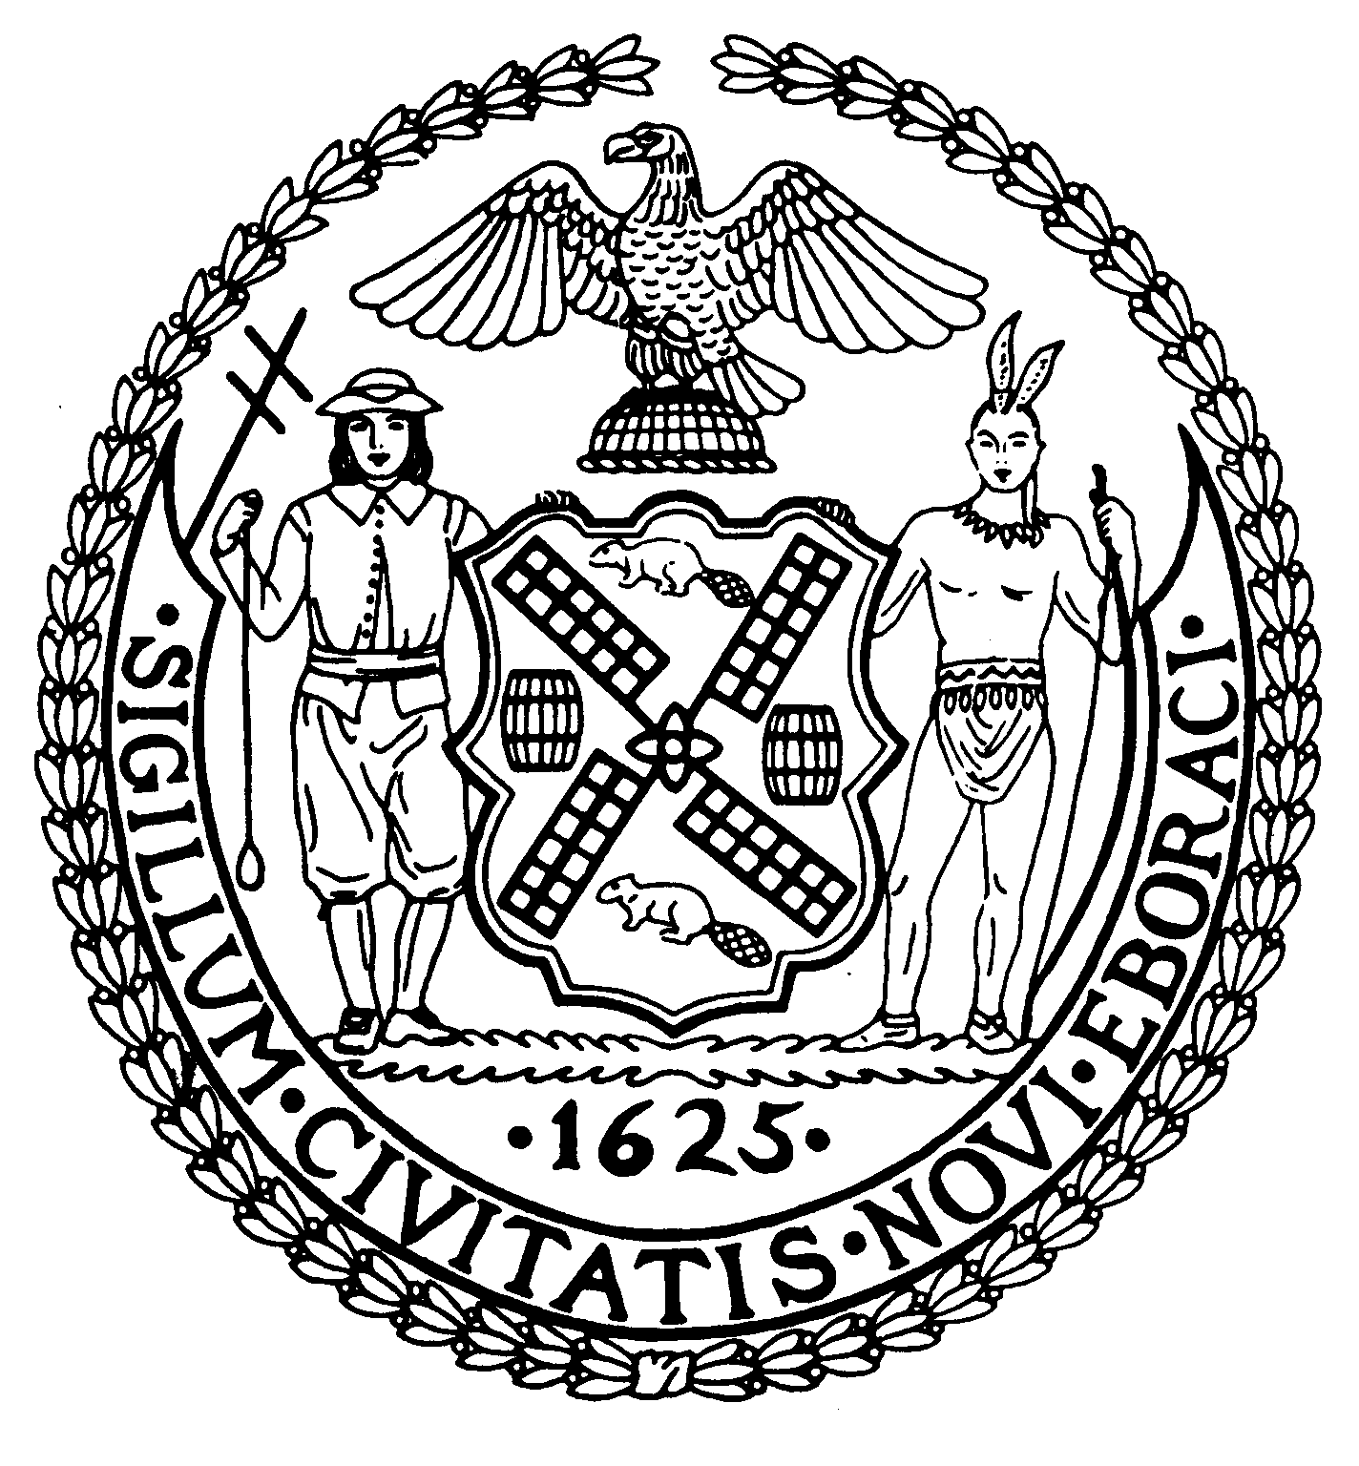
Chairman Suite 620
New York, N.Y. 10022

Latha Thompson (212) 758-4340
District Manager (212) 758-4616 (Fax)
www.cb8m.com Website
info@cb8m.com - E-Mail

The City of New York
Manhattan Community Board 8
Transportation Committee
Wednesday, June 2, 2010
NY Blood Center
310 East 67th Street, Auditorium

Present: Michael Auerbach, Michele Birnbaum, Sarah Chu, Scott Falk, Jonathan Horn, Rita Popper, Margaret Price, Barbara Rudder, Barry Schneider, Judy Schneider, Teri Slater, Cos Spagnoletti, Marco Tamayo, Alex Tisch, Betty Cooper Wallerstein, Charles Warren
Absent (excused): Jim Clynes, Lorance Hockert, Helene Simon, Hedi White

The meeting was called to order by co chair Charles Warren at 6:20 pm.

- Discussion of Traffic Issues and Street Closures related to the Third Water Tunnel Construction Project along East 59th Street (joint item with Environment & Sanitation Committee).

Shane Ojar from DDC provided a status report on this project. The contract has been awarded, but OMB has not yet issued a “Certificate To Proceed”. Until that occurs, the contractor and DDC will not be able to provide a precise schedule of street closures and work areas. There has been no change to the planned work area and traffic re-routings presented to the board in February of this year. A copy of that presentation is available on the CB8 web site. Shane agreed to return to us as soon as OMB gives their approval and the final plans are completed. He is hopeful this will occur prior to our next meeting on July 7th, but it is possible that a special meeting will be needed in late July or early August for this. DDC plans to begin construction within a few weeks of the final approval from OMB which is expected no later than sometime in July.

Steve Shane from RIOC provided an update on the tram reconstruction, which is taking place in the same area. They have had to delay their planned weekend crane work due to lack of equipment. However, the crane has now arrived at Roosevelt Island and they still expect to have completed their work prior to DDC beginning work in the area. The two agencies, along with DOT are closely coordinating this. RIOC will return in July to provide an updated status

- Discussion of Timing and Community Impacts of the East 78th Street Pedestrian Bridge Construction Project (joint item with Parks Committee).

David Dunn and Joannene Kidder from DOT presented the final construction plans for the replacement of the 78th Street Pedestrian Bridge over the FDR Drive. A copy of their PowerPoint presentation will be posted to the CB8 website, along with renderings of the bridge’s design (approved by the Community Board in January 2008). The project is expected to begin later this summer and run a total of 13 months. The bridge will be closed to pedestrians during this entire period, however actual on-site construction work will not begin until approximately Month 5.

There will be periodic lane closures on the FDR Drive during weekend and overnight hours. While the existing structure is demolished, using a crane located on a barge in the East River, a temporary full closure of the FDR between 61st and 96th Street will occur during a limited number of weekend hours. There will be extensive warning signage and deployment of traffic agents during these closures.

There will be “No Parking” on both sides of East 78th Street between the FDR Drive and Cherokee Place during the project. The Esplanade will be closed between approximately 77th Street and 79th Street during the project. Full access to and use of John Jay Park will be maintained during the project.

A dedicated community liaison has been appointed for the project. Her name is Deborah Howes and she can be reached at E.78thStBridgeReplacement2010@gmail.com or 347-834-7455. There will also be a staffed onsite construction office to address any concerns from community residents.

- A request to install a “Loading Zone” in front of 167 East 73rd Street. (Requested by Mr. Tesei, Vilcek Foundation) (joint item with Landmarks Committee)

The Vilcek Foundation has a legally registered curb cut and driveway in front of their building at 167 East 73rd Street. This driveway is used to load and unloadoften large materials used for public exhibitions in their building, among other uses. They have had an ongoing problem with vehicles parking illegally in front of their curb cut. They are prohibited by DOT from painting the curb cut yellow and because this is a landmarked building, they are limited in the size and placement of any signage indicating “No Parking” or “Active Driveway” on the building itself. In addition, some Traffic Enforcement agents have refused to issue tickets, claiming that there must be an official DOT “No Parking” sign covering the length of the curb cut. Josh Orzeck from DOT indicated that they would consider placing such signage, if requested by the Community Board.

WHEREAS, the Vilcek Foundation, located at 167 East 73rd Street regularly uses their driveway and legal curb cut for loading and unloading of exhibition materials, and
WHEREAS, they are limited in their ability to clearly mark this area as a “No Parking” zone by virtue of being a landmarked property, and
WHEREAS, DOT has indicated a willingness to consider placing “No Parking” street signage covering the length of this curb cut,
THERFORE BE IT RESOLVED, that Community Board 8M requests that DOT install “No Parking” signs at either end of the legal curb cut in front of 167 East 73rd Street.
Approved 14-0
Yes: Auerbach, Birnbaum, Chu, Falk, Horn, Popper, Rudder, B. Schneider, J. Schneider, Slater, Spagnoletti, Tamayo, Tisch, Warren

- Discussion of DOT’s conversion of single space meter poles to bicycle racks on First Avenue from 60th Street to 96th Street.

Similar to the changes recently instituted on Madison Avenue, DOT will be replacing pole meters with Muni-Maters on First Avenue from 60th Street to 96th Street. They would like to use the existing poles to install a number of new bicycle racks in these areas. The committee had a discussion on the existing number of CitiRacks on certain sections of First Avenue, as well as issues concerning clearance in front of the many sidewalk cafes on this street.

WHEREAS, DOT will be replacing the pole meters on First Avenue between 60th and 96th Street with Muni-Meters, and
WHEREAS, DOT wishes to make use of the existing poles to efficiently and inexpensively install bicycle racks on First Avenue, and
WHEREAS, DOT recently installed multiple CitiRacks on First Avenue between 60th and 67th Street,
THEREFORE BE IT RESOLVED, that Community Board 8M recommends that no more than 4 meter poles (2 on the east side and 2 on the west side) be converted to bicycle racks on First Avenue between 60th Street and 67th Street, and
BE IT FURTHER RESOLVED, that Community Board 8M recommends that between 6 and 8 meter poles (3 or 4 on the east side and 3 or 4 on the west side) be converted to bicycle racks on First Avenue between 67th Street and 96th Street, and
BE IT FURTHER RESOLVED, that Community Board 8M urges DOT to avoid converting and meter poles to bicycle racks directly in front of existing sidewalk cafes.
Approved 12-0-2
Yes: Auerbach, Chu, Falk, Horn, Popper, Rudder, B. Schneider, Slater, Spagnoletti, Tamayo, Tisch, Warren
Abstain: Birnbaum, J. Schneider

- Discussion of a request to DOT by Fairway for expanded hours and size of the Truck Loading Zone on the south side of East 86th Street between Second and Third Avenues.

Howard and Dan Glickberg from Fairway presented their request for an extended loading zone in front of proposed location at 240 East 86th Street. In order to accommodate their plans to use multiple smaller delivery vehicles for this location, they are requesting that the loading zone hours be extended to 5am to midnight, 7 days a week. They did indicate that they would rarely expect deliveries to be made after 9pm. The original length of the loading zone requested by them, and agreed to by DOT, was 100 feet covering their actual storefront. However, they subsequently learned that the loading zone on the north side of 86th Street running west from Second Avenue will be eliminated during parts of the Second Avenue Subway construction project. This means that businesses on the north side of the street will be encouraged by the MTA to use the proposed loading zone in front of Fairway’s location.

There were a number of members of the public present, all of whom spoke in strong support of Fairway and their request. A letter was received by the committee (copy attached to the minutes) from the East 86th Street Association opposing both the hours and size of the loading zone requested by Fairway.

The committee extensively discussed the pros and cons of the request. Some members raised other issues concerning Fairway’s move to the East Side, including the legality of their proposed store signage. There were some concerns raised over the way Fairway uses the sidewalk space in front of their west side store. The Glickbergs explained that the owner of the building (a 22 story rental apartment building) had insisted on very strict rules regarding their use of the sidewalks for loading, sanitation and other purposes. (A letter detailing these restrictions and the building owner’s support for Fairway’s request was received after the meeting and is attached to the minutes).

WHEREAS, members of the public have overwhelmingly expressed support for Fairway’s opening of a store at 240 East 86th, and
WHEREAS, Fairway has fully explained their intended method of operation at this location, and
WHEREAS, the terms of the lease between Fairway and the property owner strictly regulate their use of sidewalk space, storage of garbage and other issues of concern to the general community, and
WHEREAS, the MTA will be periodically removing portions of the current loading zone on the north side of East 86th Street between Second and Third Avenue for Second Avenue Subway construction work,
THERFORE BE IT RESOLVED, that Community Board 8M approves Fairway’s request for a “No Standing, Truck Loading and Unloading” zone from5 am to midnight, 7 days a week running approximately 100 feet on the south side of East 86th Street in front of their storefront, and
BE IT FURTHER RESOLVED, that Community Board 8M approves Fairway’s request to extend the length of this loading zone to 150 feet during those periods that the use of the loading zone on the north side of East 86th Street is restricted by or in use by the Second Avenue Subway construction project.
Approved 10-1-1
Yes: Auerbach, Chu, Falk, Horn, Popper, Rudder, Spagnoletti, Tamayo, Tisch, Warren
No: Birnbaum
Abstain: Slater

- Old Business

The Park Smart pilot project on 86th Street goes into effect on June 7th.
There will be a meeting on July 7th.
DOT will present the results of the Safe Streets for Seniors study in the Fall.
Questions were raised about several old resolutions concerning restoration of parking regulations following the completion of various construction projects. The office will follow with DOT.
Some concerns were raised that the installation of Bishop’s Crooks lampposts on East 86th Street has significantly reduced the level of lighting on the street, especially when the trees are fully leafed.

- New Business

There was no new business.

The meeting was adjourned at 8:55 pm
Respectfully submitted,
Jonathan Horn and Charles Warren, Co-chairs

