Jacqueline Ludorf 505 Park Avenue, Suite 620
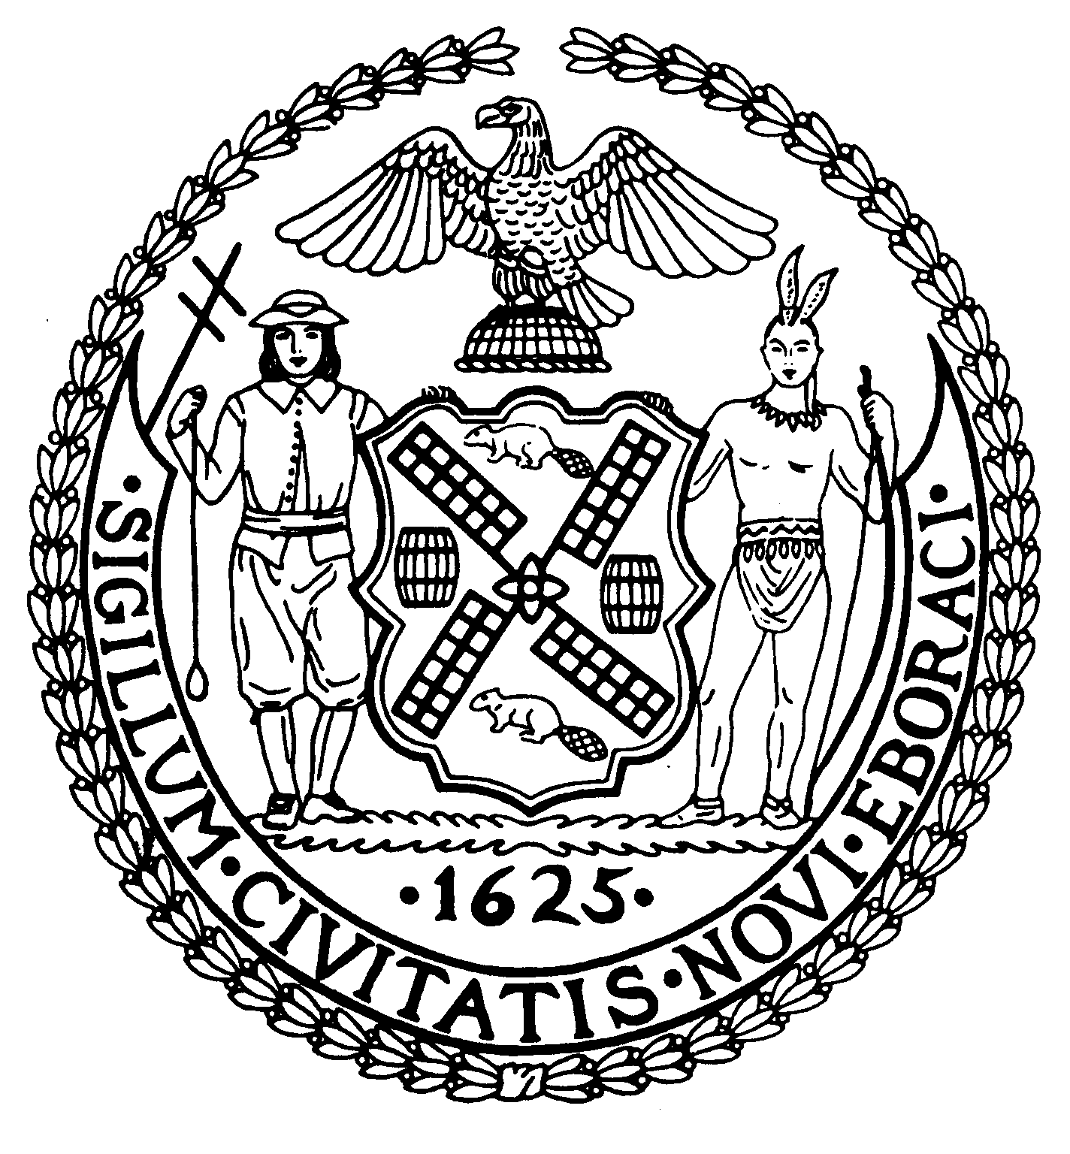
Chair New York, N.Y. 10022-1106
(212) 758-4340
Latha Thompson (212) 758-4616 (Fax)
District Manager www.cb8m.com - Website

info@cb8m.com - E-Mail

The City of New York
Manhattan Community Board 8

Landmarks Committee, June 14, 2010 – 6:30PM
Hunter College School of Social Work, 129 East 79th Street – Room 1010

Present: Jane Parshall, Teri Slater, Elizabeth Ashby, Marco Tamayo, Susan Evans, Michele Birnbaum

Absent Excused: David Liston, David Helpern, Joie Anderson

- 211 East 61st Street (between 2nd and 3rd Avenues) Treadwell Farms Historic District - Mr. Todd Wilson, Architect – Application is for a façade renovation.

WHEREAS 211 East 61st Street is a three-story house constructed by A & A Bussell in 1875.
WHEREAS 211 East 61st Street underwent a complete façade renovation in 1961-62.
WHEREAS the applicant now plans to renovate the stucco facing over the original brownstone, replace windows, flower boxes and ornamental iron work (at the windows, at the bay and at fence at the ground level) as part of a proposed façade renovation.
WHEREAS the exterior stucco finish would be scored to resemble limestone blocks with limestone trim around the windows.
WHEREAS the new bay would be painted metal with a zinc roof.
WHEREAS two portal windows at the ground level on either side of the entrance would be retained.
WHEREAS the new windows would be 6 over 6 windows.
WHEREAS the new balconies would be Juliet balconies within the window trim.
WHEREAS the cornice would be replaced with a new cornice that would replicate the original cornice and match the cornice on the building next door.
WHEREAS the façade renovation, including the proposed design for the iron work and the proposed new 6 over 6 windows, is not contextual within the Treadwell Farm Historic District and does not reflect in any way the original brownstone or the 1961-62 renovation.
WHEREAS the two portico windows being retained at the ground level are inappropriate within the historic district.
WHEREAS the only aspect of the proposed façade renovation that reflects the original design of the house is the cornice restoration which will mirror the original cornice and the cornice of the adjoining building.

THEREFORE BE IT RESOLVED that of this application is disapproved as presented.

VOTE: 4 in favor (Tamayo, Evans, Slater, Birnbaum), 1 against (Parshall) 1 abstention (Ashby)

- 66 East 93rd Street– Carnegie Hill Historic District – Mr. Oliver Cope, Architect. Application is for alterations to the front and rear facades.
THIS APPLICATION IS DIVIDED INTO TWO PARTS: Part 1: The front elevation and Part 2: The rear elevation.

Part 1: The front elevation

WHEREAS 66 East 93rd Street was designed by A. B. Ogden & Son in the Queen Anne style and constructed in 1890-91.
WHEREAS 66 East 93rd Street is the last one remaining of three small “apartment flat” buildings all designed by A. B. Ogden & Son; the basement and street level are stuccoed and the remaining three stories are red brick with brownstone trim.
WHEREAS 66 East 93rd Street is surrounded by buildings designed by some of the most famous residential architects in the history of New York, including the Baker house designed by Delano and Aldrich, the Loew house designed by Walker and Gillette, and the Virginia G. F. Vanderbilt house designed by John Russell Pope.
WHEREAS much of the fabric that was original to the façade has either been removed or allowed to deteriorate.
WHEREAS the proposed design for the façade will retain intact the upper three floors of the building, including the arched windows at the top floor, the frames around the windows, the original brickwork and the original cornice.
WHEREAS the applicant is proposing a two-story limestone base that will lighten the façade and emphasize the new “parlor floor”. [Since the building was originally built as apartments, there was no “parlor floor”; the building is being turned into a single family house.]
WHEREAS the applicant proposes to change the door at the entrance from a double door to a single door and thus keep the vertical protruding bay on the west side of the building intact for all five floors.
WHEREAS the two-story limestone base provides a solution to the problem of the bottom two floors and the applicant’s desire to preserve the bay– a characteristic of the original design of the building.
WHEREAS the new design for the front elevation, while not a replication of the original Queen Anne style, except for the top three floors, is not out of character within the historic district.

THEFORE BE IT RESOLVED that Part 1 of this application – the front elevation - is approved as presented.

VOTE: 4 in favor (Parshall, Birnbaum, Evans, Slater), 2 abstentions (Ashby, Tamayo)

Part 2 – the rear elevation

WHEREAS the rear yard is approximately 29’ deep.
WHEREAS the applicant proposes to remove an existing 13’ extension (approximately 560 sq. ft.) and an existing fire escape.
WHEREAS at the top floor (the fifth floor) the applicant proposes pulling back the wall to create a roof terrace within the body of the 5th floor.
WHEREAS at the 3rd and 4th floors the applicant proposes a zinc-coated copper bay that projects out 18”.
WHEREAS at the ground and 2nd floors the applicant proposes two floors of glazing with a window 18 ½” high and 14’ wide within a metal frame.
WHEREAS the existing extension to be demolished has 10 windows. The applicant is not creating any further window area since the removed windows from the extension will be equal to the amount of new glazing being created at the rear.
WHEREAS the applicant proposes filling in the rear yard by 3 ft. so that one can step directly out into the garden which will now be at the level of the rear entry to the house.
WHEREAS the proposed modern rear elevation reads as a contemporary elevation and is out of context and uncharacteristic within the historic district.
WHEREAS there is no relationship between the front elevation and the rear elevation.
WHEREAS the choice of fenestration -- in particular, the oversized 18 ½’ high window – intrudes into the donut that are the rear yards of the surrounding houses.

THEFORE BE IT RESOLVED that Part 2 of this application – the rear elevation - is disapproved as presented.

VOTE: 4 in favor (Parshall, Birnbaum, Ashby, Evans), 2 abstentions (Slater, Tamayo)

- 1 East 70th Street) – INDIVIDUAL LANDMARK (The Frick Museum) - Upper East Side Historic District- Mr. Robert Goldsmith, The Frick Museum, Mr. Bill Higgins Higgins and Quasebarth, Mr. Carl F. Krebs, Architect – Application is to enclose a loggia.

WHEREAS 1 East 70th Street is a Louis XVI style mansion designed by Carerre & Hastings and constructed in 1913-1914.
WHEREAS 1 East 70th Street was altered as a public museum by John Russell Pope in 1931-35 and a garden addition was constructed in 1977 (Van Dyke, Bayley and Poehlor, architects and Russell Page, landscape architect ).
WHEREAS the applicant proposes enclosing a loggia that faces south over the lawn along Fifth Avenue and is at the north part of the building that extends from 5th Ave. along 71st Street.
WHEREAS the loggia space (660 sq. ft.) has never been open to the public; an enclosed loggia would provide additional space for works of art, including sculptures, would allow an underutilized part of the museum to be used and would provide views to the garden/lawn.
WHEREAS the applicant proposes transparent glazing for the colonnade of the loggia so that the primacy of the architecture is maintained.
WHEREAS at the end bay where the masonry opening more resembles a large arched window, there will be a multipaned wood French door with an arched transom. [There is a large arched masonry opening that faces south and is at the 5th Avenue end of the building. To the east of this opening, the loggia begins].
WHEREAS the infill between the columns will be 14’ high glass units with dark bronze frames on the glass units to hold the glazing together.
WHEREAS the applicant will retain the character of the interior space and will use large lanterns to light the space (the lanterns will replicate and existing lantern in the portico).
WHEREAS the footprint of the museum will remain exactly the same.
WHEREAS the loggia is one of the most important architectural features on one of the most important buildings in New York City and should be retained as open space.
WHEREAS there must be another solution to utilize the loggia space to show the museums art.
WHEREAS using the space to exhibit the museum’s art should be subordinate to preserving the architecture of this important individual landmark.

THEREFORE BE IT RESOLVED that this application is disapproved as presented.

VOTE: 4 in favor (Slater, Tamayo, Evans, Birnbaum), 2 against (Ashby, Parshall)

4. Proposal to extend the Carnegie Hill Historic District to include Park Avenue from 86th Street through 91st Street and from 94th Street (including 1192 Park Avenue south of 94th Street on the west side of Park Avenue) through 96th Street.

WHEREAS Park Avenue is a treasured historic avenue known nationally and internationally, and
WHEREAS Park Avenue is a Historic District from East 62nd Street to the south side of East 79th Street, and
WHEREAS Community Board #8 has a 2006 resolution in support of including Park Avenue from the north side of East 79th Street to the south side of East 86th Street in an Historic District, and
WHEREAS there is already an existing Carnegie Hill Historic District on Park Avenue from 91st Street to 93rd Street, and
WHEREAS renowned architects such as Rosario Candella and Emory Roth and others have designed buildings in all three areas and the architecture of the buildings are of high quality and reputation, and
WHEREAS Park Avenue from the north side of 86th Street through 96th Street has buildings by the same architects, and they are as beautiful as those on the southern sections of Park Avenue, and
WHEREAS the New York State Historic Preservation Office has determined Park Avenue from 79th Street to 96th Street eligible for inclusion on the National Register of Historic Places,

THEREFORE BE IT RESOLVED that Community Board #8 supports that Park Avenue from East 86th Street through East 96th Streets be included in an historic district so as to protect its beauty and historic importance.

VOTE: 6 in favor (Parshall, Slater, Ashby, Tamayo, Evans, Birnbaum)

