Jacqueline Ludorf 505 Park Avenue, Suite 620
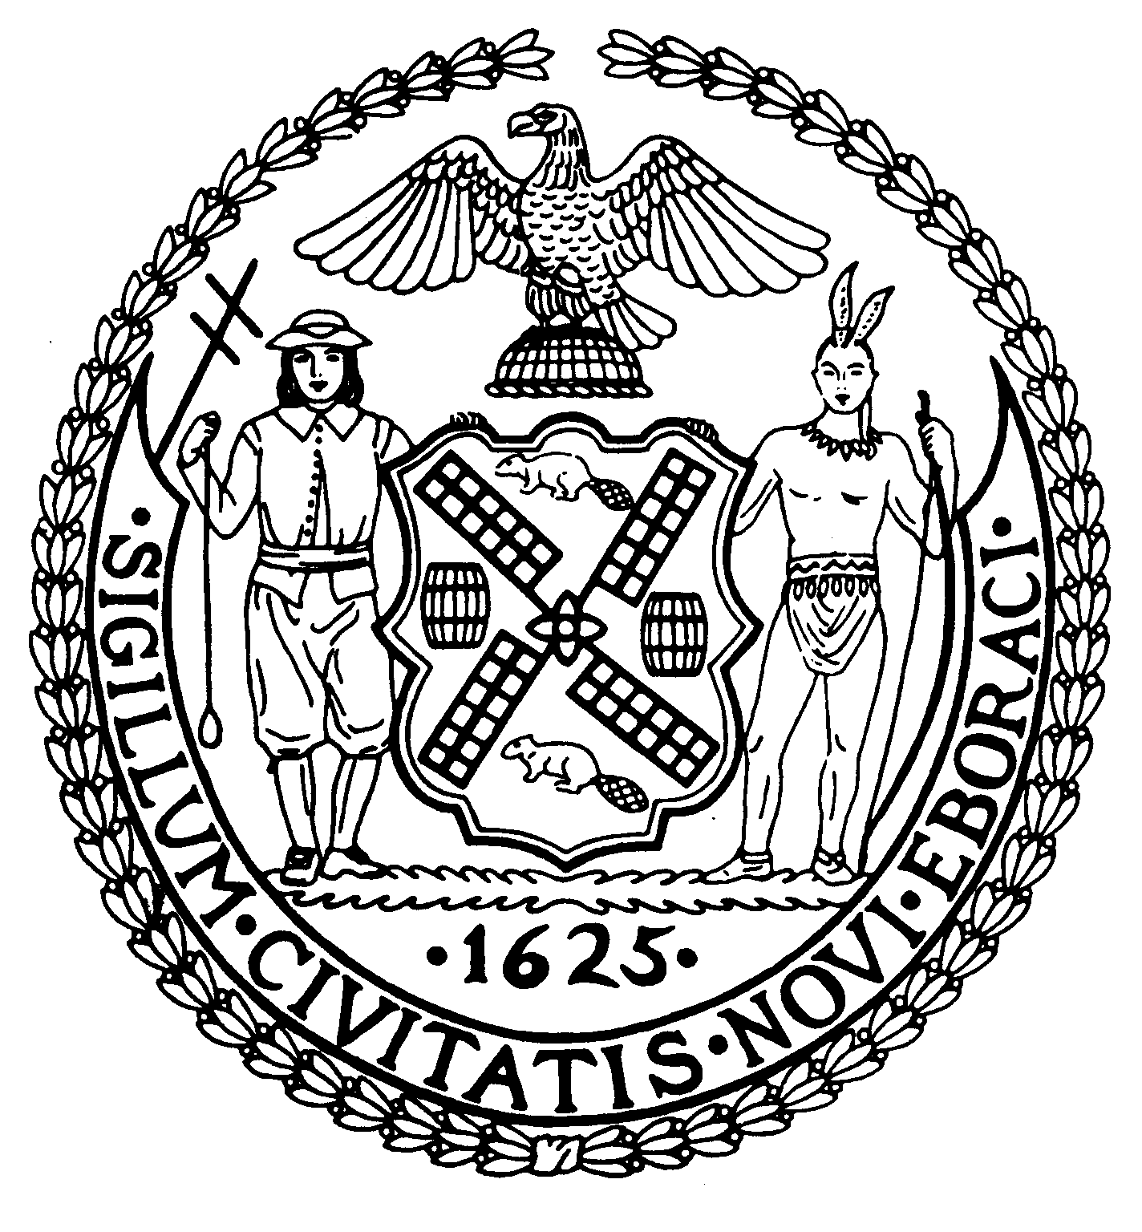
Chair New York, N.Y. 10022-1106
(212) 758-4340
Latha Thompson (212) 758-4616 (Fax)
District Manager www.cb8m.com - Website

info@cb8m.com - E-Mail

The City of New York
Manhattan Community Board 8

Health, Seniors, and Social Services Committee
Lenox Hill Neighborhood House
331 East 70th Street, Auditorium
New York, New York
Thursday, June 24, 2010, 6:30 pm

Committee members present: Mary Pike, Ellen Polivy, Barbara Rudder
Committee members absent: Lorraine J. Johnson, Deirdre Breslin, N. Sharon Pope

Forum topic: Help In Hard Times: When Food Is Scarce
Where You Can Go If You Need Help; What You Can Do To Help

Panel members:
Claire Grossman, Manager of External Affairs and Administration, Lenox Hill Neighborhood House
Mimi Choy-Brown, Director of Clinical and Quality Management for Lenox Hill Neighborhood House’s Homeless and Housing Services Programs and Clinical Director of Casa Mutua, its supportive housing program
William J. Dionne, Executive Director, Carter Burden Center for the Aging
Stephen Grimaldi, Executive Director, YCP/Yorkville Common Pantry
Rev. Ray Bagnuolo, Pastor, Jan Hus Presbyterian Church and Neighborhood House
Jim Bates, President, Roosevelt Island Disabled Association, Angel Food Program

The speakers’ presentations focused on the growing problem of hunger in New York City and the efforts being made by their respective organizations to combat it. Each of the speakers conveyed basic information about what their food-related programs are, who can access their various programs and how to go about doing it, and the effect of the current economic climate on their programs. They also offered practical suggestions about how community members can help support these vital programs during this period of escalating need on the part of growing numbers of individuals, including the elderly, women, children, and, increasingly, even entire families. The speakers also made available generous amounts of literature about their programs.

The following few points, drawn from the speakers’ presentations, illuminate the severity of the food shortage, who is in need, the types of help available through some of their programs, and some statistics about the scale of the organizations’ efforts to aid the growing numbers of those who are hungry and in need of food.

Hunger in the city is a huge issue. Both our city and our state are going through an enormous budget crisis and donors have less to give.
At the present time, approximately 36 million Americans are using some sort of emergency food; in New York City, the number is 2,500,000, and people who have never before used food stamps are having to turn to them in increasing numbers.
The city is facing the prospect of closing 50 senior centers with lunch programs in the city because DFTA’s funds have been cut as a result of the state budget difficulties.
Even with economies of scale, it is a challenge to provide all those in need with nutritious and filling meals and/or food staples and packages for off-site consumption.
While the following figures do not illustrate the full sweep of the help each organization provides, they indicate the level of need that exists and continues to rise. The Carter Burden Center for the Aging serves 200 meals per day and provided 161,000 meals to older New York City residents in 2009; the Jan Hus Presbyterian Church and Neighborhood House food pantry aids 300-400 people weekly and provides approximately 100 people dinner every Tuesday night; YCP/Yorkville Common Pantry serves 1,800 meals a week.
Growing numbers of New York City’s elderly are poor. Their 20 percent poverty rate is twice the national average.
It is increasingly important not only to make food available but also to provide information on nutrition, healthful cooking, and the importance of preparing and consuming fresh food; improved nutrition is an important factor in combating chronic and serious diseases.

If you are hungry or you know someone who is:

Lenox Hill Neighborhood House:
Description: Senior center lunch program; children's summer camp with three meals a day; snacks to older children; assistance in obtaining food stamps; community supported agriculture program makes fresh produce available to members.
General contact information: www.lenoxhill.org or call 212-744-5022.
There are two senior centers, one at 343 East 70th Street, on the corner of 70th and First Avenue (serves hot lunch seven days a week), and another in St. Peter’s Church at 54th Street and Lexington Avenue (serves lunch five days a week but not on Sunday or Tuesday). For additional information, call the Lenox Hill Neighborhood House senior center (343 East 70th Street), 212-744-5905, or the Lenox Hill Neighborhood House senior center at St Peter’s Church, 212-308-1959.

Carter Burden Center for the Aging:
Description: Programs and services for seniors, including the Carter Burden Luncheon Club and Senior Program, which offers freshly-prepared sit-down meals on-site and a meals on wheels delivery program for individuals who are homebound, 351 East 74th Street, 212-535-5235.
General contact information: www.burdencenter.org or call 212-879-7400.
To receive services: Call or come in.

Yorkville Common Pantry:
Description: New York City’s largest community-based food pantry. “No one is ever turned away.” Varied food programs providing assistance to Individuals and families, including the homeless. Ancillary service programs for those who are homeless.
Services:
Acute emergency food assistance available 24/7. Brown bag meals for homeless individuals from 7pm to midnight. Emergency grocery bags to needy families.
Hot meal program provides breakfast every weekday and dinner Mondays, Wednesdays and Fridays. Medical screenings, other help available during meal programs.
Pantry program provides fresh fruits and vegetables, milk, meat, and non-perishable items for the preparation of meals.
Cooking and nutrition classes for children and families: offers pantry participants instruction on nutritional values of foods and on healthful cooking techniques for foods being distributed.
Location: 8 East 109th Street (at Fifth Avenue and 109th)
Contact: www.ycp.org, www.facebook/co/ycpnewyork, "www.twitter.com/ycpnewyork or call 917-720-9700.

Jan Hus Presbyterian Church and Neighborhood House
Description: Multiple programs to feed and clothe and offer other forms of assistance to homeless and hungry individuals, including a Tuesday dinner program and a food pantry. The numbers of people the church served tripled within a few weeks of the closing of the nearby drop-in center for the homeless. The church welcomes assistance from neighborhood merchants and seeks out ways to enable them to help.
Location: 351 East 74th Street, New York, New York 10021-3701
General contact information: www.janhus.org; 212-288-6743; email: church@janhus.org
To receive assistance: Contact or come to the church.

Angel Food Ministries:
Description: Quality food at a discount. The Roosevelt Island Disabled Association (RIDA) partners with Angel Food Ministeries (AFM) in Georgia to provide quality food to participating Roosevelt Island residents at reduced prices. AFM is a massive purchasing group that negotiates the lowest prices for group purchases of food and then quickly distributes that food around the country. The program accepts food stamps. RIDA has been successfully providing food through this program for the past year. The program is run by volunteers. The foods are ordered through Angel Food Ministries and delivered once a month to a warehouse in Queens, where they are then made available the same day through the efforts of volunteer sorters and truckers. Any 501(c) organization can begin distributing food through the organization. Contact Angel Food Ministries in Georgia to get involved.
General contact information: www.angelfoodministries.com" www.angelfoodministries.com; unclejim@nyc.rr.com; 212-731-2547.
How to participate: Ask your local religious institution or community center to set up such an arrangement or order on-line with a credit card and pick up your individual order on Saturdays on Roosevelt Island.
To assist: Help a 501(c) organization set up a local Angel Food location for your neighborhood. Donate the use of your van or truck or assist in sorting food and/or loading truck or distributing the food on distribution day.

Volunteer opportunities for community members:
There are numerous ways community members can assist these outstanding community organizations in their efforts to help community members in need.
Some of the possibilities appear below. Donations of time and of money are of tremendous help given the great demands all of these community organizations are currently facing. Community members can check the organizations’ websites for more information on how to become involved or can simply call or email the organization at the telephone number or email address set out above.

Become a volunteer. Lenox Hill Neighborhood House, Carter Burden Center for the Aging, and YCP/Yorkville Common Pantry all offer numerous volunteer opportunities and have volunteer coordinators. Jan Hus Presbyterian Church and Neighborhood House also welcomes volunteers and is in the process of setting up a volunteer program.
Have a food drive in your building. YCP/Yorkville Common Pantry will provide guidance in setting one up.
Bring food staples consisting of canned goods and other non-perishables to Jan Hus or YCP. Fresh perishables can also be brought to the church or YCP. If you are coming by car, call first; arrangements can be made to pick up the donations curbside so you will not have to park your car.
Both YCP and Jan Hus also welcome donations of clothing and toiletries.

