Jacqueline Ludorf 505 Park Avenue, Suite 620
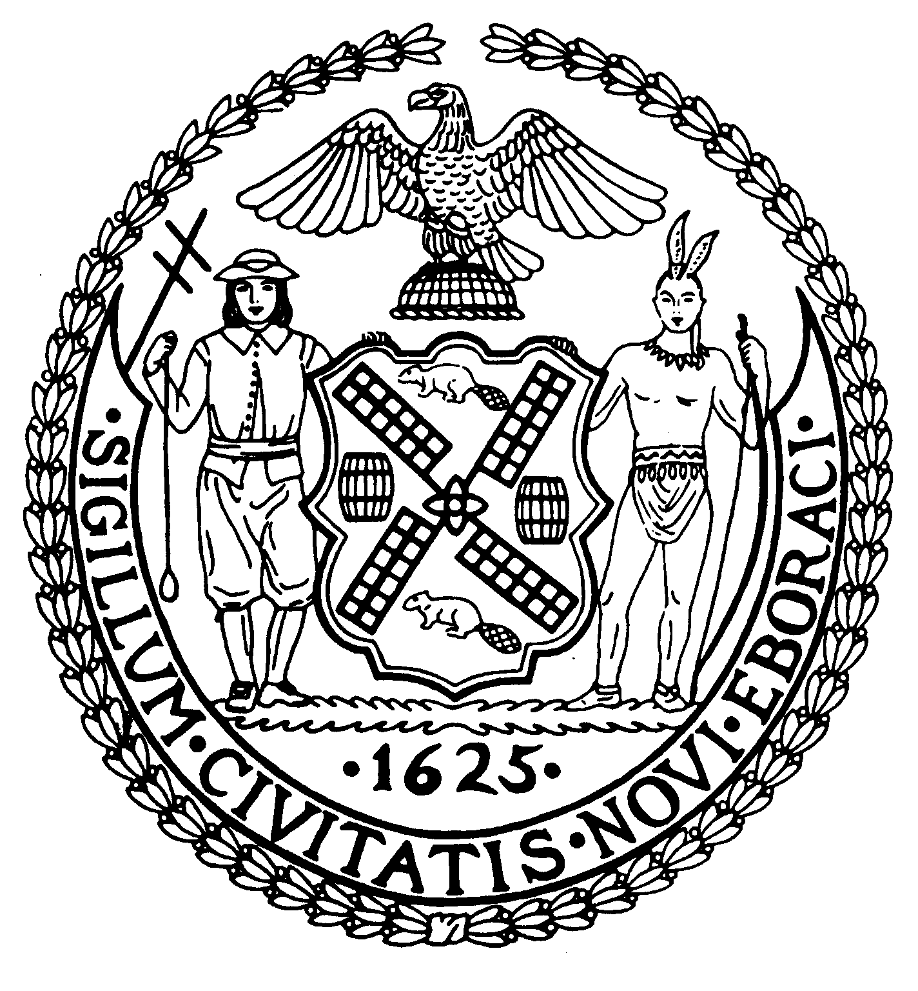
Chair New York, N.Y. 10022-1106

(212) 758-4340
(212) 758-4616 (Fax)
Latha Thompson www.cb8m.com - Website
District Manager info@cb8m.com - E-Mail

The City of New York
Manhattan Community Board 8

THIS IS AN OFFICIAL GOVERNMENT NOTICE
PLEASE DO NOT REMOVE UNTIL 6/25/10

Public Forum

HELP IN HARD TIMES:
WHEN FOOD IS SCARCE

WHERE YOU CAN GO IF YOU NEED HELP
WHAT YOU CAN DO TO HELP

Panelists

Claire Grossman, Lenox Hill Neighborhood House
William Dionne, Carter Burden Center for the Aging
Stephen Grimaldi, Yorkville Common Pantry
Rev. Ray Bagnuolo, Jan Hus Presbyterian Church and
Neighborhood House

Thursday, June 24, 2010, 6:30-8:30pm
Lenox Hill Neighborhood House
331 East 70th Street (between 1st and 2nd Avenues)

