Jacqueline Ludorf 505 Park Avenue, Suite 620
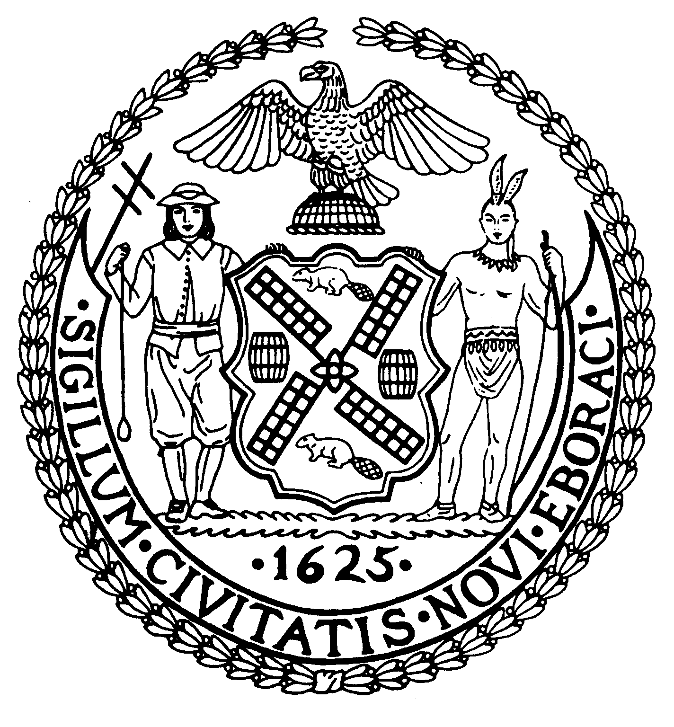
Chair New York, N.Y. 10022-1106
(212) 758-4340
Latha Thompson (212) 758-4616 (Fax)
District Manager www.cb8m.com - Website

info@cb8m.com - E-Mail

The City of New York
Manhattan Community Board 8

Communications Committee
Monday, June 28, 2010 – 6:30PM
Community Board 8 Office, 505 Park Avenue, Suite 620

Agenda

- A review of present and potential technical capabilities of the newly installed CB8M.COM website

David Rosenstein and Will Sanchez, Co-Chairs

