Jacqueline Ludorf 505 Park Avenue
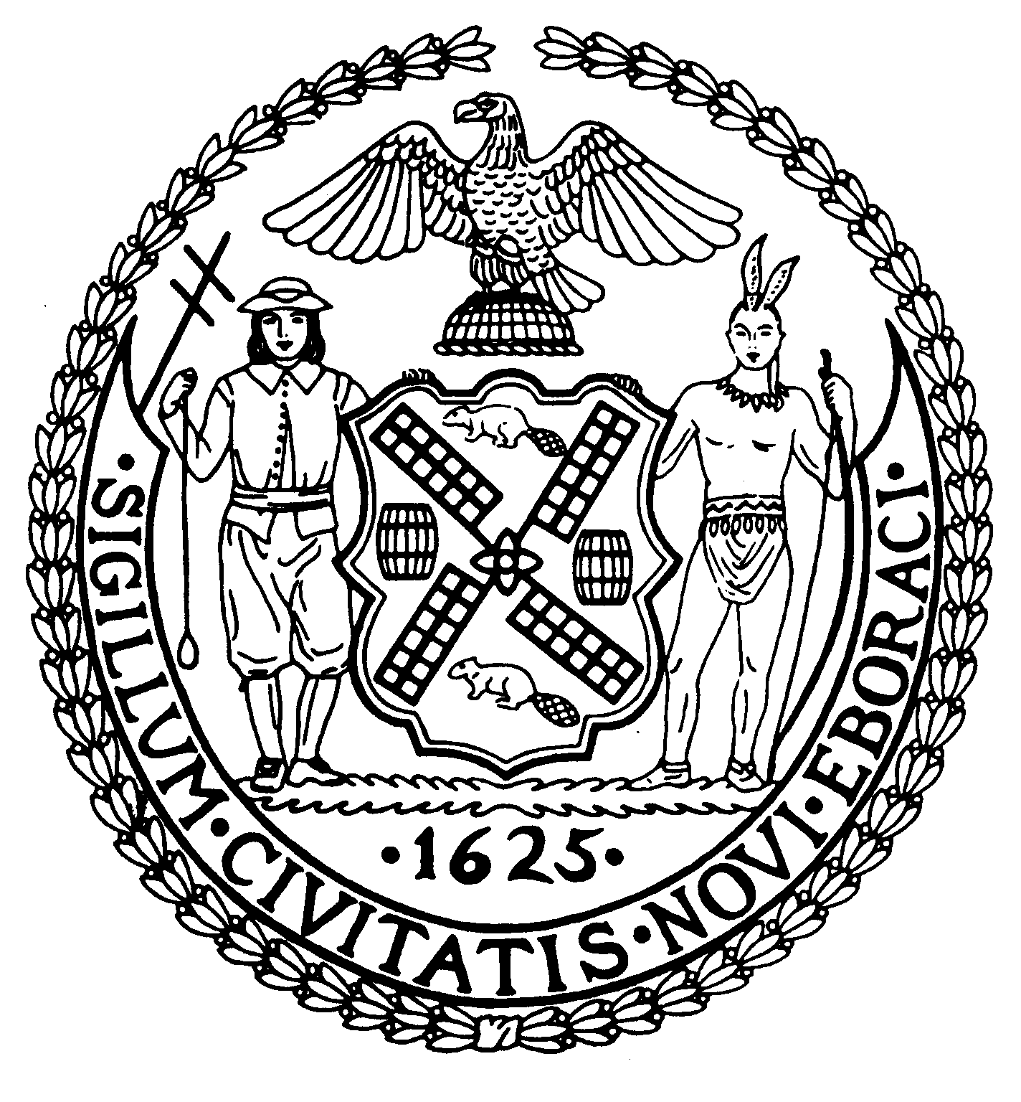
Chair Suite 620
New York, N.Y. 10022

Latha Thompson (212) 758-4340
District Manager (212) 758-4616 (Fax)
www.cb8m.com Website
info@cb8m.com - E-Mail

The City of New York

Manhattan Community Board 8

Transportation Committee Meeting
New York Blood Center
310 East 67th Street, Auditorium

Wednesday, June 2, 2010
6:15PM

Agenda

- Discussion of Traffic Issues and Street Closures related to the Third Water Tunnel Construction Project along East 59th Street (joint item with Environment & Sanitation Committee).

- Discussion of Timing and Community Impacts of the East 78th Street Pedestrian Bridge Construction Project (joint item with Parks Committee).

- A request to install a “Loading Zone” in front of 167 East 73rd Street. (Requested by Mr. Tesei, Vilcek Foundation) (joint item with Landmarks Committee)

- Discussion of DOT’s conversion of single space meter poles to bicycle racks on First Avenue from 60th Street to 96th Street.

- Discussion of a request to DOT by Fairway for expanded hours and size of the Truck Loading Zone on the south side of East 86th Street between Second and Third Avenues.

- Old Business

- New Business

Jonathan Horn and Charles Warren, Co-Chairs

