Nicholas Viest 505 Park Avenue, Suite 620
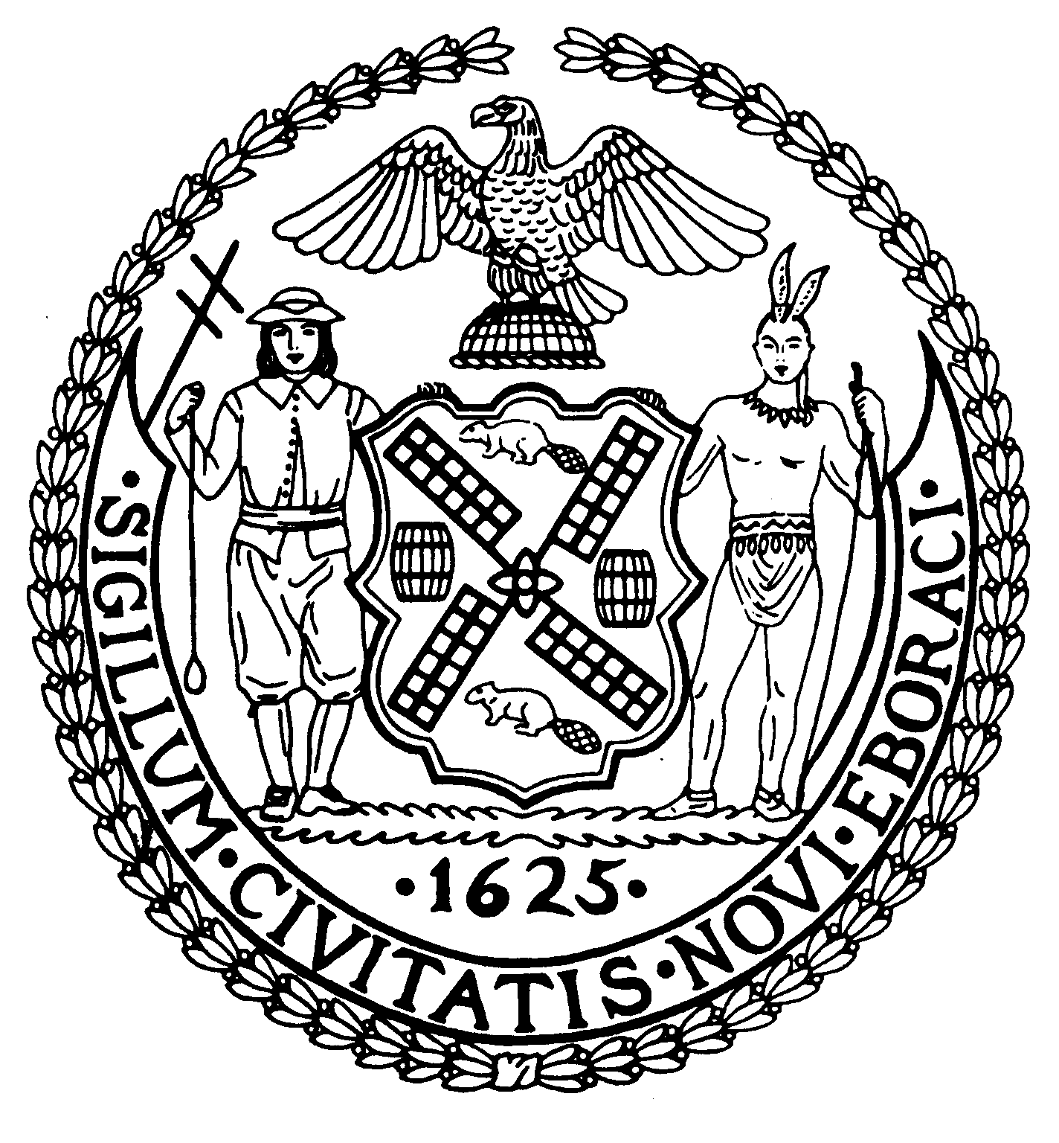
Chair New York, N.Y. 10022-1106
(212) 758-4340
Latha Thompson (212) 758-4616 (Fax)
District Manager www.cb8m.com - Website

info@cb8m.com - E-Mail

The City of New York
Manhattan Community Board 8

Vendor Task Force Committee Forum
Minutes
May 20, 2014
Present: Michele Birnbaum, Matt Bondy, Rita Popper, Nick Viest, Monica McKane-Sanchez (Public Member)

The meeting was called to order at 6:40 PM.

Michele Birnbaum, Chair, gave some opening remarks as to the purpose of
the CB8 Vendor Committee and a brief summary of the past meetings.

This Forum was an outgrowth of meetings and discussions taking place over the past almost two years during which vendor categories and vendor law were examined, and community concerns about vendor control and compliance were discussed.

There was one agenda item: Discussion on how to create a large coalition of city wide organizations to work together on vendor controls and compliance.

Michele suggested that we want to address all vendor issues with one voice, as we recognized that there is city-wide concern about control, proliferation and compliance.

Michele read e-mails that came to the office this month in which residents complained about vendor trucks parked all day at a meter, a cooking food cart is under window causing smells in an apartment all day, and notice of a business man attending the National Restaurant Association Show in Chicago which was addressing vendors issues.

Councilmember Dan Garodnick addressed the meeting on what he has accomplished with vendor legislation and gave us some insight in what he plans to do in the future. “Vendor rules are highly complicated, not regularly enforced and often ignored,” he stated. As a city, we need to address this and make sure that our vendor rules make sense and are not so complicated making them very difficult to enforce.

For the past two years, Councilmember Garodnick was Chair of the Consumer Affairs Committee of the City Council and was able to bring vendor issues to the fore and introduce legislation aimed at improving the system, clarifying and modifying the rules and making vendors more accountable. He brought legislation that tied violations to a licensee and to the person who owns the permit. Prior to this legislation, if the permit accrued violations, the licensee would not necessarily be held accountable, and the violations might not appear in the record.

He reported that The Metropolitan Museum is having a lot of difficulty at this moment, as they have many vendor complaints, but at this time, the City Rules for Vendors differ from the state rules, and while the vendors at the Museum may not be compliant with city rules, they are mostly compliant with state rules, thus making enforcement very difficult with no process for ameliorating the issues that confront the Museum and the community. The current city laws would not permit the vendors to be there, because they create a safety hazard when unloading school buses and because they position themselves in bus stops and in areas too close to entrances and exits.

Councilmember Garodnick supports a separate enforcement unit and will address vendor infractions and also the commissaries’ rules which should be enforcing sanitary and garbage collection as laid out in the City Charter.

While some communities might like the presence of vendors more than others, the rules need to be clear and need to make sense no matter the viewpoint of the community.

Michele pointed out that the Committee felt it was not only important to do research on vendor law and not only important to hear community complains about vendors, but to come up with solutions that could be vetted and, where appropriate, become
law. The aim of the effort would be to help the vendor community and the residential and business communities live together with a quality of life that is acceptable to most.

She explained some of the solutions, i.e. assigned locations, bidding for spots,
an effort to elevate the vendor to a professional business person exercising the compliance and responsibility to which a restaurant or bricks and mortar business might be held.

There is concern about new kinds of businesses coming on to the streets that use trucks and vehicles, i.e., a notary public, a dress van, bricks and mortar businesses
expanding by using trucks and not renting building space.

We think that forming a city-wide coalition is the only way to address these complicated
issues.

Nick Viest, CB8 Chair, addressed the meeting and introduced Sgt. Hammershmitt who explained the role of the Conditions Unit of the 19th Precinct. There are two shifts a day – morning and night, and the public can contact the unit when they have vendor concerns, and they will address the issue or ticket the vendor.

The Community Affairs number is (212)452-0613 Detective Helms and Officer Lombardi handle other issues, as well i.e. non-compliant bicyclists, as well as vendors.

Nick Viest told the group that we have to work hard and take small steps forward. We’re looking for enforcement and ways to mitigate the concerns. We are not seeking to get rid of vendors, but to have fair regulations and more significant enforcement of the rules that we already have on the books.

We very much want a separate vendor enforcement squad which would be self-funding. The man power in the Precincts can’t handle the infractions that are out there. Police need and want more help.

Electric ticketing would help as would feed-back to the police.

We then took general comments and questions from the audience and asked that they address how to go forward towards the formation of a city wide coalition to address vendor activity.

Comments from the audience included: Florence Friedman – reported sidewalk vendors cause congestion in CB6 and in Union Square whose street is very congested and asked what is the rule on First Amendment vendors? Michele replied that they have the right to be on the street, but they still should be compliant. If an 8’ table is a rule, a First Amendment vendor should have an 8’ table, just as a food inventory truck needs to follow the parking and clean up rules. The First Amendment category has expanded.

A neighbor reported that she witnessed a school bus unloading in front of the Metropolitan Museum and how dangerous it was to have the kids unload between the vendors. The Met is a construction site, and the sidewalk is not wide enough. Michele replied that because vendors want to be in the most crowded area, they often create a safety hazard by crowding the pedestrian way. Councilmember Garodnick is working with the Met to address their vendor concerns. Genevieve Michel, the Councilmember’s legislative aide, addressed the question and explained that the issue at the Met is a dangerous safety concern which her office is trying to address. She suggested that the public call 311 and e-mail the CB when they see infractions so as to create a record that could be used to put pressure on the Museum and the vendors and incite them to action.
The CB will follow-up.

The Museum had the Department of Health, The Parks Department. and all agencies involved in the recent meeting with Councilmember Garodnick, and all are frustrated. The vendor vehicles are causing problems at the Met too, and there are similar complaints at the Guggenheim.

Peter Davies of the Soho BID has been doing a lot of work on vendor compliance and
informed the group that a recent directive about propane tanks and generators was put out by the New York Fire Department that clarifies their use, and he will forward the new directive to Michele.

It was also reported, yet again, that food carts are causing trouble on subway grating by having food spill into the subways and feeding the rat population, and yet this issue is not being addressed.

A resident says she is willing to chip in and plant trees and flowers to beautify sidewalk space. Each property owner is responsible for the cleanliness of sidewalk up to 14 inches in to gutter. She asked for help in getting trees planted and was told to call the CB8 office for help.

One resident complained about 86th Street in front of Shake Shack as being a “total mess.” Michele pointed out that she invited Shake Shack’s management team to the meeting and would reach out to them again.

Michele states that 86th Street is a “fiasco” between 2nd and Lex Avenues, and she reiterated news of Board of Health sweeps on those blocks. She asked the public to please notify the Board office with complaints so that we can create a record to show
the Department of Health.

A gentleman asked if it is possible to check on the names and the license numbers of the vendor licensees and permitees. Is there a list available to the public with the information by permit or license number? Genevieve Michel of Dan Garodnick’s office will look into this.

Rita Popper noted that when the 2nd Avenue Subway is completed, 2nd Avenue will
look very different, and we should talk about what we want the future to look like with respect to vending. She stated that vendors have rights, but so do residents, and we should have input in to what we want our neighborhoods to look like.

We want rules and regulations to be enforced. We want standardized street furniture
so that the consumer and law enforcement can easily identify the legal vendor, and we want prominent signage that would further identify a veteran vendor.

Michele wants us all to be heard as one voice. She referred to the table configuration
of the meeting which grouped those with like interests together, i.e. BIDS at one table, RETAIL at another, BLOCK ASSOCIATIONS at another, GOVERNMENT, VENDORS, RESIDENTS, etc. each having their own table. There was also row seating for anyone who preferred that.

The meeting paused for 15 minutes so that these groups could caucus and come up
with suggestions as to how to go forward in establishing a city-wide coalition to address mutual concerns. Then the meeting resumed and table representatives made their comments and recommendations to the meeting attendees.

Joe Clark recommended that permit numbers be run against income tax returns to make sure that vendors pay taxes. He suggested that we match permits to NYC City, New York State and Federal Income Tax records.

Michele stressed to the attendees the importance of clarity of their contact information, because in order to go forward, we must be able to reach each other.

A woman reported that there are three fruit stands in a one block area on Third Avenue between 90th and 91st Street. They are there 24/7, sleep in the van, and talk and mingle in the middle of the night being disruptive and making noise.

Ricky Wong of the Department of Consumer Affairs addressed the group and informed all about the city winning a law suit against a truck holding cell phones for a fee while children are in school. The DOC would not grant a license because he was vending from a motor vehicle. The City won the suit and was correct in their decision to deny the license.

He clarified for the group that DOC licenses merchandise vendors not food vendors which is licensed by the Department of Health.

Richard Lipsky represents a part of the retail food community, i.e. Bodega Association, Korean Grocers and others, and he spoke to encourage all to get together and get funding. Without the money, nothing will be accomplished. He suggested that we need to go to City Hall and get 200 people out there so that we can make a real statement, but he stressed that you need money and lobbyists to do this and exhibit genuine grass roots outrage. He can get some of the retail people involved, but we need to include landlords, residents, etc. with funding and unity. The emotional feed-back from going to a rally is not the same as creating a symbolic movement, but funding by BIDS and others are necessity. We need to involve the working class community.

Michele explained she tried this years ago and wanted to call it THE COALITION FOR CONTROLLED AND COMPLIANT VENDING. You need paid staff, fundraisers, seed money, a fiscal conduit, and expertise in outreach and public relations.

Matt Bondy is familiar with a group of people who knew how to read and interpret
the vendor laws. Matt used to meet with a counterfeit unit in order to address those concerns. We must have a unified and wide reaching effort. Michele says that each person needs to reach out to a couple of other people or other groups in a strong
outreach effort.

CB 6 wants to know how to limit permits and locations. Michele read from her list
of 35 suggestions as to how to mitigate vendor challenges, but cautioned that only
certain suggested regulations would pass the City Council at this time. Michele
suggested working on commissary regulations.

When there is a Council hearing, many more vendors than the public come down to testify.

People with a vision and the right kind of expertise need to be organized.

Michele will e-mail blast the minutes and the list of suggestions.

Michele asked all to refer to the resolutions that she had sent with the meeting
invitation and asked all to keep them.

Enforcement is the main thing to work on. She had asked Councilmember Garodnick to also work on commissary regulation, because it is an easy give for
vendors and law makers; they should jumped on Board to support legislation that addresses the health concerns for which commissaries are responsible.

Each community group has to approach its own Council Member so that if a bill is introduced, a Council Member feels he has support.

Having an inventory truck permits a vendor to be on the street 24/7, but a vendor should leave the street when his cart is empty and in compliance with the hours of vending permitted and the list of restricted streets.

Bob Schwartz had a suggestion about organizing a coalition and said we should begin with a small group, meet and come up with strategies and a mission statement, and not start with 100 people. You need to create a steering committee and start with a small dedicated nucleus of people who are willing to work hard. SABO suggests flushing those out, and Bob volunteered to participate. Michele will organize such a steering committee, and expresses that down the road, we will need expertise in business, finance, public relations, advertising, and organization.

Getting control of a license and tying it to a specific location could be helpful in
controlling vending locations. In response to a question, Michele explains that .all city legislation on vending goes through the City Council. State law does not.

Limiting the number of licenses is the most important issue at the moment, but there is other support that would want the number of licenses to be increased so as to
accommodate the number of people on a waiting list. Michele points out that there’s a list for taxi licenses also, but there’s only so much additional street traffic activity
that the city can tolerate. There is no need to feel it is a necessity to be influenced by a waiting list.

Restaurants and businesses are expanding using trucks, and this is has a very large impact on our streets and quality of life, in general.

Michele reported that the fines for vendors were reduced by the Council at a past hearing. Without a city wide coalition, vendor activity will proliferate.

Jim Cohen stated that if each building could get signatures from all the tenants supporting vendor control, it would be helpful.

A quality of life argument can be made on many levels. For example, we don’t have a coalition to express outrage at sales of merchandise that are not appropriate to the
neighborhood standard, i.e. drug paraphernalia.

Michele thanked the Board office and Anub for configuring the room, sending out the notices providing her with index cards and everything she needed for this meeting to happen.

The meeting was adjourned at approximately 8:45 PM.

Respectfully submitted,

Michele Birnbaum, Chair
Vendor Task Force Committee, CB8

