Jacqueline Ludorf 505 Park Avenue, Suite 620
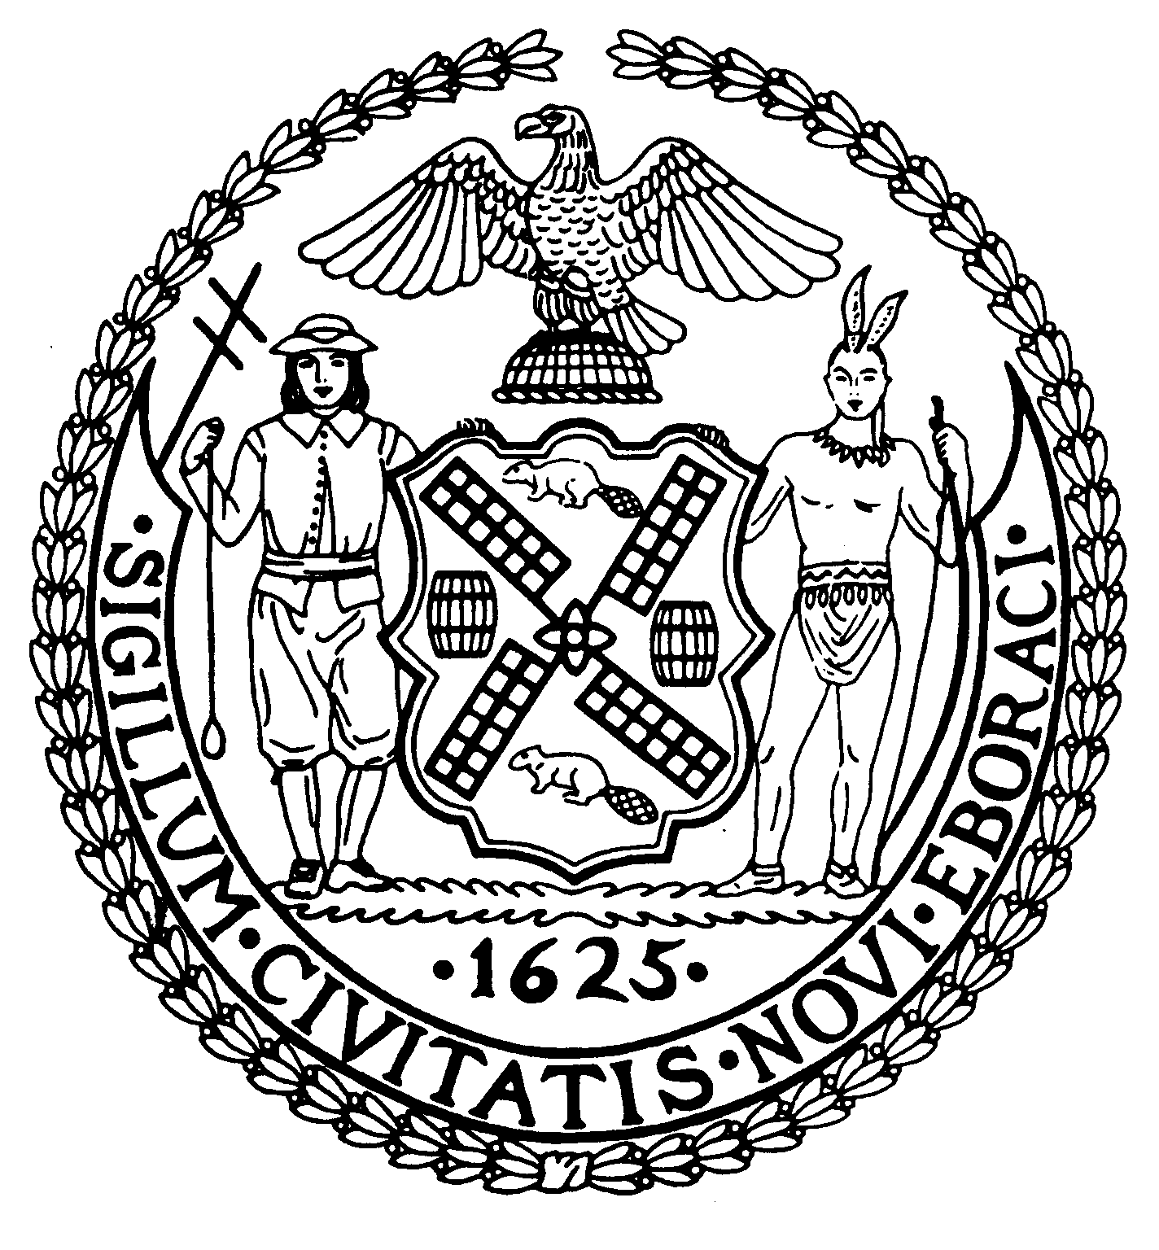
Chair New York, N.Y. 10022-1106
(212) 758-4340
Latha Thompson (212) 758-4616 (Fax)
District Manager www.cb8m.com - Website

info@cb8m.com - E-Mail

The City of New York
Manhattan Community Board 8

Transportation Committee Meeting
New York Blood Center Auditorium
310 East 67th Street
Wednesday, May 4, 2011
6:30 PM

Minutes

Present: Michele Birnbaum, A. Scott Falk, Larry Hockert, Rita Popper, and Charles Warren.

Absent excused: Jonathan Horn, Helene Simon

The Meeting was called to order at 6:30 PM by Co-Chair Charles Warren.

- Presentation by DOT on the results of their Ed Koch Queensboro Bridge Bus Priority Study.

A presentation was made by Mr. Will Carry of NYCDOT. He described the study focus areas: (1) 60th Street and Second Avenue: bus safety; (2) 57th Street and Third Avenue: opportunity for bus priority; (3) Crescent Street and Queens Plaza North: pedestrian and bike safety; (4) Thomson Avenue and Van Dam Street: traffic congestion and pedestrian safety; and (5) Thomson Avenue ramps: traffic congestion.

The solution for 60th Street and Second Avenue is to reconfigure 60th Street to provide two westbound bus lanes and stops. This will save five minutes for the Q101 and remove a bus stop for the Q101 from the Second Avenue bus lane. There will also be fewer bus turns in Manhattan. The DOT is also planning to add a left turn signal for buses turning from 60th Street on to Second Avenue to be activated only when buses are turning.
The solution for 57th Street and Third Avenue is to give the eastbound bus signal priority which will reduce bus delays and bus side-swipe crashes when attempting to merge left. The other recommendations in the study have no impact in our Community District.

- Request for “No Standing Any Time Taxi Stand” and “No Standing Hotel Loading Zone” to replace “No Parking Anytime 7 am to 7pm Except Sunday” signs in front of the Union Club entrance at 101 East 69th Street.

A presentation was made on behalf of the Union Club by Mr. Brendan J. Contant. The Union Club has 21 hotel rooms and 8 banquet rooms and hosts a number of events such as memorial services, weddings, symposiums, and charitable galas. The existing No Parking zone routinely has cars parked there, limiting access to the club and making it difficult to receive deliveries and guests. Other similar clubs in the area have Hotel Loading zones and taxi stands.

The Committee adopted the following resolution:

WHEREAS, the Union Club functions as a hotel and catering facility, and
WHEREAS, the existing No Parking zone does not allow effective pick-ups and drop-offs in front of the Club,
RESOLVED, that Community Board 8 recommends that two spaces in front of the Union Club be set aside as “No Standing Hotel Loading Zone”.

Approved 5-0
Yes: Michele Birnbaum, A. Scott Falk, Larry Hochert, Rita Popper, and Charles Warren.

- Discussion of Proposed Safety Improvements Around 96th Street and FDR Drive.

A presentation was made by representatives of Civitas, Stanley Isaacs Neighborhood Center and Transportation Alternatives. The groups discussed the problems that pedestrians have crossing the FDR access roads at 96th Street and the lack of knowledge about access to the esplanade in the area. After discussion, the Committee adopted the following resolution:

WHEREAS, pedestrians have difficulty crossing the access roads at 96th Street and the FDR Drive because of a lack of painted crosswalks and pedestrian signals, and
WHEREAS, there is no signage indicating access to the esplanade in this area,

RESOLVED, that Community Board 8 recommends the installation or repainting of crosswalks at all of the pedestrian crossings at 96th Street and the FDR Drive;

FURTHER RESOLVED, that pedestrian walk signals be installed at all existing traffic lights at the 96th Street and FDR Drive crossings; and

FURTHER RESOLVED, that two signs be installed in the most appropriate places to inform drivers and pedestrians of access to the East River esplanade.

Approved 5-0
Yes: Michele Birnbaum, A. Scott Falk, Larry Hochert, Rita Popper, and Charles Warren.

- Discussion of noise complaints resulting from Fresh Direct delivery vehicles parked on 61st Street between First and Second Avenues.

A number of residents on 61st Street discussed the problem of Fresh Direct trucks parking on the street for long periods of time, and arriving at 5 am, creating a tremendous amount of noise from the refrigeration units on the trucks. The Committee decided to put the item on the June agenda and invite Fresh Direct, the Police Department, DOT, and Consumer Affairs to discuss the situation.

There being no further business, the meeting was adjourned at 8:15 PM.

Respectfully submitted,

Charles Warren and Jonathan Horn, Co-Chairs

