Jacqueline Ludorf 505 Park Avenue, Suite 620
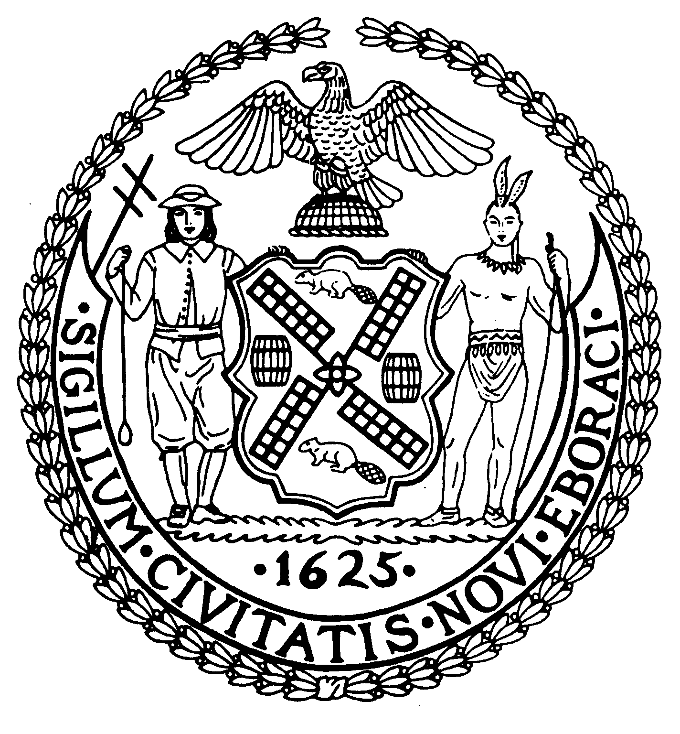
Chair New York, N.Y. 10022-1106
(212) 758-4340
Latha Thompson (212) 758-4616 (Fax)
District Manager www.cb8m.com - Website

info@cb8m.com - E-Mail

The City of New York
Manhattan Community Board 8

Transportation Committee Meeting
New York Blood Center
310 East 67th Street, Conference Room 1
Wednesday, May 5, 2010
6:30 PM

Minutes

Present: Michael Auerbach, Michele Birnbaum, A. Scott Falk, Rita Popper, Helene Simon, Teri Slater, Alexander Tisch, Betty Wallerstein, Charles Warren and Hedi White.

Absent excused: Jonathan Horn

The Meeting was called to order at 6:30 PM by Co-Chair Charles Warren.

- Presentation by DOT on “Safe Routes to School” program.

A presentation was made by Mr. Kim Lua of NYCDOT. He described the program which applies to all schools over 250 students K-12. The program consists of new school intersections, school crossing messages and advance crossing warning signs. There is also an updated traffic safety map for over 1400 elementary and middle schools to help students identify the safest route to school. In addition, there is a pilot program for reduced speed zones adjacent to schools, including speed reducers or humps.
There was a discussion by the Committee of situations where there appeared to be too many signs on blocks near schools. Mr. Lua stated that DOT followed the federal guidelines but that he would check into the question and report back to the Board.

- Request for a “School Parking Zone” in front of 11 East 89th Street (requested by William Truffa, Chief Financial Officer, Trevor Day School).

Mr. Truffa indicated that this was a school for very young children who, when dropped off by their parents, need to be escorted into the school. There has been a problem with Traffic Enforcement issuing tickets to parents who park the car in front of the school and then escort their child into the building. A parent at the school suggested that a “No Standing Zone” could be established in front of the school and discussions could be initiated with Traffic Enforcement to avoid tickets when parents are stopped briefly in that zone. The Committee was sympathetic to the school’s difficulty, particularly since the school will be moving out of that location in June 2013 and any change would only be temporary. The item was laid over until the June Meeting in order to discuss the situation with Traffic Enforcement.

- Discussion of possible resolution on protected bike lanes along the M15 Select Bus Service Route.

Committee Member Michael Auerbach asked the Committee to consider a resolution approving a different type of bike lane for Second Avenue between 68th Street and 61st Street when the Select Bus Service program is instituted. Instead of having the bikes share a lane with cars, there would be a separate lane, which is now the parking lane, for bicycles.
The Committee decided to lay this item over until the June Meeting so that the area could be posted to make sure that businesses could be heard on the issue of losing parking spaces for the morning and evening rush hours.

- Old Business.

An update was requested from DOT on the “Safe Streets for Seniors” program. Josh Orzeck of DOT said he would report back next month on the program.
Josh Orzeck announced that the dates for this year’s “Summer Streets” program will be August 7, August 14, and August 21. Park Avenue will be closed up to 72nd Street until 1 PM on all of those dates.

There being no further business, the meeting was adjourned at 8:15 PM.

Respectfully submitted,

Jonathan Horn and Charles Warren, Co-Chairs

