Jacqueline Ludorf 505 Park Avenue, Suite 620
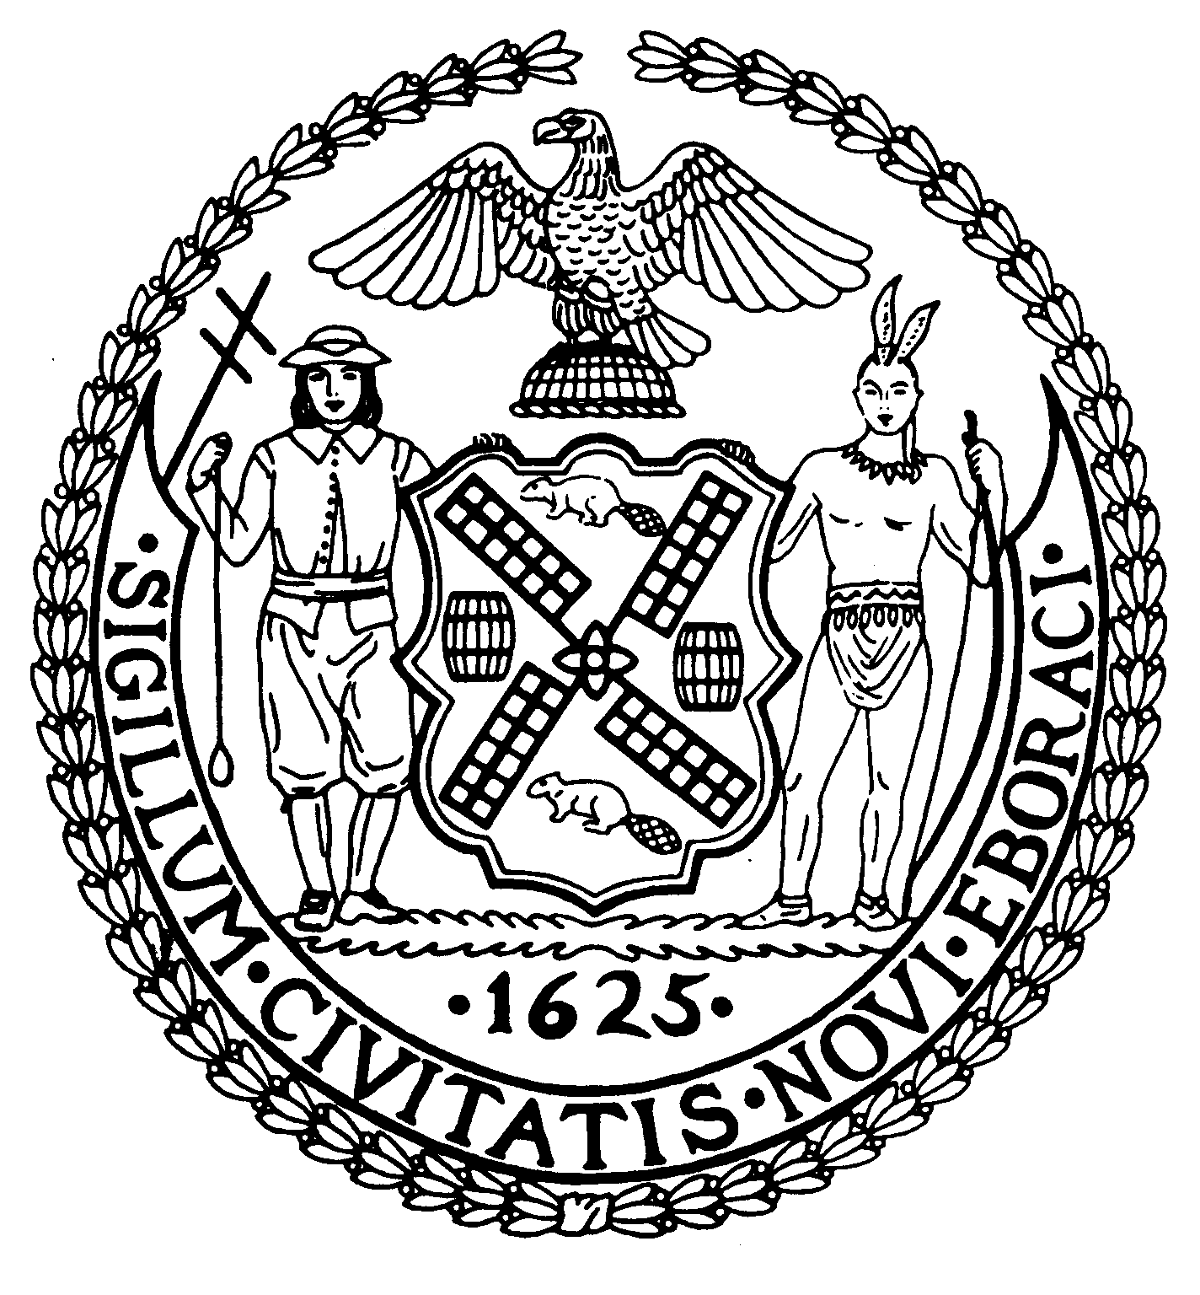
Chair New York, N.Y. 10022-1106
(212) 758-4340
Latha Thompson (212) 758-4616 (Fax)
District Manager www.cb8m.com - Website

info@cb8m.com - E-Mail

The City of New York
Manhattan Community Board 8
SECOND AVENUE SUBWAY TASK FORCE
Manhattan Community Board 8
Wednesday, May 25, 2010
New York Blood Center, 310 East 67th Street – Auditorium

Present: Michele Birnbaum, Scot Falk, Jonathan Horn, Laura Lijewski, Jackie Ludorf, Margaret Price, Rita Popper, David Rosenstein, Barry Schneider, Teri Slater, Helene Simon, Cos Spagnoletti, H. Patrick Stewart, Marco Tamayo

Excused: Barbara Chocky, Helene Simon

The meeting was called to order at 6:35 PM

- Construction Update

Representatives from the three construction companies PowerPointed the work to date and the outlook for the next several weeks – from the Launch Box at E. 95 – E 91st Streets, the Pump Station at E. 78th Street and the Shaft Sites E. 74th – E. 69th Streets.

- Presentation of subway entrance at 301 East 69th Street

Ken Griffen, the MTA’s architect, reviewed the plans for the revised rendering of the 72nd Street Station Entrance No. 1 at 301 E. 69th Street. The revisions included shortened glass walls, higher spandrels and the reuse of previously removed red brick. Representatives of the co-op at 301 E. 69th Street questioned the extensive use of clear glass. The MTA agreed to continue discussions with the building representatives and their consultants.

NOTE: The PowerPoint presentation, consisting of 58 slides, is available at this link: http://www.mta.info/capconstr/sas/documents/100525cp.pdf

- A discussion of a request to permit outdoor advertising within 100’ feet of Second Avenue, along the subway alignment, to mitigate the economic impact from the Second Avenue Subway during the construction project only.

Richard Bass, Chief Planning and Development Specialist with Herrick, Feinstein LLP presented the proposal, as follows: The [2nd Avenue Subway] Project has and will result in significant adverse economic impacts on affected properties, including, for example, loss of retail business due to lack of visibility, non-rentable retail/restaurant and service establishments, vacant rental apartments, and lost coop and condo sales. The subsequent loss of income has damaged the economic viability of property owners, landlords, coops and condos. To mitigate the impact, he proposed that all forms of non-illuminated outdoor advertising be permitted on the zoning lot, including, but not limited to bill boards. He further stated that such advertising signage would produce a new revenue source to the economically impacted properties and would produce new tax revenue.

After a thorough discussion among members of the public and members of the Task Force, the following resolution was proposed:

WHEREAS the proposal to permit all forms of outdoor advertising be permitted along the subway alignment during the construction project would set a dangerous precedent for all construction sites, and

WHEREAS the proposed outdoor advertising would negatively impact the neighborhood character of the community giving this portion of the Upper East Side a tawdry, 42nd Street personality, and

WEHREAS the anticipated revenue would not directly benefit the many small businesses that continue to suffer the economic consequences of this decade-long construction project,

THEREFORE BE IT RESOVLED that Manhattan Community Board 8 unequivocally rejects any attempt to modify existing regulations that would allow outdoor advertising of any kind within 100’ of Second Avenue, along the subway alignment during the construction project.

The vote: 12-1-1

In favor: Michele Birnbaum, Scot Falk, Jonathan Horn, Jackie Ludorf, Margaret Price, Rita Popper, David Rosenstein, Barry Schneider, Teri Slater, Helene Simon, Cos Spagnoletti, Marco Tamayo

Opposed: H. Patrick Stewart

Abstaining: Laura Lijewski

Respectfully submitted, M. Barry Schneider and Patrick Stewart, SAS TF Co-Chairs

