Jacqueline Ludorf 505 Park Avenue, Suite 620
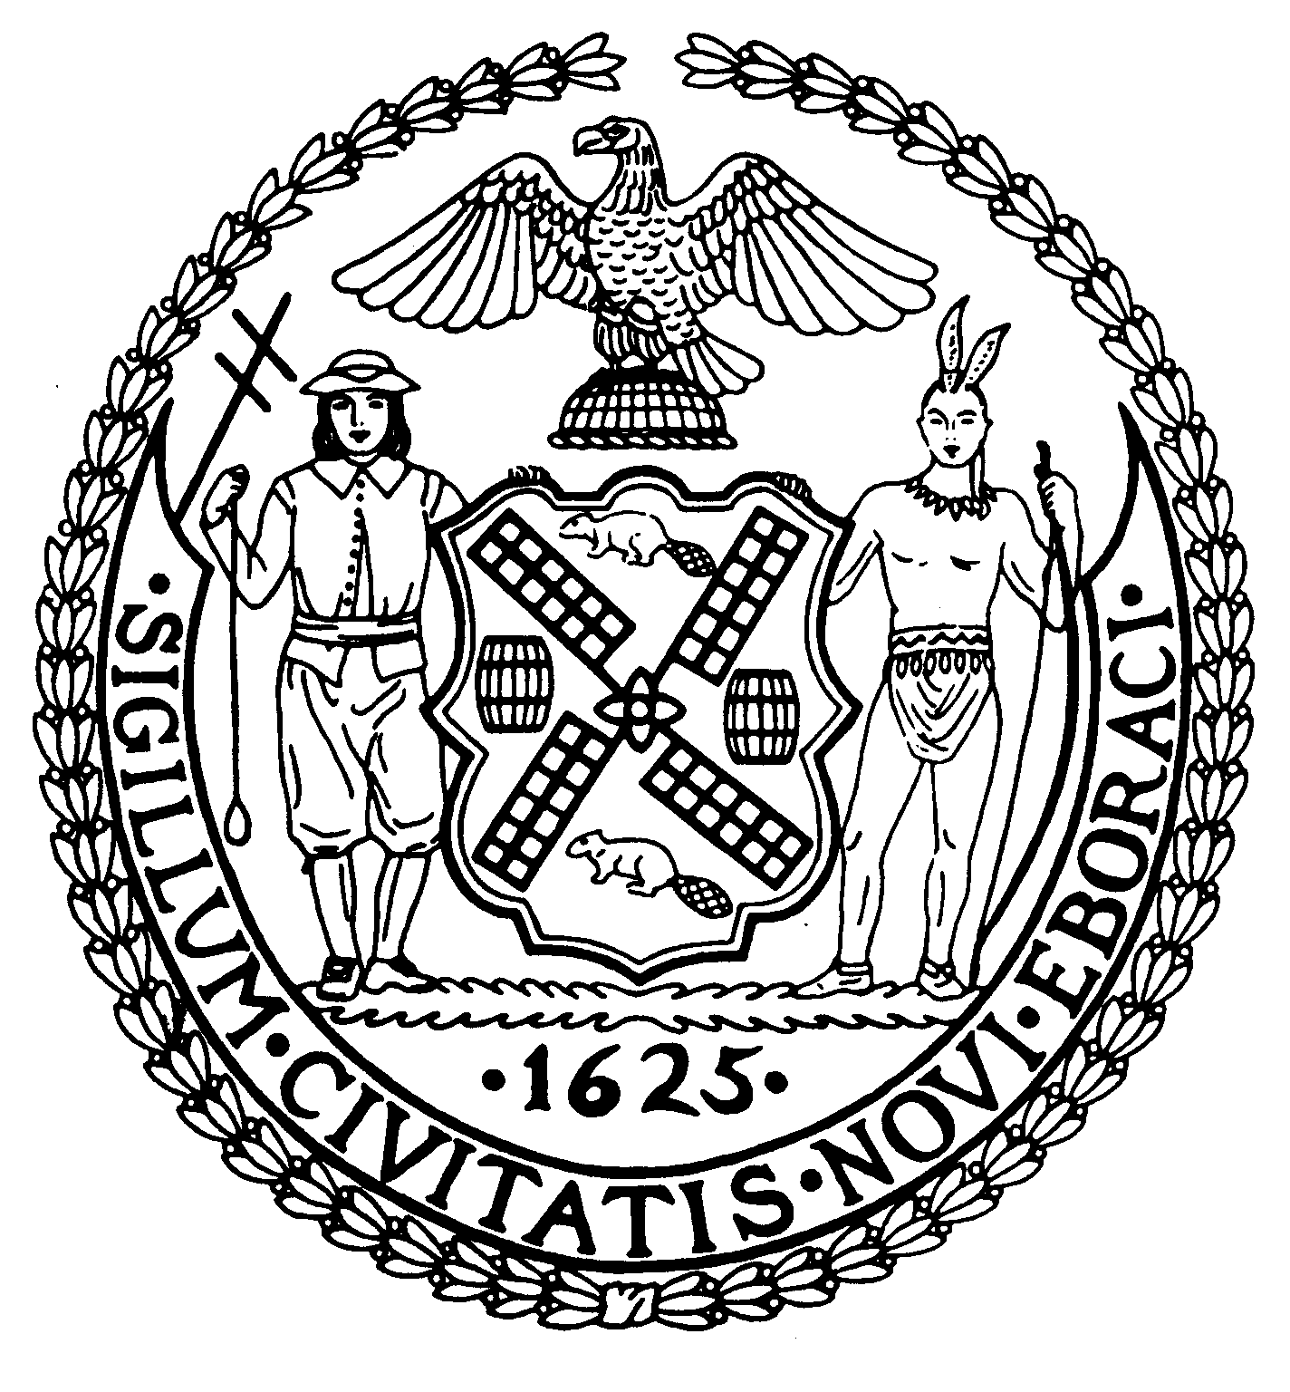
Chair New York, N.Y. 10022-1106
(212) 758-4340
Latha Thompson (212) 758-4616 (Fax)
District Manager www.cb8m.com - Website

info@cb8m.com - E-Mail

The City of New York
Manhattan Community Board 8

Landmarks Committee, May 10, 2010 – 6:30PM
Hunter College School of Social Work, 129 East 79th Street – Room 1010

Present: Jane Parshall, Teri Slater, Elizabeth Ashby, Joie Anderson, Marco Tamayo, David Helpern, Susan Evans, Michele Birnbaum

Absent Excused: David Liston

- 57 East 75th Street (Park-Madison) – Upper East Side Historic District- Mr. Jim Hill, Architect – Application is for a façade renovation.

This application is divided into two parts: 1. Changing windows on the center section of the front elevation and 2. Changing the windows at the balconies on the center section to doors

Part 1 – Changing windows on the center section of the front elevation.

WHEREAS 57 East 75th Street is a Brutalist-style apartment building constructed in 1973-79.
WHEREAS “Brutalism” refers to a pared down, strict, formal architectural style that refers back to Le Corbusier
WHEREAS the applicant proposes replacing the existing windows on the center section of 57 East 75th Street with larger windows to allow more light and air into the interior.
WHEREAS the existing four sets of windows on the center section would be replaced with larger sets of double hung windows that would match an existing window on the upper floor
WHEREAS the proposed change to the windows on the center section of the elevation would change the character of the original “Brutalist” façade
WHEREAS the architect did provide windows on the angled sides that flank the center section that are larger and that provide light and a view to the apartments behind.
THEREFORE BE IT RESOLVED that Part 1 of this application is disapproved as presented.

VOTE: 6 in favor (Parshall, Ashby, Anderson, Tamayo, Helpern, Evans), 1 against (Birnbaum) 1 abstention (Slater)

Part 2 – Changing the windows at the balconies on the center section to doors

WHEREAS the applicant proposes extending the windows on the existing balconies on the front elevation into doors so that access to the balconies would be provided.
WHEREAS the applicant also proposes to add railings to the balconies so that building code safety requirements would be met.
WHEREAS the bottoms of the windows are not visible behind the balconies; the bottoms of the proposed doors would also not be visible behind the balconies.
THEREFORE BE IT RESOLVED that Part 2 of this application be approved as presented PROVIDED THAT the color of the railings matches the color of the existing window frames and that the horizontal mullions of the windows be repeated in the doors.

VOTE: 7 in favor (Parshall, Ashby, Anderson, Tamayo, Helpern, Evans, Birnbaum), 1 abstention (Slater)

- 1056 Fifth Avenue (SE corner 87th Street) – Carnegie Hill Historic District – Mr. Carl Pucci, Architect. Application is to create a Master Pan for the enclosure of the building’s balconies.

WHEREAS 1056 Fifth Avenue is a modern-style apartment building designed by George F. Pelham, Jr. and constructed in 1948-49.
WHEREAS 30 of the 34 balconies on the building are now enclosed
WHEREAS there is no consistency among the 30 balconies that are now enclosed
WHEREAS the applicant would like to create consistency of design for the remaining 4 and when renovations are planned for existing enclosures
WHEREAS the proposed Master Plan calls for large scale tilt-and-turn windows – each enclosed balcony would have 4 windows that would replicate the floor-to-ceiling openings of the existing balconies and bring consistency to the façade.
WHEREAS the building already has Master Plans for the windows and for air conditioners
THEFORE BE IT RESOLVED that this application is approved as presented.

VOTE: 4 in favor (Parshall, Birnbaum, Evans, Helpern), 1 against (Ashby), 3 abstentions (Anderson, Slater, Tamayo)

- 910 Fifth Avenue (NE corner 72nd Street)– Upper East Side Historic District- Mr. Peter Folsom, Architect – Application is for window replacement.

WHEREAS 910 Fifth Avenue is a neo-Italian Renaissance apartment building designed by Fred F. French and constructed in 1919.

WHEREAS in 1958, the façade was changed and the building is now considered to be a “no-style” building
WHEREAS the applicant proposes to change one bay of windows on the 5th floor
WHEREAS the bay now has a group of six windows and the applicant proposes to change this to a group of five windows since a 5-window bay is the dominant window style in the building.
WHEREAS the windows will be aluminum windows and match the existing windows
WHEREAS the applicant’s proposed change introduces more uniformity to the façade.
THEREFORE BE IT RESOLVED that this application is approved as presented.

VOTE: 8 in favor (Parshall, Slater, Ashby, Anderson, Tamayo, Helpern, Evans, Birnbaum)

- 12 East 78th Street (between Fifth and Madison) Metropolitan Museum Historic District – Ms. Sarah Lopergolo, Architect – Application is for restoration of the front façade including replacement of all windows and for a new rear façade.

This application is divided into two parts: 1. The front elevation and 2. The rear elevation

Part 1: The front elevation

WHEREAS 12 East 78th Street is one of a row of six brownstones constructed by Charles Graham in 1886-87
WHEREAS the applicant proposes to keep the front elevation exactly as it is
WHEREAS the applicant proposes to restore the stoop and to replace all existing windows with in-kind wooden windows
WHEREAS the existing stucco finish and existing color of the stucco finish will be maintained
(The Landmarks Preservation Commission is not open to changing the paint color and usually prefers the paint color that was in place when the district was designated)
THEREFORE BE IT RESOLVED that Part 1 of this application is approved as presented

VOTE: 8 in favor (Parshall, Slater, Ashby, Anderson, Tamayo, Helpern, Evans, Birnbaum)

Part 2: The rear elevation

WHEREAS at the rear, the height is 60’ [at the front the height is 50’]
WHEREAS the proposed new rear elevation presents as an overglazed modern façade that uses sliding windows
WHEREAS there is no reference at the back to the building to the front of the building
WHEREAS there are precedents to contemporary facades in the rear; the Landmarks Preservation Commission is open to contemporary facades that are sympathetic to the environment.
WHEREAS in this case, however, the applicant is proposing too much glass and too little masonry
WHEREAS the proposed new rear elevation does not make any reference to the front elevation.
THEREFORE BE IT RESOLVED that Part 2 of this application is disapproved as presented.

VOTE: 5 in favor (Slater, Ashby, Anderson, Evans, Birnbaum), 2 against (Parshall, Helpern), 1 abstention (Tamayo)

5. Old Business: The public hearing for the Park Avenue proposal to extend the Carnegie Hill Historic District to include Park Avenue from 86th Street through 91st Street and from 94th Street (including 1192 Park Avenue south of 94th Street on the west side of Park Avenue) through 96th Street will be heard at the June meeting of the Landmarks Committee.

