Jacqueline Ludorf 505 Park Avenue, Suite 620
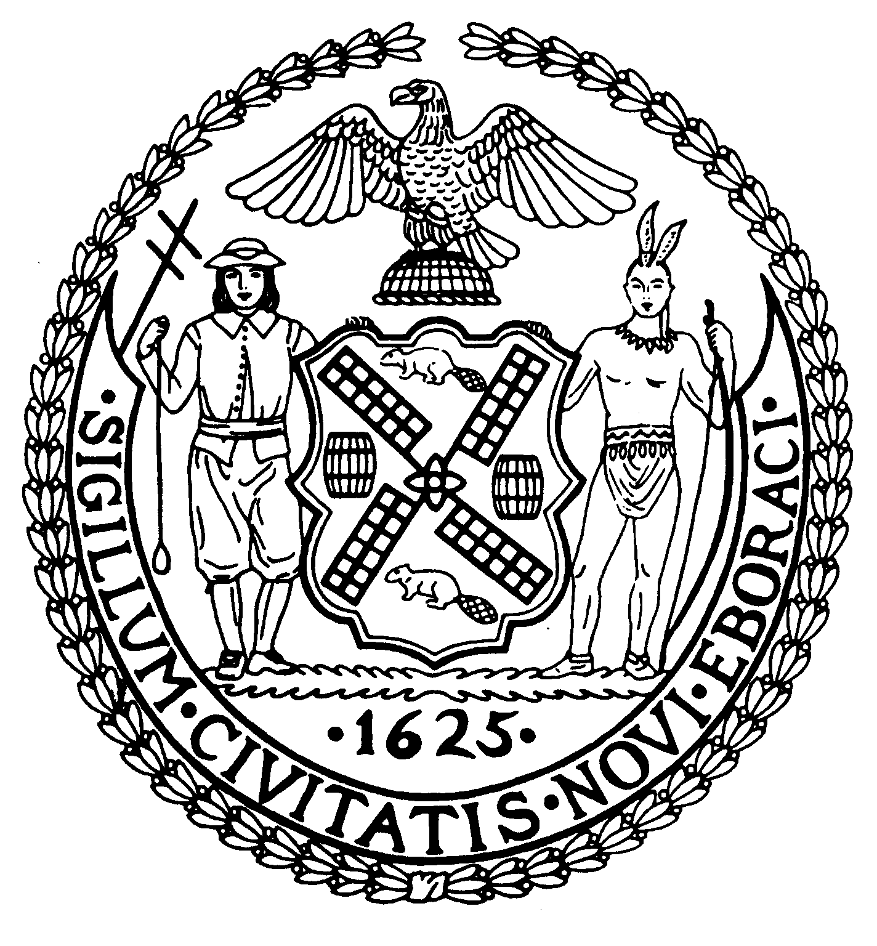
Chair New York, N.Y. 10022-1106
(212) 758-4616 (Fax)
Latha Thompson www.cb8m.com – Website
District Manager info@cb8.com - E-Mail

The City of New York
Manhattan Community Board 8

Zoning & Development Committee
Wednesday, May 26 – 6:30 PM
Ramaz School, 125 East 85th Street, Social Hall

Agenda

1. Update on the status of the Duane Reade marquee on East 86th Street. A representative from the Dept. of Buildings will be present to answer questions.

2. Continued discussion of C1 and C2 local retail uses in residential neighborhoods. A representative from Councilmember Dan Garodnick's office will report on a proposed study of zoning regulations in other cities re: local retail uses.

3. Discussion of the Office of the Manhattan Borough President's Community Planning Fellow Program.

4. Old Business

5. New Business

Teri Slater and Elaine Walsh, Co-Chairs

