Jacqueline Ludorf 505 Park Avenue
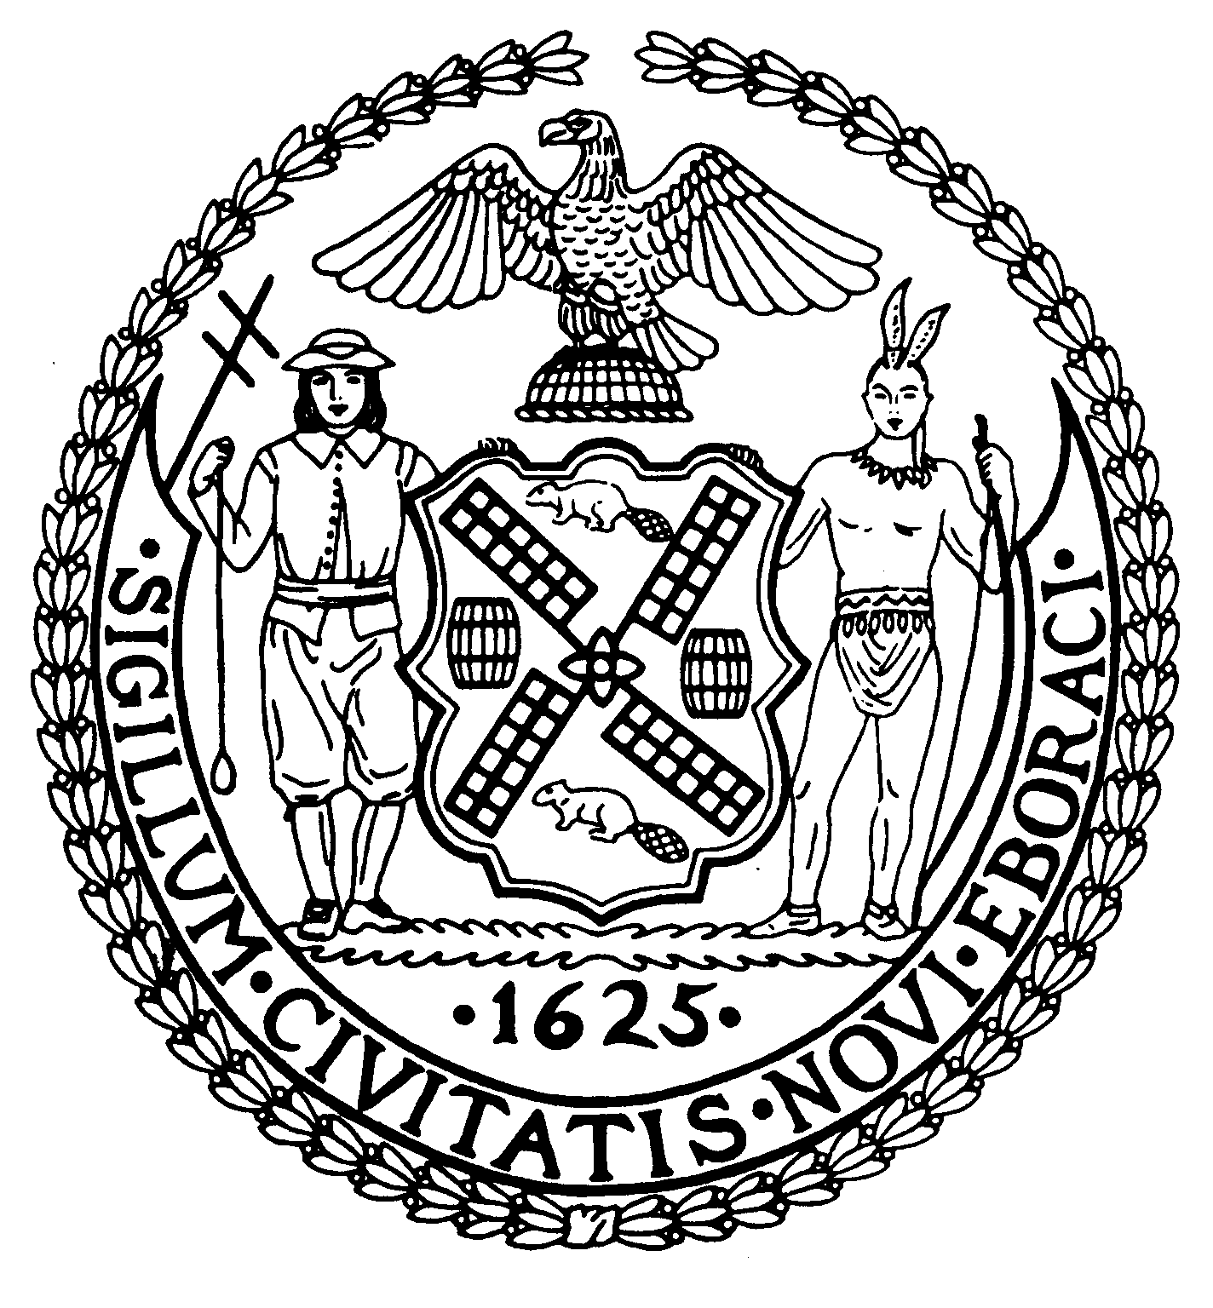
Chair Suite 620
New York, N.Y. 10022

Latha Thompson (212) 758-4340
District Manager (212) 758-4616 (Fax)
www.cb8m.com Website
info@cb8m.com - E-Mail

The City of New York

Manhattan Community Board 8

Transportation Committee Meeting
New York Blood Center
310 East 67th Street, Conference Room 1

Wednesday, May 5, 2010
6:30PM

Agenda

- Presentation by DOT on “Safe Routes to School” program.

- Request for a “School Parking Zone” in front of 11 East 89th Street (requested by William Truffa, Chief Business Officer, Trevor Day School).

- Discussion of possible resolution on protected bike lanes along the M15 Select Bus Service route.

- Old Business

- New Business

Jonathan Horn and Charles Warren, Co-Chairs

