Jacqueline Ludorf 505 Park Avenue, Suite 620
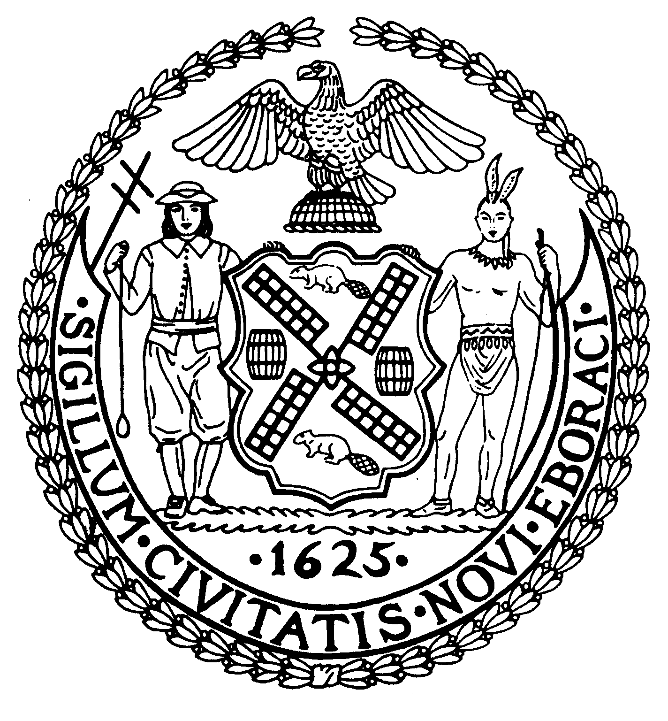
Chair New York, N.Y. 10022-1106
(212) 758-4340
Latha Thompson (212) 758-4616 (Fax)
District Manager www.cb8m.com - Website

info@cb8m.com - E-Mail

The City of New York
Manhattan Community Board 8

Manhattan CB 8 Housing Minutes
April 28, 2010
CB 8 Board Office, 505 Park Avenue, New York
Conference Room
6:30PM

- General Housing Issues:

Father Mark Hallinan, Secretary/Coordinator of the East Side Congregations for Housing Justice discussed the following:

- Lack of affordable housing for New Yorkers.
- 2008: 574,000 NYC residents used 50% or more of their incomes for rent and another 447,000 used between 30% to 49% of their income toward rent.
- Increase in over-mortgaged/leveraged buildings at risk of financial default and foreclosure.
- Record number of homeless persons.
- Decrease in number of units renting for less than $1,000 impacting seniors, retirees, fixed-income and low-income New Yorkers.

Federal Action Items:
- Fund National Low Income Trust Fund

State Action Items:
- Repeal of vacancy decontrol
- Protect former Mitchell-Lama & Section 8 Tenants
- Create a New York State Housing Investment Fund
- Oppose the State’s $65 million cut to the Adult Shelter System

City Action Items:
- Allocation for Citywide Homeless Prevention Fund ($250,000)
- Allocation for City-Wide Task Force on Housing Court ($500,000)
- Allocation for Community-Based Consultants (Homelessness Prevention) ($830,00)
- Housing Preservation Initiative within HPD (Housing Preservation and Development) ($1.5 million)

B. Illegal Hotels Issues:

Sara Hale-Stern, District Office Director, State Senator Liz Krueger discussed the following:

- Landlords/developers are increasingly converting apartment units to transient hotel room use.
- Ambiguous language in the Multiple Dwelling Law and Administrative Code of NYC Buildings Department have enabled landlords/developers to convert apartments to transient hotel uses.
- Upper East Side has largest number of illegal hotels.
- Tenants no longer feel safe in such buildings with the increase in transient individuals and suggests there are fire/safety code concerns;
- Liz Krueger has sponsored legislation to clarify certain provisions in the Multiple Dwellings Law that would make it easier to close illegal hotels.
- Manhattan Community Board 2 have passed resolutions supporting Krueger’s legislation to amend the Multiple Dwellings Law.

