Jacqueline Ludorf 505 Park Avenue
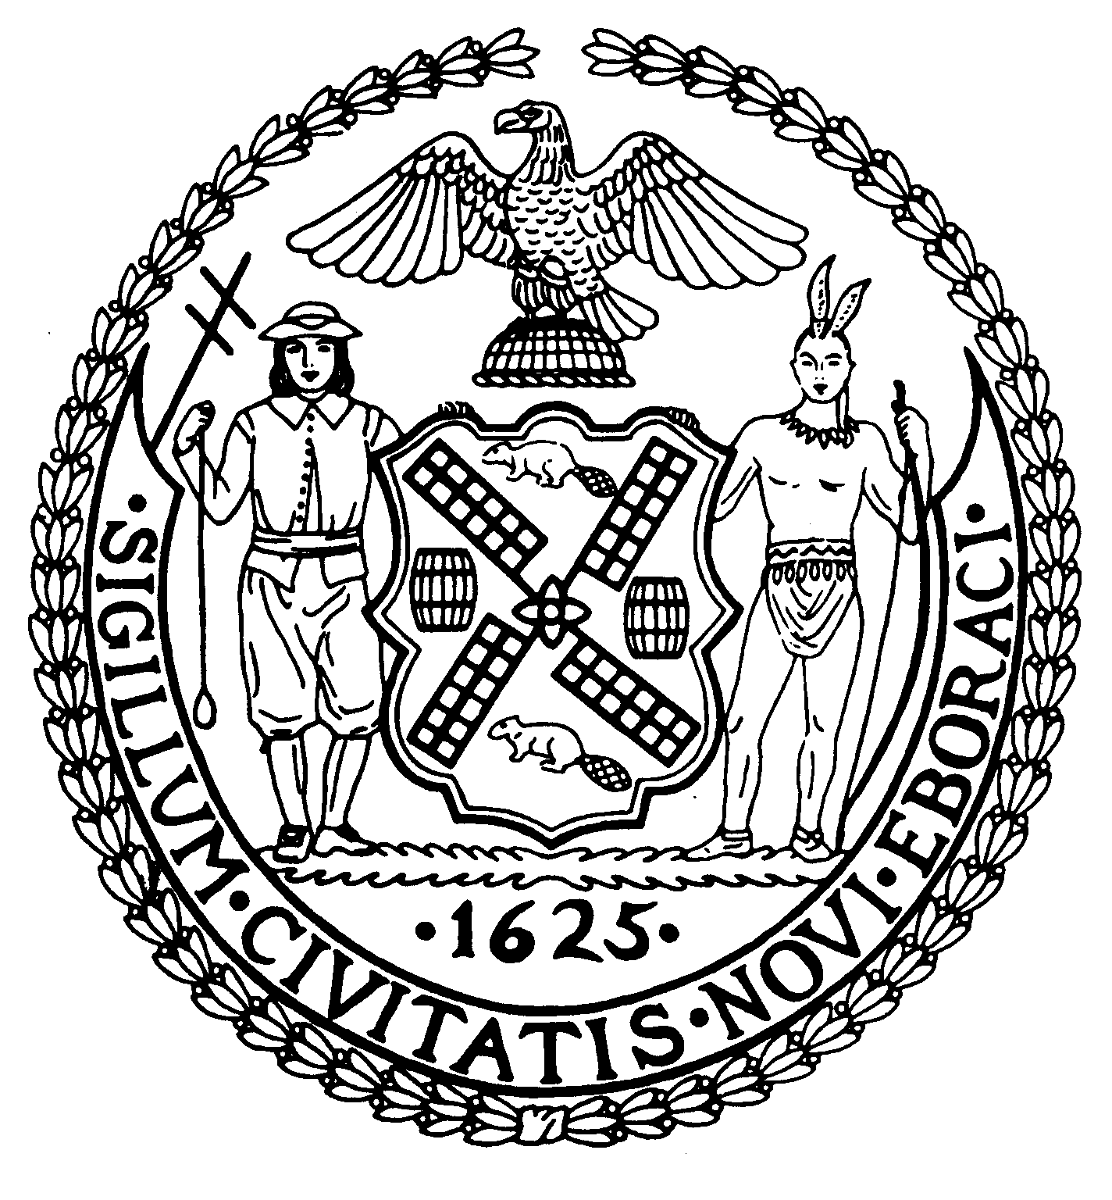
Chairman Suite 620
New York, N.Y. 10022

Latha Thompson (212) 758-4340
District Manager (212) 758-4616 (Fax)
www.cb8m.com Website
info@cb8m.com - E-Mail

The City of New York

Manhattan Community Board 8

Youth and Education Committee Meeting

The Blood Center
310 East 67th Street, Conference Room
April 26, 2010
7:00 pm

Agenda

- Cassidy Jones, Park Avenue Armory Education Coordinator, on family workshops in conjunction with the art exhibit of Christian Boltanski.

- Presentation by Jamie Smarr on the new PS 59 & Art and Design High School at 56th Street

- Update by Jamie Smarr on the status of the East Side Middle School

- Progress of Second Teacher Assistants in the classroom

- Report CECD2 on Wait List Issue—TIME PERMITTING

- Future Agendas
May: Internet Safety Forum joint with the Public Safety Committee
June: Invite new principal from PS 267

- New Business/Old Business

James Clynes and Judith E. Schneider Co-Chairs

