Jacqueline Ludorf 505 Park Avenue, Suite 620
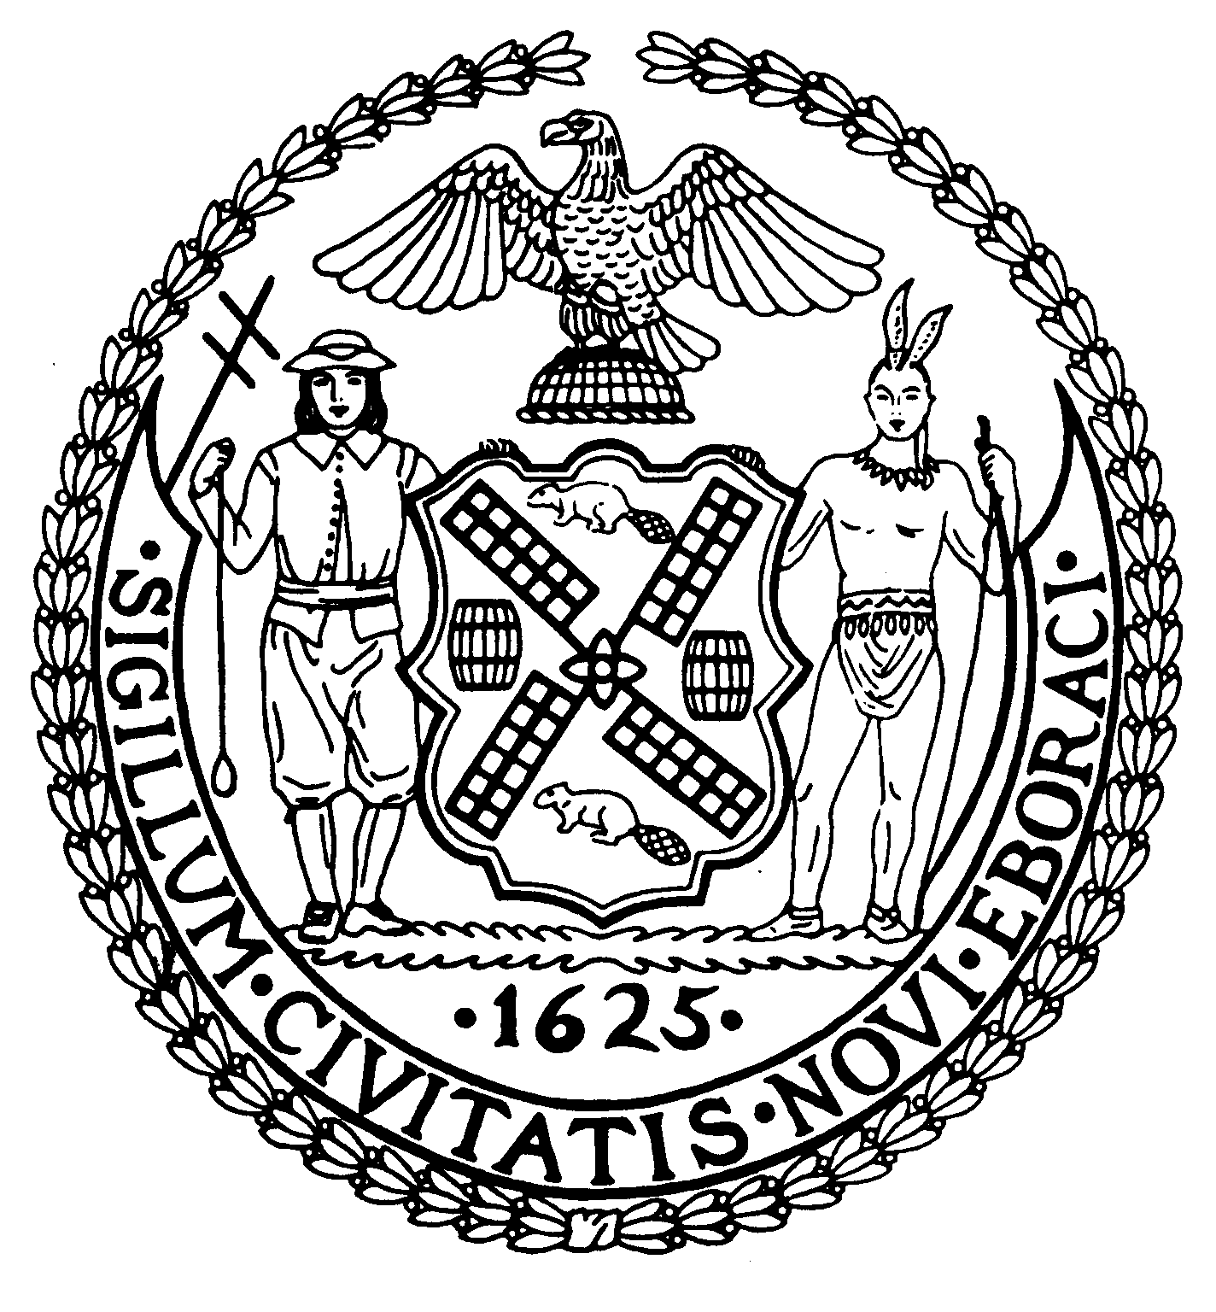
Chair New York, N.Y. 10022-1106

(212) 758-4340
Latha Thompson (212) 758-4616 (Fax)
District Manager www.cb8m.com - Website
info@cb8m.com - E-Mail

The City of New York
Manhattan Community Board 8

Parks Committee
Thursday, May 6, 2010 @ 6:30 PM

New York Blood Center
310 East 67th Street, Conference Room 1

Agenda

- Discussion of winter indoor tennis at Central Park's Tennis Center--joint issue with the Landmarks Committee.

- Review of the status of the Queensboro Oval.

- Review of the Parks Dept.'s new rules on vending in parks.

- Discussion of CB6's resolution on the need for greater communication about, and public input into, city plans for our parks.

- Old Business

- New Business

Margaret Price and Barbara Rudder, Parks Committee Co-Chairs

