Jacqueline Ludorf 505 Park Avenue
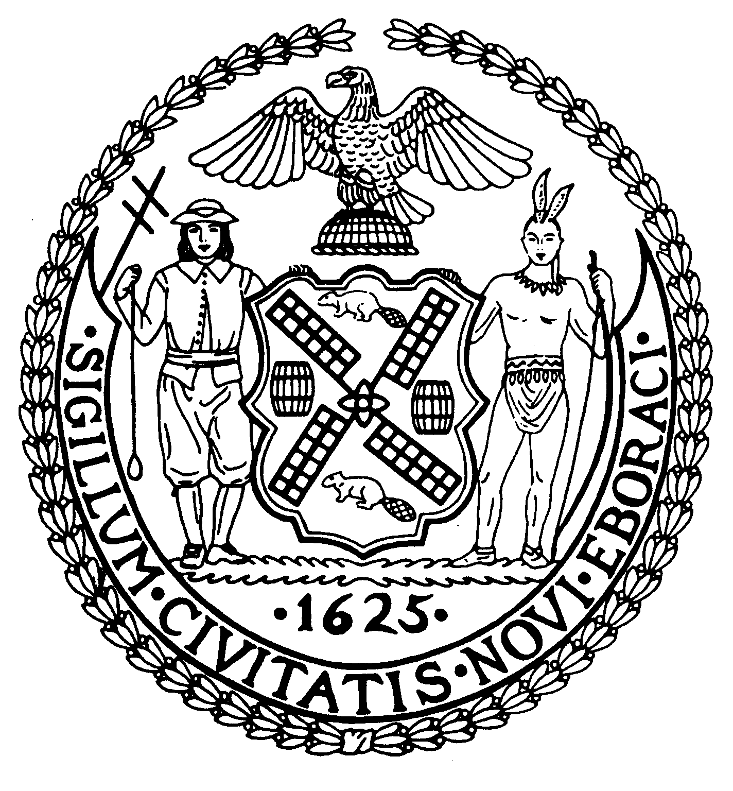
Chair Suite 620
New York, N.Y. 10022

Latha Thompson (212) 758-4340
District Manager (212) 758-4616 (Fax)
www.cb8m.com Website
info@cb8m.com - E-Mail

The City of New York

Manhattan Community Board 8

Transportation Committee Meeting
New York Blood Center
310 East 67th Street, Conference Room 1

Wednesday, April 7, 2010
6:30PM

Agenda

- A request to change two “No Standing, Except Trucks Loading & Unloading, 8AM to 7PM, Except Sunday” signs to “No Parking” signs. (Requested by Mr. Greenstein, 150 East Tenants Corp.)

- A request for additional lighting on East 88th Street between First and Second Avenues. (Requested by Ms. Auletta, agent for 360 East 88th Street)

- Department of Transportation presentation on Safe Routes to School

- Old Business

- New Business

Jonathan Horn and Charles Warren, Co-Chairs

