Jacqueline Ludorf 505 Park Avenue
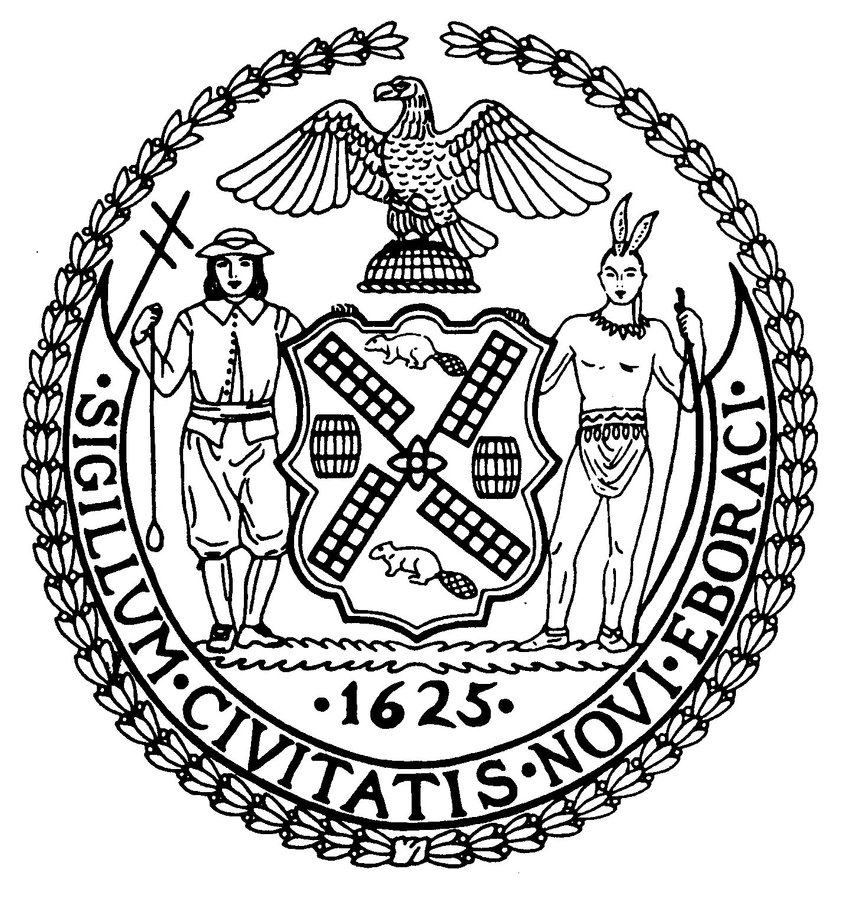
Chairman Suite 620
New York, N.Y. 10022

Latha Thompson (212) 758-4340
District Manager (212) 758-4616 (Fax)
www.cb8m.com Website
info@cb8m.com - E-Mail

The City of New York
Manhattan Community Board 8
Transportation Committee
Wednesday, March 2, 2011
New York Blood Center, 310 East 67th Street, Auditorium
Present: Michael Auerbach, Michele Birnbaum, Scott Falk, Lorance Hockert, Jonathan Horn, Rita Popper, Barry Schneider, Judy Schneider, Helene Simon, Cos Spagnoletti, Charles Warren, Hedi White
Absent (excused): Alex Tisch

The meeting was called to order by co-chair Jonathan Horn at 6:35 pm.
- Request for a bus shelter at the NW corner of East 72nd Street and 3rd Avenue

A site visit took place with representatives of the building to determine whether a space existed that would accommodate a bus shelter. The only area identified during the site visit would not work due to an oil intake vault located nearby. The board of 165 East 72nd Street will be considering a request to install a bench underneath their entrance marquee at their meeting on March 3rd. The committee and the resident who had requested the bus shelter considered this a better solution than considering a relocation of the bus stop to the Northeast corner. The issue, and the status of any potential solution, will be reviewed at our April meeting.

- Discussion of pedestrian safety issues at the intersection of East 73rd Street and York Avenue

DOT has not finished their review of this intersection. A discussion ensued among members of the committee and several local residents who had raised these safety issues. The committee reviewed the existing signal configuration and discussed a number of alternate ideas that might allow pedestrians to cross without being concerned about vehicles turning into them. DOT has indicated that they will institute any changes recommended by their traffic engineers prior to reporting back to the community board. Accordingly, it was decided that the committee chairs would draft a letter to DOT identifying the suggestions discussed at this meeting, specifying that the committee neither supported nor opposed any of them. In this way, we could ensure that the public’s opinions were considered by DOT before making any change.

- Request for a new Revocable Consent at 110 East 70th Street

This is a request for a fenced in area that has already been approved by our Landmarks Committee and the Landmarks Preservation Commission. The area would extend to a point equal with other fenced in areas on this block.

BE IT RESOLVED that Community Board 8M approves the request for a Revocable Consent permitting a fenced-in area at 110 East 70th Street.
Approved 11-0
Yes: Auerbach, Birnbaum, Falk, Horn, Popper, B. Schneider, J. Schneider, Simon, Spagnoletti, Warren, White

- Request for a “No Horn Honking” sign at 1454 Second Avenue

This request was the result of an agreement between the Stumble Inn located at 1454 Second Avenue and local residents on various steps to relieve noise issues created by the establishment’s patrons. The agreement was reached as a condition of CB8’s approval of the business’s liquor license renewal. The horn honking issue arises late at night when taxicabs are attempting to solicit riders from the patrons leaving the bar.

WHEREAS the community and the Stumble Inn located at 1454 Second Avenue have identified an issue with taxicabs excessively honking their horns in an attempt to solicit riders,
THEREFORE BE IT RESOLVED that Community Board 8M approves the request for a “No Horn Honking” sign to be installed in front of 1454 Second Avenue.
Approved 11-0
Yes: Auerbach, Birnbaum, Falk, Horn, Popper, B. Schneider, J. Schneider, Simon, Spagnoletti, Warren, White

- Request for ambulette parking at 475 East 72nd Street

Hospital for Special Surgery is expanding and relocating a number of their facilities, including their ambulatory care center, to space in the building located at 475 East 72nd Street. In order to avoid ambulettes regularly double-parking at this location, which would further impede traffic on York Avenue, they would like to have 2 or 3 spaces in front of their entrance converted to “Ambulette Only Parking” from 7am to 7pm.

WHEREAS the Hospital for Special Surgery will be locating their ambulatory care facility at 475 East 72nd Street, and
WHEREAS there will be a regular need for ambulettes to drop off and pick up patients during the day, and
WHEREAS providing spaces for ambulettes at this location may help alleviate some of the York Avenue traffic issues,
THERFORE BE IT RESOLVED that Community Board 8M approves the request to install a “NO STANDING EXCEPT PICK UPS & DROP OFFS – AMBULETTE 7am to 7pm Monday to Friday” regulation on the South side of East 72nd Street from a point 80 feet West of York area heading East to the restricted fire hydrant zone (a total of approximately 2 car spaces).
Approved 11-0
Yes: Auerbach, Birnbaum, Falk, Horn, Popper, B. Schneider, J. Schneider, Simon, Spagnoletti, Warren, White

- Old Business
There was no old business
- New Business
A member of the public asked about guide-a-ride signs at locations with multiple bus lines and bus stops without bus shelters. He was referred to the board office to identify the specific locations of concern.
The meeting was adjourned at 7:40 pm
Respectfully submitted,
Jonathan Horn and Charles Warren, Co-chairs

