Jacqueline Ludorf 505 Park Avenue, Suite 620
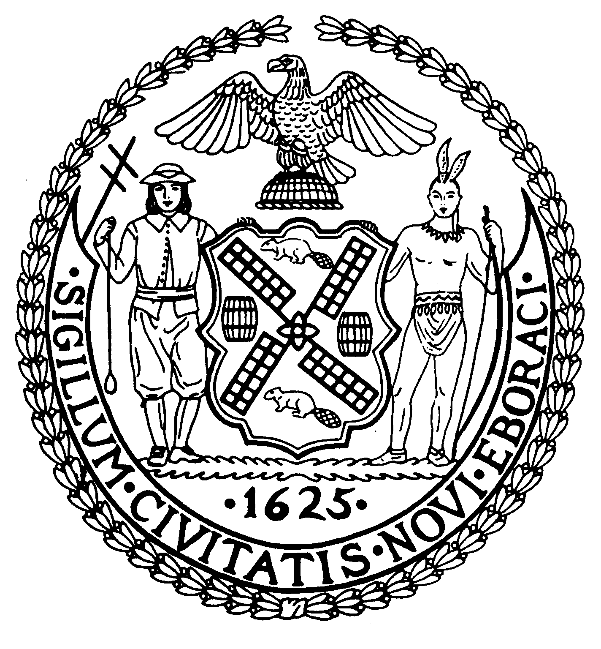
Chair New York, N.Y. 10022-1106

(212) 758-4340
Latha Thompson (212) 758-4616 (Fax)
District Manager www.cb8m.com - Website
info@cb8m.com - E-Mail

The City of New York
Manhattan Community Board 8

SECOND AVENUE SUBWAY

TASK FORCE

Wednesday, March 24, 2010

New York Blood Center
310 East 67th Street, Auditorium
6:30PM

Agenda

- Discussion of Ancillary Facilities
- Old Business
- New Business

M. Barry Schneider and H. Patrick Stewart, Co-Chairs

