Jacqueline Ludorf 505 Park Avenue
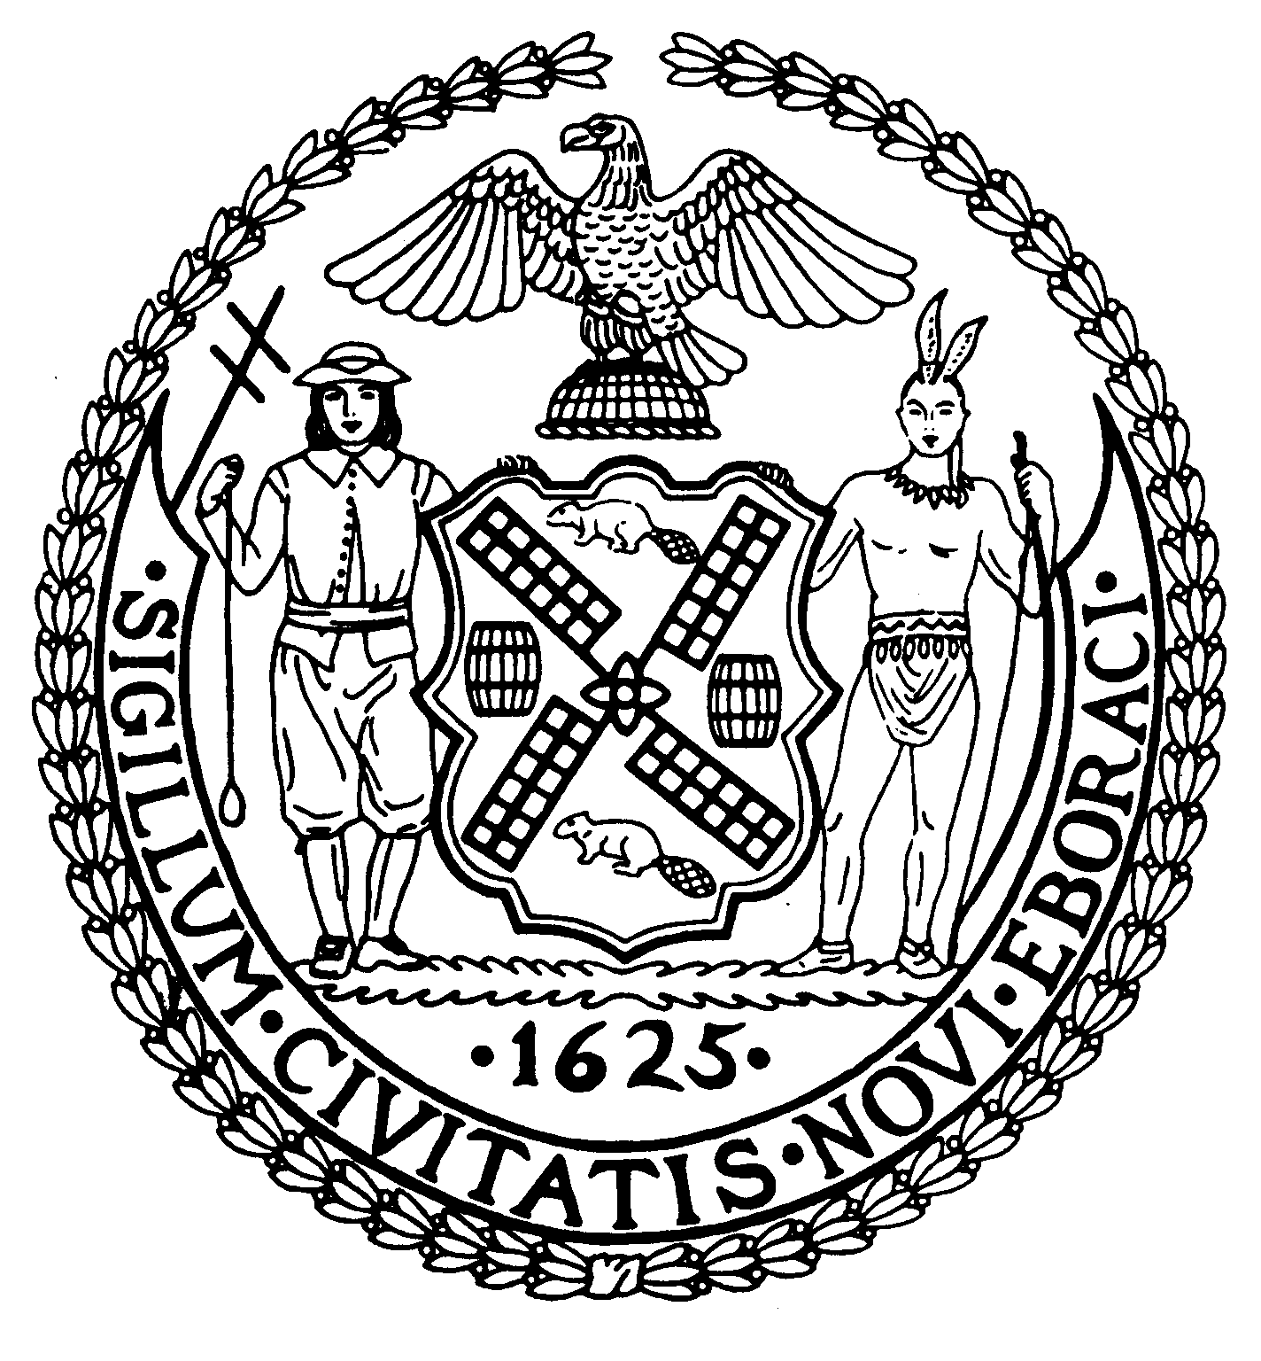
Chairman Suite 620
New York, N.Y. 10022

Latha Thompson (212) 758-4340
District Manager (212) 758-4616 (Fax)
www.cb8m.com Website
info@cb8m.com - E-Mail

The City of New York
Manhattan Community Board 8
Transportation Committee
Wednesday, March 3, 2010
NY Blood Center
310 East 67th Street, Conference Room 1

Present: Michele Birnbaum, Deirdre Breslin, Jim Clynes, Jonathan Horn, Edward Kramer, Rita Popper, Barry Schneider, Judy Schneider, Helene Simon, Patrick Stewart, Alex Tisch, Charles Warren, Scott Falk (Public Member)
Absent (excused): Michael Auerbach, Richard Burg, Betty Cooper Wallerstein, Hedi White Absent (unexcused): Larry Hockert (Public Member)

The meeting was called to order by co chair Jonathan Horn at 6:35 p.m.
- Update on Roosevelt Island Tram Construction Project

Representatives from RIOC, DOT and the project manager, POMA updated the committee on the work that started two days earlier and will last until late August until early September. The construction and traffic impacts have not significantly changed since their last presentation to us. However, DOT has requested that work in the area around the 59th Water Main project be completed by late June to avoid conflicts. RIOC will report on their progress towards this goal at a joint meeting of Environment & Sanitation and Transportation committees devoted to the Water Main project on April 29th.

- A discussion of Park Smart on East 86th Street

David Stein from DOT provide an update on this proposed pilot project. A temporary shortage of new muni-meters available for installation has caused a change in suggested pilot area. DOT currently is suggesting a project starting in the spring covering 86th Street from First Avenue to Madison Avenue and continuing south on Madison Avenue to 79th Street. The increased rate period would be Noon to 4pm with the fee being $3.75/hour (as opposed to the new base rate of $2.50/hour). If judged successful, an expansion could take place in the fall or winter, as new equipment becomes available. Indications at the meeting were that the 86th Street Merchants Association and Madison Avenue BID would be willing to try this out, so the following resolution was passed.

BE IT RESOLVED, that Community Board 8M supports the proposed Park Smart pilot program along 86th Street and Madison Avenue as presented by DOT to our Transportation Committee on March 3, 2010.
Approved 13-0
Yes: Birnbaum, Breslin Clynes, Horn, Kramer, Popper, B. Schneider, J. Schneider, Simon, Stewart, Tisch, Warren, Falk (Public Member)

- Old Business
There was no old business.

- New Business
There was no new business

The meeting was adjourned at 8:10 pm
Respectfully submitted,
Jonathan Horn and Charles Warren, Co-chairs

