Jacqueline Ludorf 505 Park Avenue, Suite 620
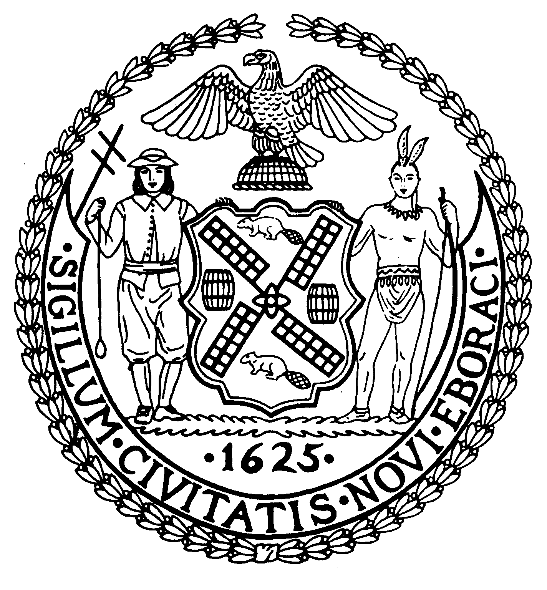
Chair New York, N.Y. 10022-1106
(212) 758-4340
Latha Thompson (212) 758-4616 (Fax)
District Manager www.cb8m.com - Website

info@cb8m.com - E-Mail

The City of New York
Manhattan Community Board 8

SECOND AVENUE SUBWAY TASK FORCE
Manhattan Community Board 8
Wednesday, March 24, 2010
New York Blood Center, 310 East 67th Street – Auditorium

Present: Barbara Chocky, Laura Lijewski, Peggy Price, David Rosenstein, Barry Schneider, Judy Schneider, Helene Simon, Cos Spagnoletti, H. Patrick Stewart

Excused: Michele Birnbaum, Richard Burg, Barbara Rudder

The meeting was called to order at 6:35 PM

Co-chair Barry Schneider read the following statement from Alissa Kosowsky from the MTA:

“MTA appreciates community input and has incorporated it into the Second Avenue Subway design and construction wherever possible. Unfortunately, we are unable to attend tonight's meeting but look forward to receiving comments from Community Board 8 on the ancillary structures.”

Members of the committee distributed 4” x 6” index cards and asked the members in the audience to write down their questions, comments, observations or any remarks they would like to be presented to the MTA. The cards would be picked up during the evening and then forwarded to the MTA for their response. As soon as the Community Board receives the written comments from the MTA, they would be posted on the Community Board website.

After a spirited discussion concerning the absence of members of the MTA, the following resolution was proposed and voted on:

Whereas the MTA, its contractors and other participants in the Second Avenue Subway ("SAS") project have committed to regular public meetings with the affected communities in Manhattan Community Board #8 ("CB8M"), and

Whereas there are a number of issues of concern to CB8M that are unrelated to ongoing litigation concerning SAS ancillary facilities, e.g., the recent temporary building vacate orders in the block north of 96th St. on Second Avenue; a heightened level of blasting for horizontal "starter" tunnels extending south from the Tunnel Boring Machine launch box, which take place after dark, crack walls and ceilings, and create thunder-like booming blasts of frightening intensity; and an outpouring of rats on blocks adjacent to the launch box blasting, which rats the MTA states it is unable to abate as the problem is outside its official construction zone, and

Whereas many members of the community and this Community Board attended the scheduled March 24, 2010, SAS Task Force meeting expecting to dialogue with the MTA et al. about these and other SAS issues unrelated to pending litigation, and

Whereas the MTA et al. did not attend the March 24, 2010, public meeting to address concerns unrelated to pending litigation,

Therefore be it resolved, that CB8M finds the MTA's failure to attend unacceptable, disrespectful and an insult to the Community Board and the concerned members of the public who attended the March 24, 2010, public meeting, which scheduled date was widely publicized well in advance.

The Vote: 9 -0 -0

In favor: Chocky, Lijewski, Price, Rosenstein, B. Schneider, J. Schneider, Simon, Spagnoletti, Stewart

During the remainder of the meeting, until approximately 9: 00 PM, members of the community expressed their concerns about various aspects of the Project: blasting into the evening, much louder blasting, the infestation of rodents, the recent announcement in the press of the need to relocate temporarily residents of several buildings in the 90s due to loosened facades, the height of several ancillary facilities, and more.

After all the 4” x 6” cards were collected, the meeting was adjourned.

Respectfully submitted, M. Barry Schneider and Patrick Stewart, SAS TF Co-Chairs

