Jacqueline Ludorf 505 Park Avenue, Suite 620
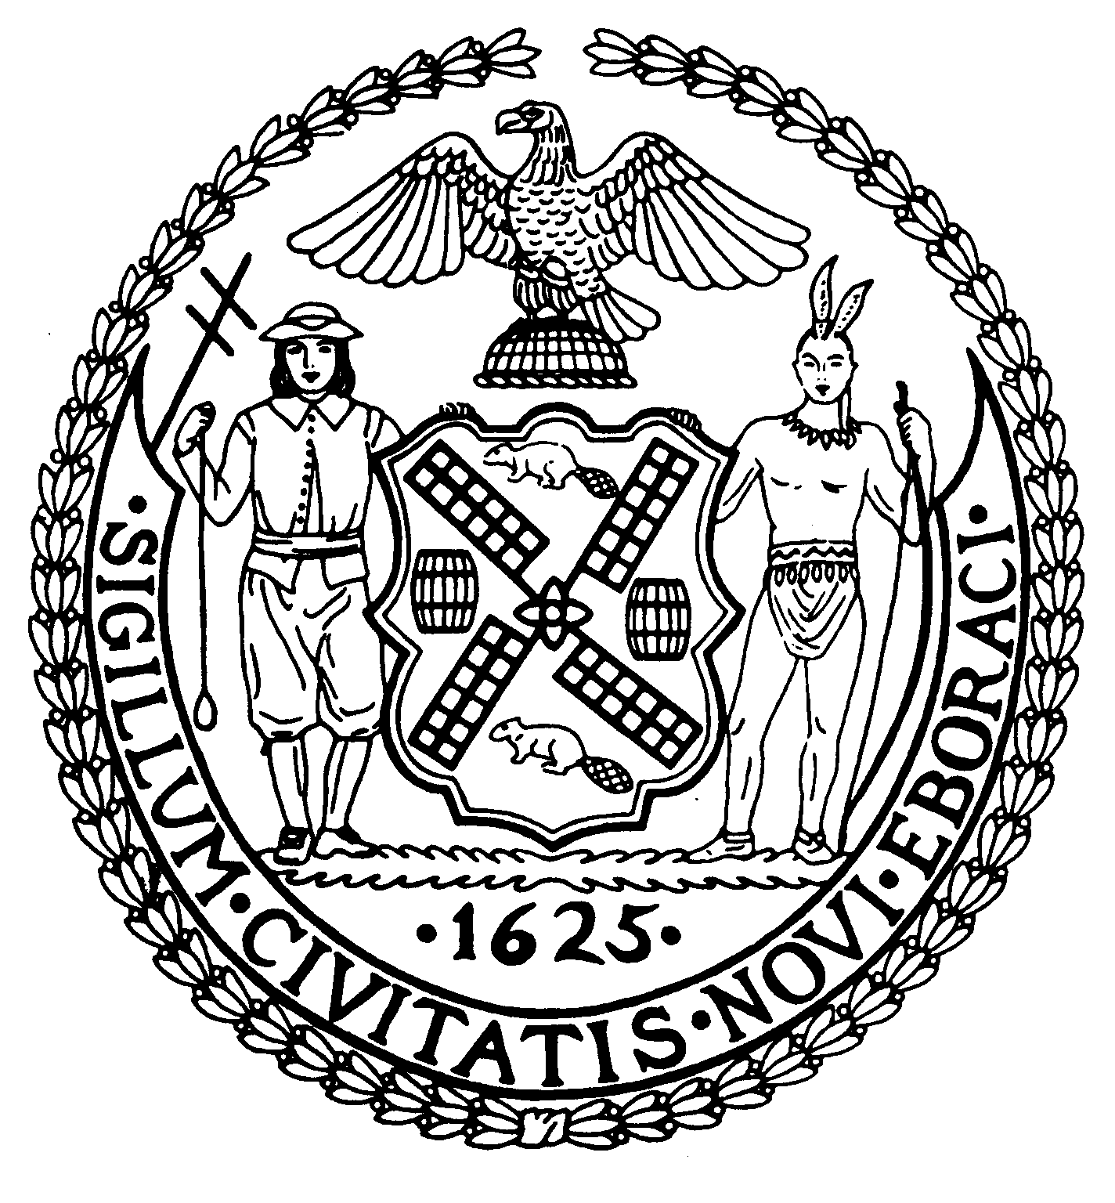
Chair New York, N.Y. 10022-1106
(212) 758-4340
Latha Thompson (212) 758-4616 (Fax)
District Manager www.cb8m.com - Website

info@cb8m.com - E-Mail

The City of New York
Manhattan Community Board 8

Parks Committee meeting
Thursday, March 4, 2010, 6:30 PM
New York Blood Center, 310 East 67th St.
Conference Room 1

CB8 Members in attendance: Susan Evans, Peggy Price, Barbara Rudder, Judy Schneider, Teri Slater
Absent (excused): Rita Popper, David Rosenstein, Barry Schneider
1. Proposal for a Floral Sculptural Exhibition along the Park Ave. Mall in 2011
Artist Will Ryman presented a computer-generated design of his plan, endorsed by the Parks Dept., for a series of large floral sculptures along the Park Avenue Mall next year. As proposed, the sculptures, of roses and rose pedals, would sit in the Malls from East 57th to East 67th Streets. They would be installed in January after the Christmas trees were removed from the sites and taken out after the tulip bulbs were removed in May.
This outdoor showing would be an extension of Mr. Ryman’s floral exhibition at the Marlborough Gallery this past September.
As described by Mr. Ryman of Manhattan, the rose sculptures for the outdoor show would stand either 9 feet or 22 feet tall, depending on the location. Excluding the smaller, much lighter rose pedals, the weight per sculpture would range from 1,000 pounds to 2,500 pounds. One Mall—running from E.66 to E. 67th Street would have two such sculptures, for a combined weight of roughly 4,000 pounds. According to Jennifer Lantzas, the Parks Dept.’s public arts coordinator, the weight of the sculptures would fall below the city’s weight limit of 10,000 pounds per Mall, with each item weighing no more than 5,000 pounds.
The sculptures would be made of stainless steel, fiberglass resin and auto paint. They would be supported by a rammed earth base that has “the strength of concrete” and can withstand wind gusts “of up to 120 miles per hour,” according to Konstanin Bojanov of KB Projects Ltd., fabricator of the project.
Will Ryman said that he would be financing the $1 million cost of the project through the pre-sales of the sculptures. So far, he’s collected about half the needed funding. The city will not be financially benefitting from the project, Ms. Lantzas said.
Jennifer Lantzas presented a letter from the Fund for Park Avenue citing its “enthusiasm” for Will Ryman’s proposed exhibition in 2011.
Although Community Board members in attendance unanimously approved the plan for the sculptures, members did air several issues. These included: concern about the sculptures’ effect on the spring tulip beds in the Malls; and the possibility of damage from any traffic accidents. One CB8 member noted that the 6-foot square base of each sculpture would limit the number of tulips planted in each Mall. However, the Parks Dept.’s Ms. Lantzas noted that the beds are a larger 20 feet by 20 feet. In fact, she said the Fund for Park Avenue had asked to extend the exhibition to include the tulip-blooming season. As for the traffic issue, she said the exhibition would comply with all city and state regulations and it would be insured for up to $1 million.
RESOLUTION
WHEREAS the proposed series of floral sculptures along the Park Avenue Mall would brighten the appearance of the Mall during the winter and spring seasons; and
WHEREAS the sculptures would be firmly grounded and constructed in a manner that would withstand inclement weather and would comply with the city’s weight regulations for structures on the Park Ave. Mall; and
WHEREAS the proposed sculptures would be placed temporarily from East 57th to East 67th Streets along the Park Ave. Mall from January until May 2011;
WHEREAS the Fund for Park Avenue, which plants and maintains the trees and flowers in the Park Ave. Malls, has expressed its support of the proposal;
THEREFORE, be it resolved that Community Board 8 Manhattan approves of the plan for floral sculptures along the Park Avenue Mall from East 57th to East 67th Streets from January until May 2011.
VOTE: 5-0-0. In favor: Susan Evans, Peggy Price, Barbara Rudder, Judy Schneider, Teri Slater.
2. Spring Tree Planting in the CB8M District
The Committee distributed the list of 120 spring tree planting sites in the CB8M area.
Community Board 8 is owed 444 trees as replacements for those removed due to Second Ave. Subway construction. Of that total, the MTA is responsible for funding 363 trees.
Judy Schneider pointed out that the current list does not include trees to be removed for the creation of the E. 63rd St. subway entrance. It’s not yet known how many of those trees will be affected. But members agreed that the MTA should remove as few tree as possible. And once that number is set, the Parks Dept. and the MTA should devise an additional tree replacement agreement to cover the East 63rd St. area.
CB8 members also noted that beds around recently planted trees don’t include Belgian block protections. Members asked Terese Flores, the Parks Dept.’s field representative for our area, to find out whether the Parks Dept. has changed its policy about providing Belgian block protections around tree beds. In any case, the Committee asked that these protections be installed where they don’t exist and be included as part of the tree planting process.
New Business
3.Waterfront in the CB8M District
At its December meeting, the Parks Committee discussed revamping the East River waterway in CB8 with Joshua Laird, the Parks Dept.’s assistant commissioner for planning and various representatives of elected officials. It was determined that that the poor condition of the underpinnings must be repaired before any redesign can start. CB8 unanimously passed a resolution urging the Parks Department to assess the scope of work needed to repair the underpinning and surface of the East River Esplanade and to provide involved city, state and federal officials with a cost estimate for this work.
More recently, the Committee learned that a representative of the City Planning Dept. would address CB8’s Land Use meeting March 10 about the need to update the city’s Comprehensive Waterfront Plan. Since the Committee wanted to be sure that CB8 is included in this waterfront plan, we decided to present our December resolution to the CPD representative and urge that CB8 obtain the necessary funding for repairs to our waterfront. We agreed that we should not approve a plan that excludes our waterfront. We also decided to inquire whether Joshua Laird has yet sent cost estimates to Rep. Carolyn Maloney to start the funding process.
Budget Requests
It was agreed that our committee’s top priorities for capital funding are: refurbishing of the East River Esplanade and the creation of an adult recreation section at John Jay Park (projected to cost about $1.6 million).
Pool at John Jay Park
According to published reports, the City may close swimming pools for budgetary reasons. While the city has not yet identified these pools, the Committee determined we should carefully monitor the situation to ensure that it doesn’t involve the pools at John Jay Park—which are the only public pools in our district. The Committee heard that these pools are very heavily used, both by area residents and City camps and groups. Moreover, since the city has been reconstructing the bathhouse at John Jay Park, it would seem unwise to shut down the pools at that site.

