Jacqueline Ludorf 505 Park Avenue, Suite 620
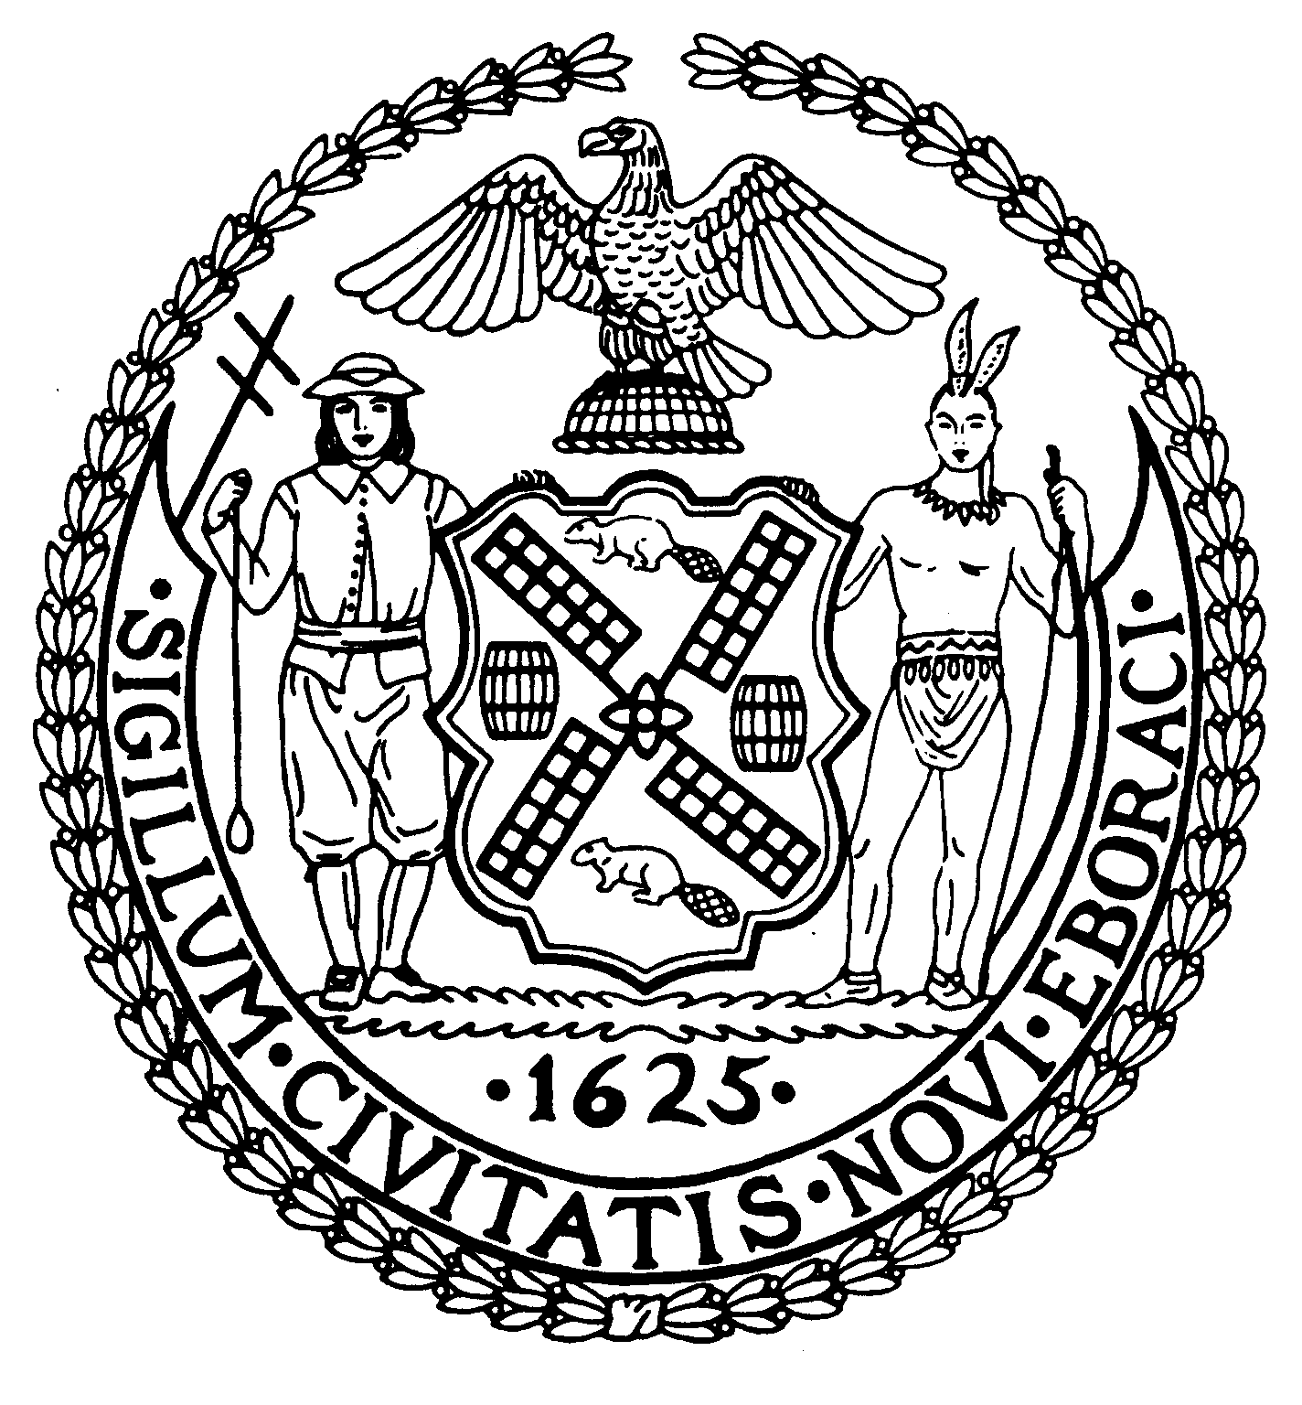
Chair New York, N.Y. 10022-1106
(212) 758-4340
Latha Thompson (212-758-4616 (Fax)
District Manager www.cb8m.com - Website

info@cb8m.com - E-Mail

The City of New York
Manhattan Community Board 8

LAND USE MEETING
WEDNESDAY, MARCH 10, 2010 – 6:30PM
HUNTER COLLEGE SCHOOL OF SOCIAL WORK
129 EAST 79TH STREET
AUDITORIUM

Present: Joie Anderson, Elizabeth Ashby, Michael Auerbach, Kenneth W. Austin, Michele Birnbaum, Lori Ann Bores, Deirdre Breslin, Roy H. Carlin, Sarah Chu, James Gerard Clynes, Christina R. Davis, Susan Evans, Jonathan Horn, Dave Kleckner, Laura Lijewski, Jacqueline Ludorf, Domenico Minerva, Mary Boresz Pike, Ellen Polivy, N. Sharon Pope, Rita Lee Popper, Margaret Price, Dan Quart, David Rosenstein, Barbara Rudder, William Sanchez, Judith Schneider, M. Barry Schneider, Helene Simon, Teri Slater, Cos Spagnoletti, Marco Tamayo, Debra Teitelbaum, Alexander Tisch, Nicholas Viest, Elaine Walsh, Charles S. Warren,

Absent (Excused): Richard Burg, Barbara Chocky, George Fuchs, David Paul Helpern, Lorraine Johnson, David Liston, William Sanchez, Betty Cooper Wallerstein

Absent (Unexcused): Matthew Bondy, Ruth Halberg, Edward Kramer, Jane Parshall, Patrick H. Stewart, Hedi White

Jacqueline Ludorf, Chair, called the meeting to order at 6:30pm

1. Public Hearing: BSA Application 20-10-BZ; CEQR 10BSA046M; 1470 Third Avenue aka 171-173 East 83rd Street, Ground Floor Block 1512, Lot 33

Whereas, BSA Application 20-10-BZ; CEQR 10BSA046M; 1470 Third Avenue aka 171-173 East 83rd Street, Ground Floor Block 1512, Lot 33 -This is an application for a special permit, pursuant to Section 73-36 of the Zoning Resolution, to permit a health club a the Subject Premises, which is located at 1470 Third Avenue. The health club is on the ground floor of a six story building also known as 171-173 East 83rd Street which is at the northwest corner of Third Avenue, in a C1-9 zoning district. The street entrance to the health club is at 1470 Third Avenue. The health club, which is known as Soul Cycle occupies approximately 1,480 square feet on a portion of the ground floor of the subject premises.

Whereas, Community Board 8M held a public hearing regarding this matter;

Be It Resolved, that Community Board 8M recommends approval of this application provided the signage and window treatment is legal.

Community Board 8M passed this resolution by a vote of 28 in favor, 6 opposed, and 2 abstentions.

- Public Hearing: Vision 2020-NYC Comprehensive Waterfront Plan-City Council legislation (Intro 809-a) requires the Department of City Planning to update the New York City Comprehensive Waterfront Plan by December 31, 2010, an every 10 years thereafter. The plan is a document which lays out a new vision for the future of the city’s waterfront and will be established through a three-phase public planning process. Melissa Cerezo, NYC Department of City Planning discussed the upcoming hearings.

- Street Life Committee-Cos Spagnoletti and Nicholas Viest, (Co-Chairs)
1. Renewal Applications to the Department of Consumer Affairs for Sidewalk Cafes:
- Old Heidelberg Corp. d/b/a Heidelberg Restaurant, 1648 Second Avenue (85th/86th Streets) – Renewal application for an unenclosed sidewalk café with 12 tables and 24 seats, DCA #1142288. Due date: March 22nd. Hours: 10p – 4a everyday. Food/Drink: 80/20.
WHEREAS there were no objections and no changes to the café,
BE IT RESOLVED THAT the application is Approved.
Community Board 8M passed this resolution by a vote of 35 in favor, 0 opposed, and 0 abstentions.

- Southwest 85th Restaurant Corp. d/b/a Mustang Grill, 1633 Second Avenue (@ 85th Street) – Renewal application for an unenclosed sidewalk café with 18 tables and 43 seats, DCA #0909014. Due date: April 2nd. Hours: 2p – 1a weeknights and 10:30a – 3a weekends. Food/Drink: 60/40.
WHEREAS there were no objections and no changes to the café,
WHEREAS the applicant agreed to close window by 10:00PM,
BE IT RESOLVED THAT the application is approved.
Community Board 8M passed this resolution by a vote of 30 in favor, 2 opposed, and 3 abstentions.

- Mon Petit Café Inc. d/b/a Mon Petit Café, 801 Lexington Avenue (@ 62nd Street) – Renewal application for an unenclosed sidewalk café with 4 tables and 8 seats, DCA #1165444. Due date: March 29th. Hours: 7a – 11p everyday. Food/Drink: 90/10.
WHEREAS there were no objections and no changes to the café,
WHEREAS the applicant agreed to close window by 10:00PM,
BE IT RESOLVED THAT the application is Approved.
Community Board 8M passed this resolution by a vote of 35 in favor, 0 opposed, and 0 abstentions.

- Lumi Corporation d/b/a Lumi Restaurant, 963 Lexington Avenue (@ 70th Street) – Renewal application for an unenclosed sidewalk café with 7 tables and 14 seats, DCA #0930600. Due date: March 26th. Hours: 11a – 12a weeknights and 11a – 1a weekends. Food/Drink: 80/20.
WHEREAS there were no objections and no changes to the café,
WHEREAS the applicant agreed to close window by 10:00PM,
BE IT RESOLVED THAT the application is Approved.
Community Board 8M passed this resolution by a vote of 35 in favor, 0 opposed, and 0 abstentions.

- Dharadhara, LLC d/b/a Gobo, 1426 Third Avenue (@ 81st Street) – Renewal application for an unenclosed sidewalk café with 9 tables and 19 seats, DCA #1262390. Due date: April 5th. Hours: 12p – 11p everyday. Food/Drink: 85/15.
WHEREAS there were no objections and no changes to the café,
WHEREAS the applicant agreed to close window by 10:00PM,
BE IT RESOLVED THAT the application is Approved.
Community Board 8M passed this resolution by a vote of 35 in favor, 0 opposed, and 0 abstentions.

2. New Applications to the Department of Consumer Affairs for Sidewalk Cafes:
- Alberobello Café, Inc. d/b/a Espresso’s Caffe, 1135 First Avenue (62nd/63rd Streets) – New application for an unenclosed sidewalk café with 6 tables and 12 seats, DCA #1343896. Due date: March 22nd. Hours: 10a – 11p everyday. Food/Drink: 90/10.
WHEREAS there were no objections and this is a new application,
BE IT RESOLVED THAT the application is Approved.
Community Board 8M passed this resolution by a vote of 35 in favor, 0 opposed, and 0 abstentions.

- Don Pablo, Inc. d/b/a Libertardor, 1725 Second Avenue (@ 89th Street) – New application for an unenclosed sidewalk café with 16 tables and 32 seats, DCA #1344183. Due date: March 25th Hours: 10a – 11p weeknights and 8a – 11p weekends. Food/Drink: 90/10.
WHEREAS there were no objections and this is a new application,
WHEREAS the applicant agreed to close window by 10:00PM,
BE IT RESOLVED THAT the application is approved.
Community Board 8M passed this resolution by a vote of 35 in favor, 0 opposed, and 0 abstentions.
- Agata & Valentina, 1505 First Avenue (78/79th Streets) – New application for an unenclosed sidewalk café with 12 tables and 24 seats, DCA #1345829. Hours: 8a – 10:30p everyday. Food/Drink: 90/10.
WHEREAS this is a new application,
WHEREAS this was approved before with 12 tables and 24 seats,
WHEREAS there were objections concerning pedestrian and vehicular traffic,
WHEREAS the applicant agreed to clean the area as required,
WHEREAS the applicant agreed to reduce the application to 8 tables and 16 seats,
BE IT RESOLVED THAT the application is approved.
Community Board 8M passed this resolution by a vote of 32 in favor, 3 opposed, and 0 abstentions.
3. New Applications to the Department of Consumer Affairs for Proposed Newsstands:
a. Second Avenue & East 66th Street (South East Corner) – New application for a proposed newsstand, DCA #1343178
WHEREAS there is un-known foot traffic as the new building is not fully opened,
WHEREAS there were objections from MSK,
WHEREAS there were objections from another newsstand owner at 67th street,
WHEREAS the stand would be located close to drop-off/pickup at the new building,
BE IT RESOLVED THAT the application is DIS-Approved.
Community Board 8M passed this resolution by a vote of 29 in favor, 6 opposed, and 0 abstentions.
4. New Applications to the New York State Liquor Authority for Liquor Licenses:
- 1471 Amici Restaurant Corp. d/b/a Oh Mama Mia, 1471 Second Avenue (76th/77th Streets) – New application for the transfer of an on-premises liquor license. Hours: 11:30a – 2a everyday.
WHEREAS this is only a change in corporation,
WHEREAS this establishment has been at this location for many years,
WHEREAS there were no objections,
BE IT RESOLVED THAT the application is Approved.
Community Board 8M passed this resolution by a vote of 34 in favor, 0 opposed, and 0 abstentions.
- Faith EFI Corp. d/b/a Effy’s Café, 1638-42 Third Avenue (91st/92nd Streets) - New application for a beer and wine license. Hours: 10a – 11p weeknights and 8a – 11p weekends. Food/Drink: 90/10. Hours: 7a – 10p everyday. Food/Drink: 90/10.
WHEREAS this is only for beer and wine,
WHEREAS there were no objections,
BE IT RESOLVED THAT the application is Approved.
Community Board 8M passed this resolution by a vote of 34 in favor, 0 opposed, and 0 abstentions.
- 1304A Second Avenue Associates LLC, d/b/a TBD, 1304A Second Avenue (@ 68th Street) – New application for a beer and wine license. Hours: 11a – 12a weeknights and 11a – 2a weekends. Food/Drink: 80/20.
WHEREAS this is only for beer and wine,
WHEREAS the DBA will be GOLOSI,
WHEREAS there were no objections,
BE IT RESOLVED THAT the application is approved.
Community Board 8M passed this resolution by a vote of 34 in favor, 0 opposed, and 1 abstention.
- 1710 Restaurant Corp., 1710 Second Avenue (88th/89th Streets) – New application for an on-premises liquor license. Hours: 5p – 11p everyday. Food/Drink: 75/25.
WHEREAS the hours will be till 11:00 PM,
WHEREAS there will be NO eating or drinking in the rear yard,
WHEREAS this is the old Carino reastaurant,
WHEREAS there were members of the public in favor,
BE IT RESOLVED THAT the application is Approved.
Community Board 8M passed this resolution by a vote of 34 in favor, 0 opposed, and 1 abstention.
- Cipolla Rossa on 61, Inc., 1109 First Avenue (60th/61st Streets) – New application for an on-premises liquor license. Hours: 11a – 11p everyday. Food/Drink: 75/25.
WHEREAS there were no objections,
WHEREAS this is the old Angels restaurant,
BE IT RESOLVED THAT the application is Approved.
Community Board 8M passed this resolution by a vote of 34 in favor, 0 opposed, and 0 abstentions.
f. Chipotle Mexican Grill of Colorado, LLC d/b/a Chipotle Mexican Grill, 1153 Third Avenue (67th/68th Streets) – New application for an on-premises liquor license. Hours: 10a – 12a everyday. Food/Drink: 97/3.
WHEREAS this is a new application,
WHEREAS this is a “chain”,
WHEREAS the hours will be till 12:00PM every night,
BE IT RESOLVED THAT the application is Approved.
Community Board 8M passed this resolution by a vote of 33 in favor, 1 opposed, and 1 abstention.

g. Sark Holdings, LLC, 153 East 60th Street (Lexington/Third Avenues) – New application for an on-premises liquor license. Hours: 11a – 3a everyday. Food/Drink: 85/15.
WHEREAS the establishment is located on a fairly busy commercial street,
WHEREAS the applicants have run other establishments,
WHEREAS there is a relatively small bar seating of 7 seats,
BE IT RESOLVED THAT the application is approved.
Community Board 8M passed this resolution by a vote of 34 in favor, 0 opposed, and 0 abstentions.
  - SunBurger, LLC d/b/a Brgr, 1026 Third Avenue (60th/61st Streets) – New application for a beer and wine license. Hours: 11a – 11p weeknights and 11a – 12a weekends. Food/Drink: 95/5.
WHEREAS there were no objections,
WHEREAS this is only beer and wine,
BE IT RESOLVED THAT the application is Approved.
Community Board 8M passed this resolution by a vote of 34 in favor, 0 opposed, and 0 abstentions
.
With no further business the meeting was adjourned at 8:30 pm.

