Jacqueline Ludorf 505 Park Avenue
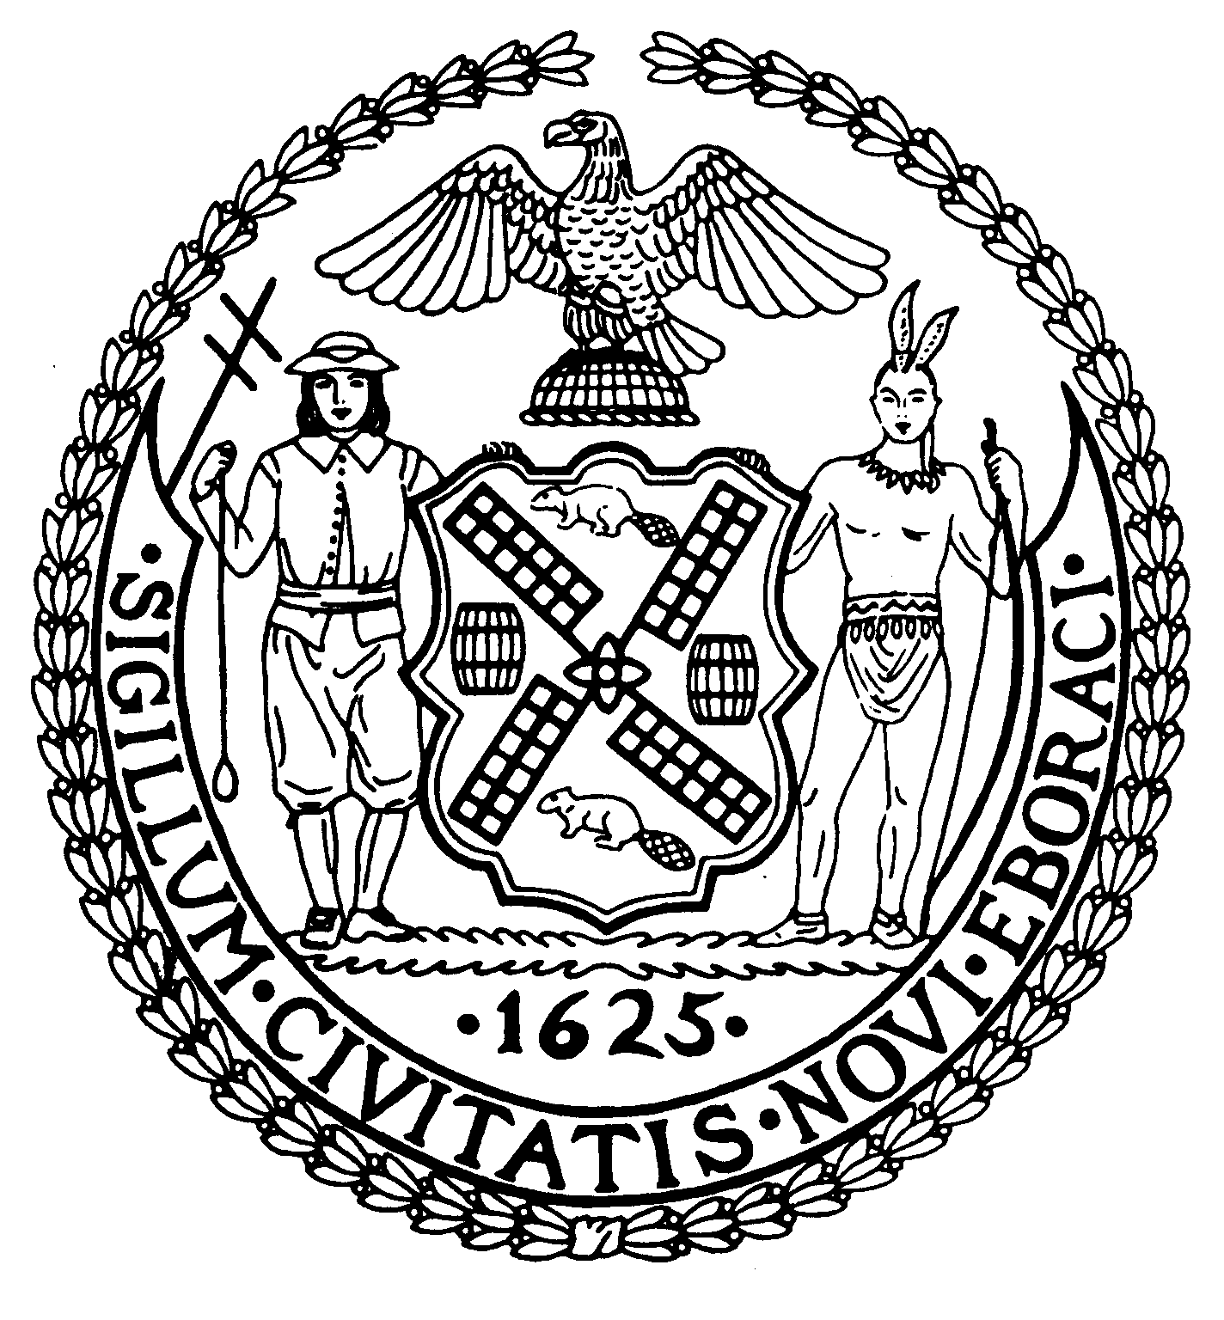
Chair Suite 620
New York, N.Y. 10022

Latha Thompson (212) 758-4340
District Manager (212) 758-4616 (Fax)
info@cb8m.com- E-Mail
www.cb8m.com – Website

The City of New York
Manhattan Community Board 8

Environment and Sanitation Committee Meeting
Tuesday, March 9, 2010
New York Blood Center
310 East 67th Street, Conference Room #1
6:30 pm

Board Members Present: Dave Kleckner, Debbie Teitelbaum, Mike Auerbach, Roy Carlin, Jonathan Horn, Mary Pike, Judy Schneider, Barry Schneider
Committee Members Absent: Ellen Polivy
Number of Attendees: 18 (one sign-in sheet is missing from the meeting)

The meeting was called to order at 6:35pm

NYC Dept of Sanitation (DSNY) Garage

Daniel Klein, Director of the DSNY Real Estate Division provided an update and answered questions. The E. 74th St DSNY garage that was demolished in order to be replaced by a new garage remains unfunded with no projection on when construction may commence. The design of the new garage is entirely complete, and DSNY would be filing a ULURP application for a required zoning change if/when funding is restored.

In the interim, DSNY reached out to the Dept of Citywide Administrative Services (DCAS) to let it be known that the space could be temporarily leased out for alternative uses until DSNY is funded to construct the facility. Although it is DCAS’s decision on if/how the space is used, DSNY indicated that possible uses include leasing the space to the adjacent auto-body shop that expressed interest in using the space to store autos, or to an organization such as Patio.com that could quickly mobilize and demobilize at such a location for displaying patio furniture. DSNY has not heard back from DCAS, and it was discussed that CB8 could write a letter to DCAS inquiring about leasing out the space.

Instead, the Committee passed a resolution (attached) intended to be presented to DCAS. The Committee believes this is important due to concerns about security, appearance, and storm-water run-off from the site potentially impacting neighboring buildings. A member of the public indicated that an E 74th St building has been impacted by drainage problems at the site, and the Committee will pass more detailed information along to DSNY if it can be obtained from the building management.

During Q/A, the status of plans for the E. 91st Street Marine Transfer Station was raised. DSNY sent this follow-up reply:

This was the Commissioner’s response to the City Council when recently asked about the status of the MTS. Please share with the committee and full board.
E. 91st St. – State environmental permits (solid waste/air/tidal wetlands) were issued in 2009; NYSDEC was sued upon permit issuance by petitioners involved in permit proceeding. City is defending Article 78 brought by petitioners. The City has already prevailed in two civil lawsuits against the project. DSNY expects to solicit construction bids in mid 2010 and anticipates that construction will begin in early 2011 and be completed in 2014.
Air Quality/Heating Oil Forum

Per the request of the Co-Chairs, CB8 Member Michael Auerbach discussed the article that the Committee Co-Chairs disseminated to the Committee that had appeared in Our Town regarding launching of an East Side biodiesel campaign by a coalition that includes Upper Green Side (of which Michael Auerbach is a member). The intent was to ensure that the air quality/heating oil forum we’ve been discussing convening for this spring work synergistically and not in conflict with this coalition.

It was decided that the Committee should continue planning for a forum for May or June. Further, it was discussed that while biodiesel may be highlighted at the forum as a potential alternative and environmentally preferable source of fuel oil, that the forum should not feature a particular biodiesel company such as the one that is a member of the coalition. Rather, we will seek to recruit a building owner/manager that uses biodiesel or another enviro preferable fuel oil, in addition to reaching out to others such as the NY Association of Cooperatives and Condominiums, the DOE Fund, and local elected or other government officials.

Shaft 33B Water Mains/Water Tunnel No. 3

As a follow-up to last month’s lengthy meeting that included a presentation by NYC DDC, and attended by high level officials from DEP and DOT, the Committee passed the attached resolution in support of the City’s decision on siting the redundant water main along E. 56th Street instead of in CD8 on E. 64th Street.

Meeting adjourned at ~8:30pm.

Respectfully submitted,
Debbie Teitelbaum and Dave Kleckner
Co-chairs Environment and Sanitation Committee

