Jacqueline Ludorf 505 Park Avenue
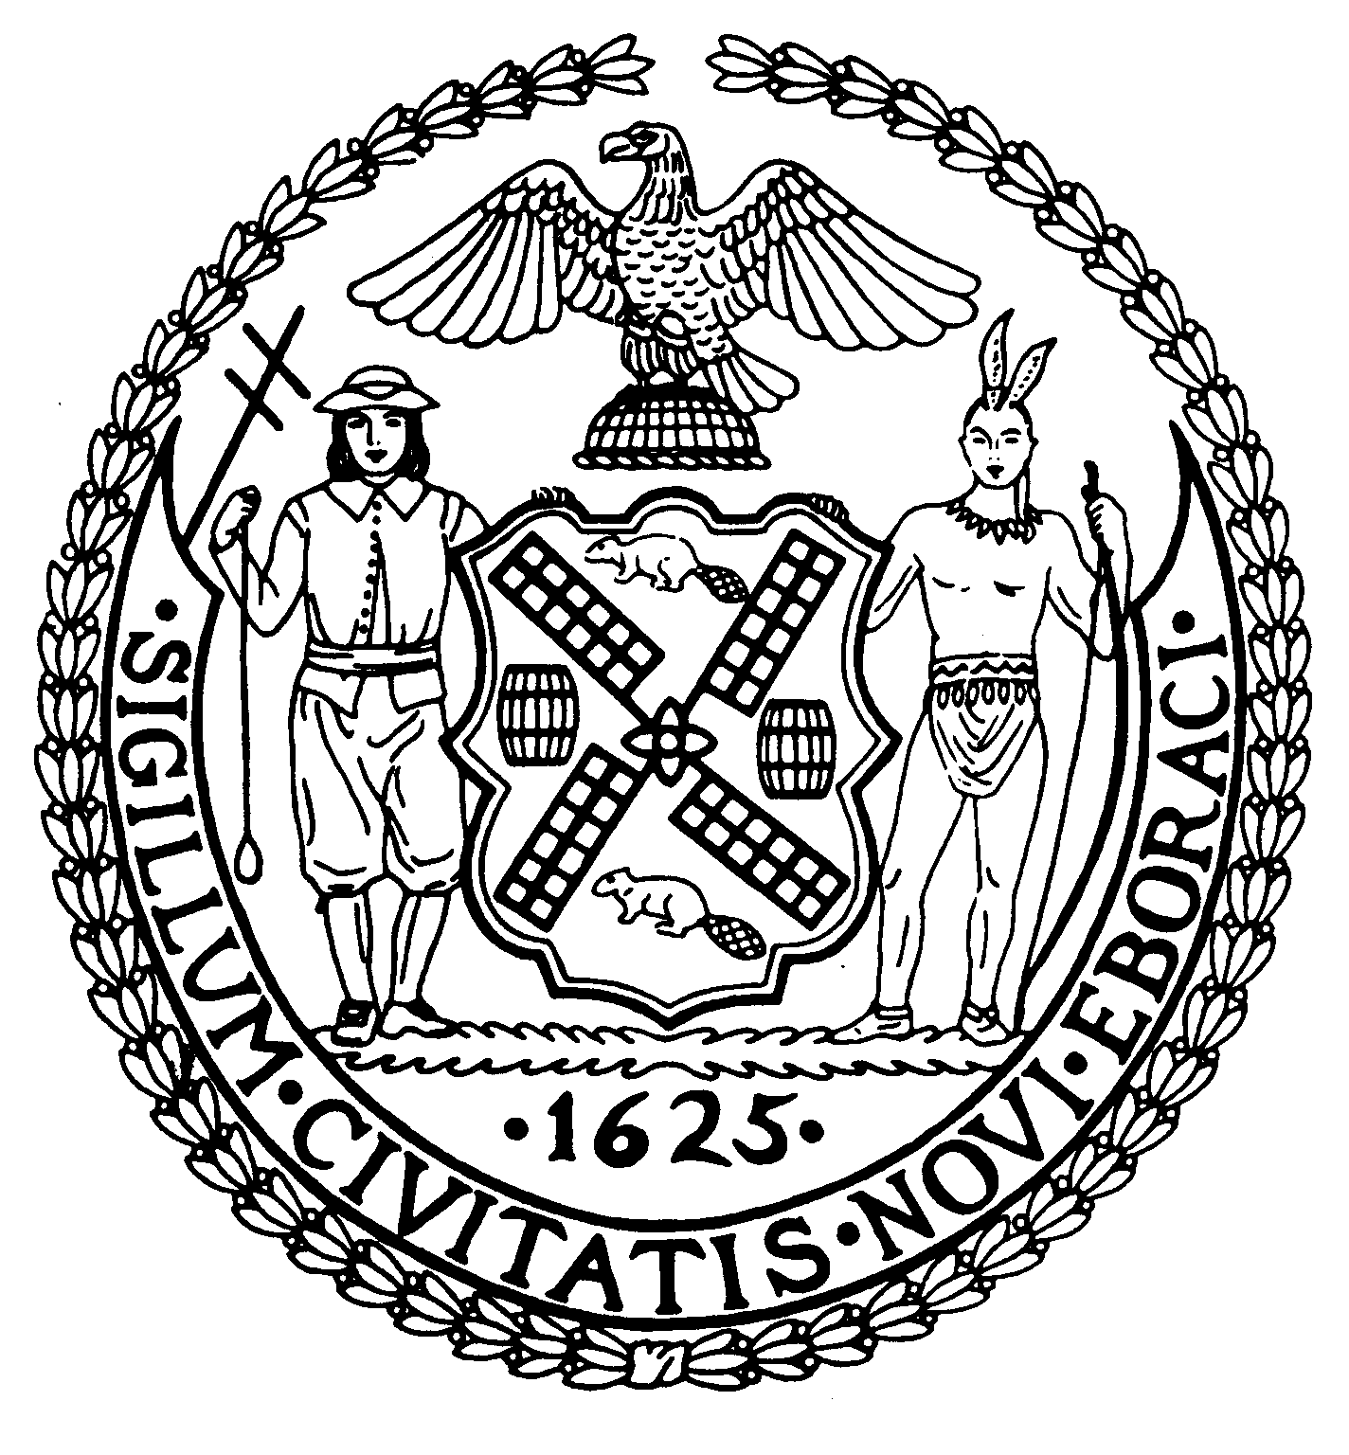
Chair Suite 620
New York, N.Y. 10022

Latha Thompson (212) 758-4340
District Manager (212) 758-4616 (Fax) info@cb8m.com- E-Mail www.cb8m.com – Website

The City of New York
Manhattan Community Board 8

Budget Committee Meeting
Monday, March 8, 2010

Community Board 8 Office, 505 Park Avenue, Suite 620

Members Present: Roy Carlin, Barbara Chocky, Jacqueline Ludorf, Domenico Minerva, Margaret Price, Will Sanchez, Teri Slater

Members of the Public: Monica McKane Sanchez, Latha Thompson (District Manager, Community Board 8M),

- Discussion and Preparation of FY2011 Capital and Expense Budget Requests.
Those present reviewed CB8’s FY2010 priorities for FY 2011 budget requests.

Capital Budget Priorities
- Increase funding for permanent housing for homeless people.
- Provide funding to repair and restore the Esplanade.
- Funding for the creation of an Older Adult recreation area in John Jay Park
- Fund generators to power Fire Houses during emergencies.
- Fund repair of Roosevelt Island Seawall.
- Fund NYC Department of Parks and Recreation for the repair of all infrastructure bridges.
- Fund the expansion of the Roosevelt Island Branch of the New York City Public Library.
- Increase funding for HPD’s 8A Loan Program for the Rehabilitation of Multiple Dwelling Buildings.
- Provide Air Conditioning for all Homeless Shelters.
- Funding for the design and reconstruction of the NYC Department of Sanitation’s M6/M8/M8A Garage on East 73rd Street.
- Fund the installation of pedestrian countdown timers at dangerous intersections.
- Provide funding to retain an intake site in Manhattan for the male homeless population.
- Fund a fully built Park along the East River between 60th and 63rd Streets.
- Provide funding to upgrade computer center at Hunter College Campus Schools

Continuing Support/Capital:
CS Fund new school building for children zoned at PS 151.
CS Provide funding to construct additional public school seats to accommodate current levels or overcrowding and anticipated student growth.
CS Fund the full renovation of the Carnegie Hill Branch Library located at 112 East 96th Street.
CS Provide funding for the renovation of the women’s homeless shelter at the Seventh Regiment Armory.
CS Fund the reconstruction of the East Meadow in Central Park.
CS Provide funding to repair or reconstruct the 78th Street and 81st Street Bridges over the FDR Drive.
CS Provide funding for the Third Water Tunnel.
VOTE: 6 In Favor, (Carlin, Chocky, Ludorf, Price, Sanchez, Slater) 0 Opposed, 0 Abstentions

Expense Budget Priorities
- Continue to fund Out of School Time Programs for all children who go to school in Community Board 8 or who have parents that work in Community Board 8.
- Increase funding for youth programs in Community Board 8.
- Increase funding for Rodent Extermination on city streets.
- Fund the NYC Department of Parks and Recreation and the Department of Sanitation for the placement of “rat-proof” garbage containers in Community Board 8 Parks and throughout the district.
- Increase funding for services to Older Adults, including Personal and Home Care; Transportation Services; Meals-On-Wheels; and Senior Congregate Care Meal Programs.
- Provide additional funding for Adult Day and Respite Programs.
- Increase funding for Homeless Services Outreach personnel, especially during the overnight hours and provide the Department of Homeless Services with updated Information Technology equipment.
- Provide funding to the NYC Department of Transportation for the necessary materials and personnel to repair potholes and repave avenues and major cross-town streets more frequently than every 10 years within Community Board 8.
- Restore funding for HPD Code Enforcement.
- Provide additional funding for Eviction Prevention Services for At-Risk Senior Citizens.
- Increase funding for the Department of Health enforcement of all Food Vendor rules and regulations.
- Increase funding for additional Park enforcement personnel, maintenance staff, tree pruners and tree climbers.
- Provide funding to all NYPL to maintain six-day service, increase hours, resources and programs.
- Provide additional funding for Children’s Services, especially programs to prevent abuse and neglect.
- Restore funding for all staffing of FDNY Fire Marshalls.
- Add Department of Buildings Inspectors for complaint investigations with an emphasis on Crane Installation and Maintenance, Saturday work, After Hours work and Signage Enforcement.
- Continue to fund the replacement of Curb Cuts and Contract new Curb Cuts where they are missing.
- Provide funding for small business loans to all businesses affected by Second Avenue Subway construction.
- Fund additional PEP officers for all Community Board 8 Parks.
- Continue funding for basket service.
- Maintain recycling program
- Continue funding to NYCHA to insure that all senior centers remain open.
- Continue funding to insure all NYCHA community centers remain open.
- Fund additional DCA inspectors for sidewalk café and street vendor regulation enforcement.

VOTE:7 In Favor, (Carlin, Chocky, Ludorf, Minerva, Price, Sanchez, Slater) 0 Opposed, 0 Abstentions

The meeting was adjourned at 8:30PM.

