Jacqueline Ludorf 505 Park Avenue, Suite 620
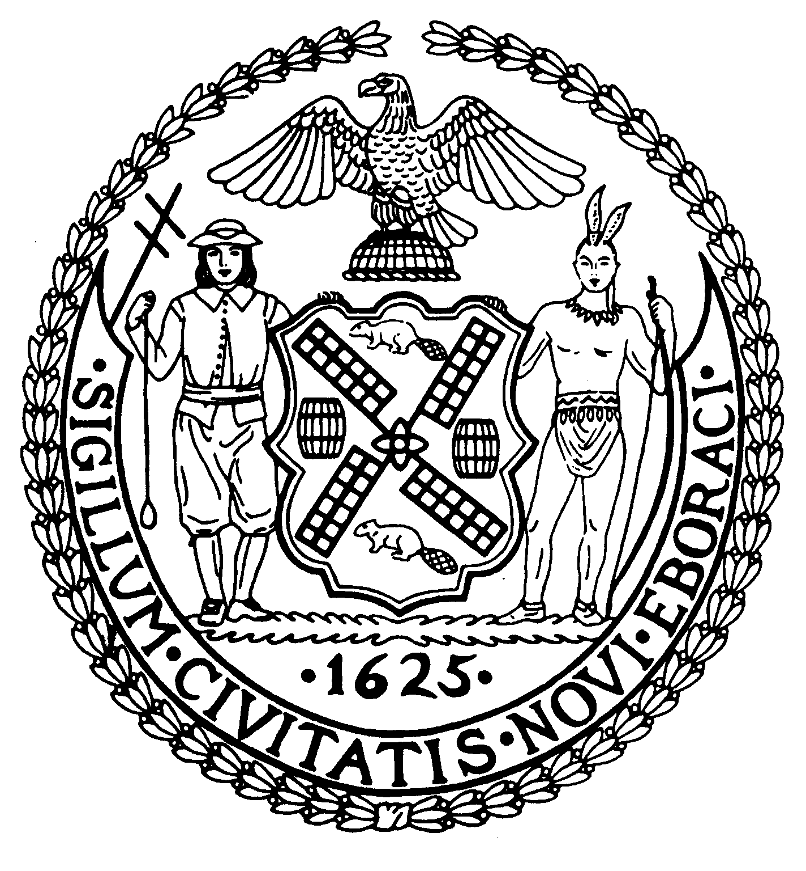
Chair New York, N.Y. 10022-1106
(212) 758-4616 (Fax)
Latha Thompson www.cb8m.com – Website
District Manager info@cb8.com - E-Mail

The City of New York
Manhattan Community Board 8

Zoning & Development Committee
Thursday, March 25, 2010 – 6:30 PM
Hunter College School of Social Work, 129 East 79th Street
Hexter Lounge

Agenda

- Update on a local owner-operated grocery store and the owner's efforts to remain in their location on upper Madison Avenue.

- Discussion of a proposed Local Law to amend the Administrative Code of the City of New York in relation to notices of violation issued by the Department of Sanitation for illegal postings.

- Illegal signage discussion and update. The Duane Reade/Walgreen's illegal marquee on East 86th Street and other examples of illegal signage will be discussed. Steven Figueiredo, Department of Buildings.

- Discussion: Zoning policies in other cities and strategies to strengthen the small business environment in the C1 and C2 local retail areas throughout New York City. Kurt Cavanaugh, Managing Director of the East Village Community Coalition.

- Old Business.

- New Business.

Teri Slater and Elaine Walsh, Co-Chairs

