Jacqueline Ludorf 505 Park Avenue, Suite 620
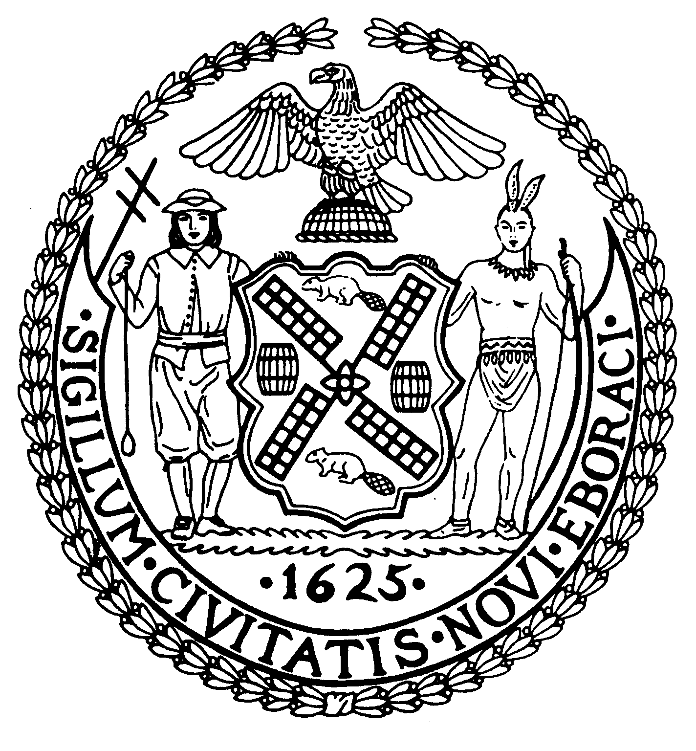
Chair New York, N.Y. 10022-1106

(212) 758-4340
Latha Thompson (212) 758-4616 (Fax)
District Manager www.cb8m.com - Website
info@cb8m.com - E-Mail

The City of New York
Manhattan Community Board 8

Housing Committee
Tuesday, March 23, 2010 – 6:30 PM
Community Board 8 Office, 505 Park Avenue, Conference Room 1

1. Caroline Winston, President, East Side Housing Coalition will discuss Upper East Side Housing
issues.
2. Old Business

3. New Business

N. Sharon Pope, Chair

