Jacqueline Ludorf 505 Park Avenue, Suite
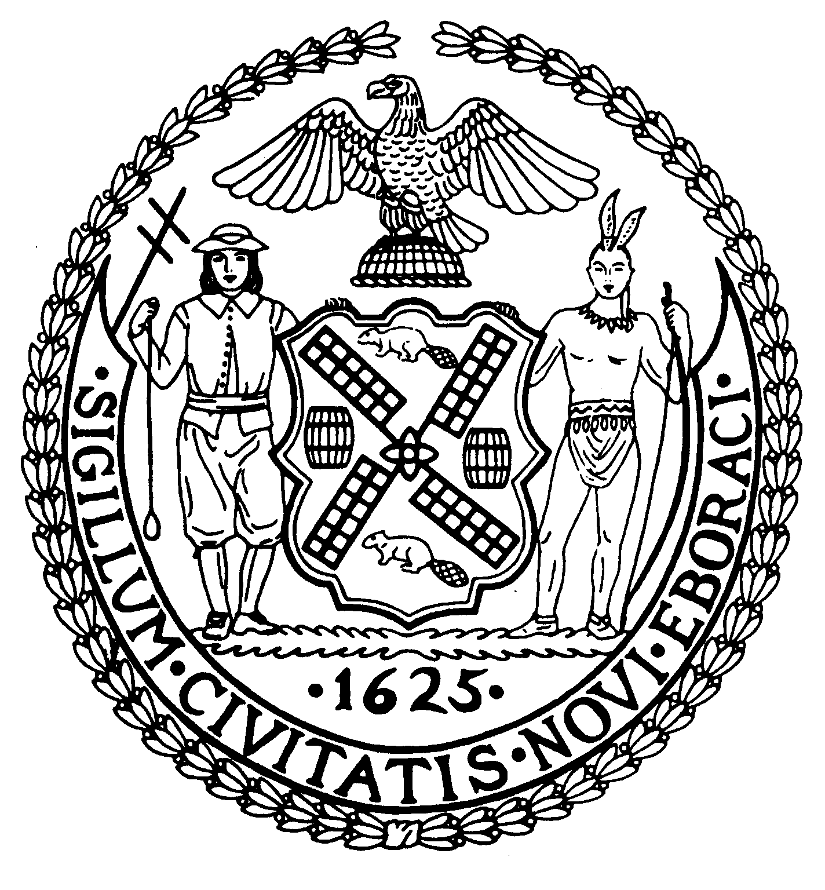

Chair New York, N.Y. 10022-1106

(212) 758-4340
Latha Thompson (212) 758-4616 (Fax)
District Manager www.cb8m.com - Website
info@cb8m.com - E-Mail

The City of New York
Manhattan Community Board 8

Environment and Sanitation Committee

Wednesday, March 9, 2010
New York Blood Center
310 East 67th Street
Conference Room 1
6:30PM

Agenda

1. Discussion of NYC Dept of Sanitation E. 74th St garage site (security, safety, interim use) with DSNY
representative.
2. Continued discussion of proposed forum on UES air quality with focus on boilers and heating oil for
residential buildings.

3. Possible discussion of shaft 33-B and water main project for Third Harbor Water Tunnel.

David Kleckner and Debra Teitelbaum, Co-Chairs

