Jacqueline Ludorf 505 Park Avenue
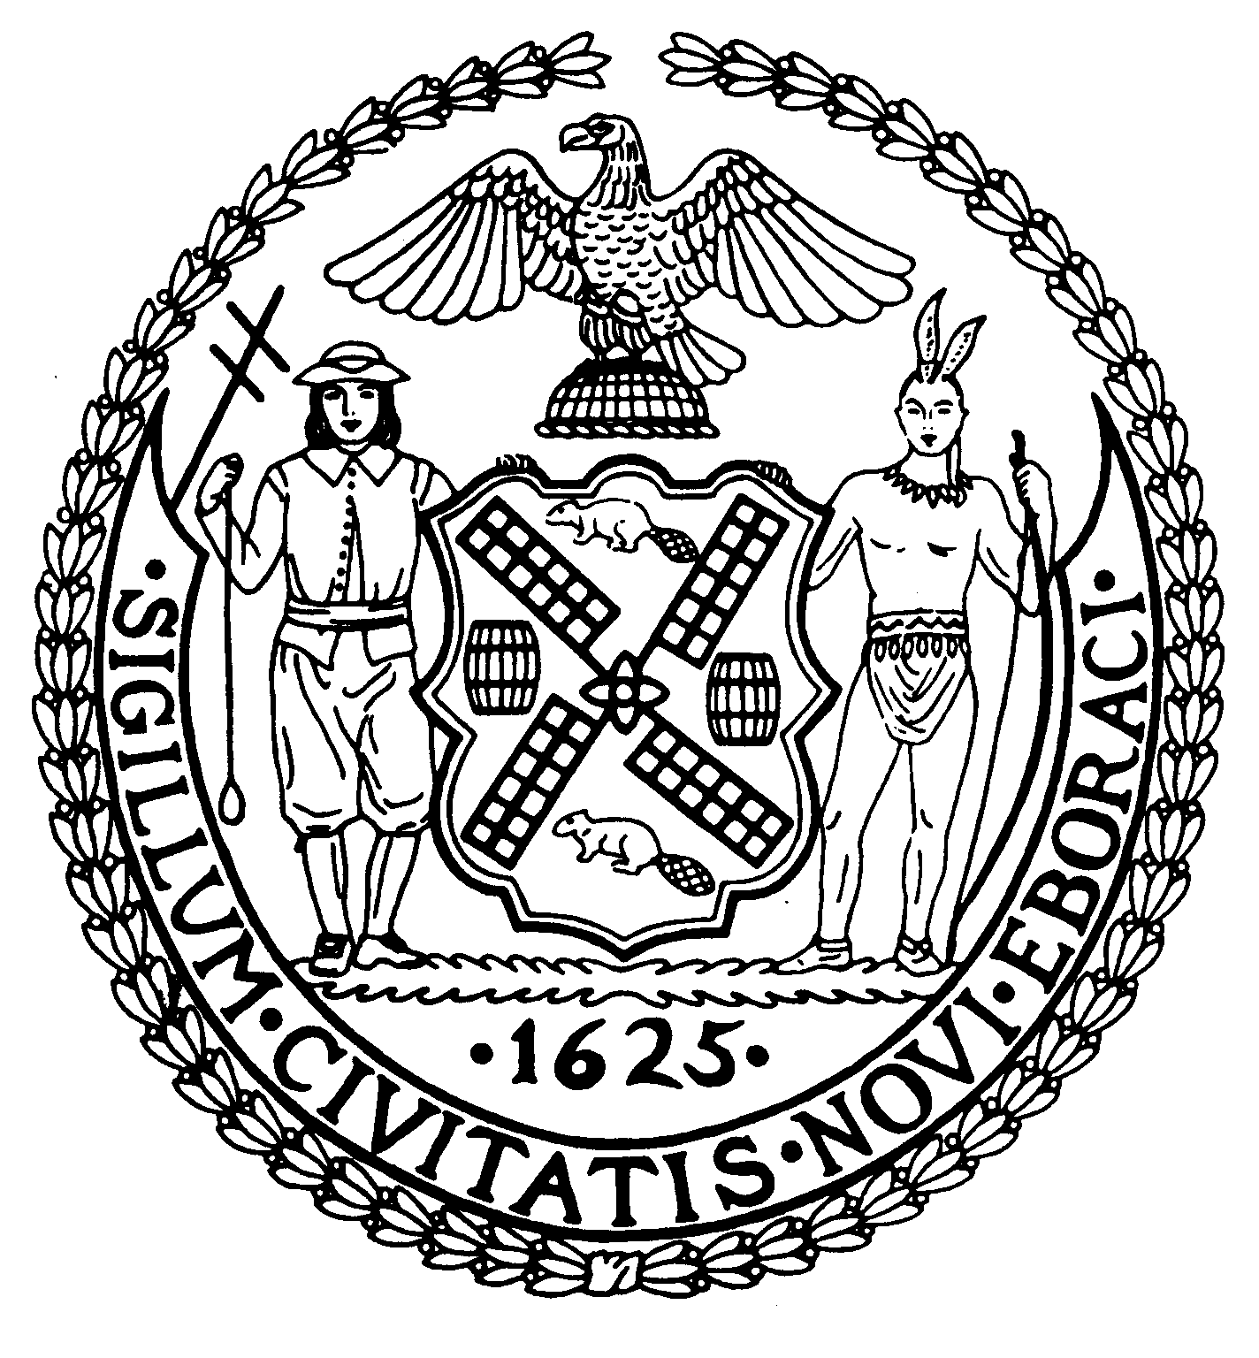
Chair Suite 620
New York, N.Y. 10022

Latha Thompson (212) 758-4340
District Manager (212) 758-4616 (Fax)
www.cb8m.com Website
info@cb8m.com - E-Mail

The City of New York

Manhattan Community Board 8

Transportation Committee Meeting
New York Blood Center
310 East 67th Street, Conference Room 1

Wednesday, March 3, 2010
6:30PM

Agenda

- Update on Roosevelt Island Tram Construction Project

- A discussion of Park Smart on East 86th Street

- Old Business

- New Business

Jonathan Horn and Charles Warren, Co-Chairs

