Jacqueline Ludorf 505 Park Avenue
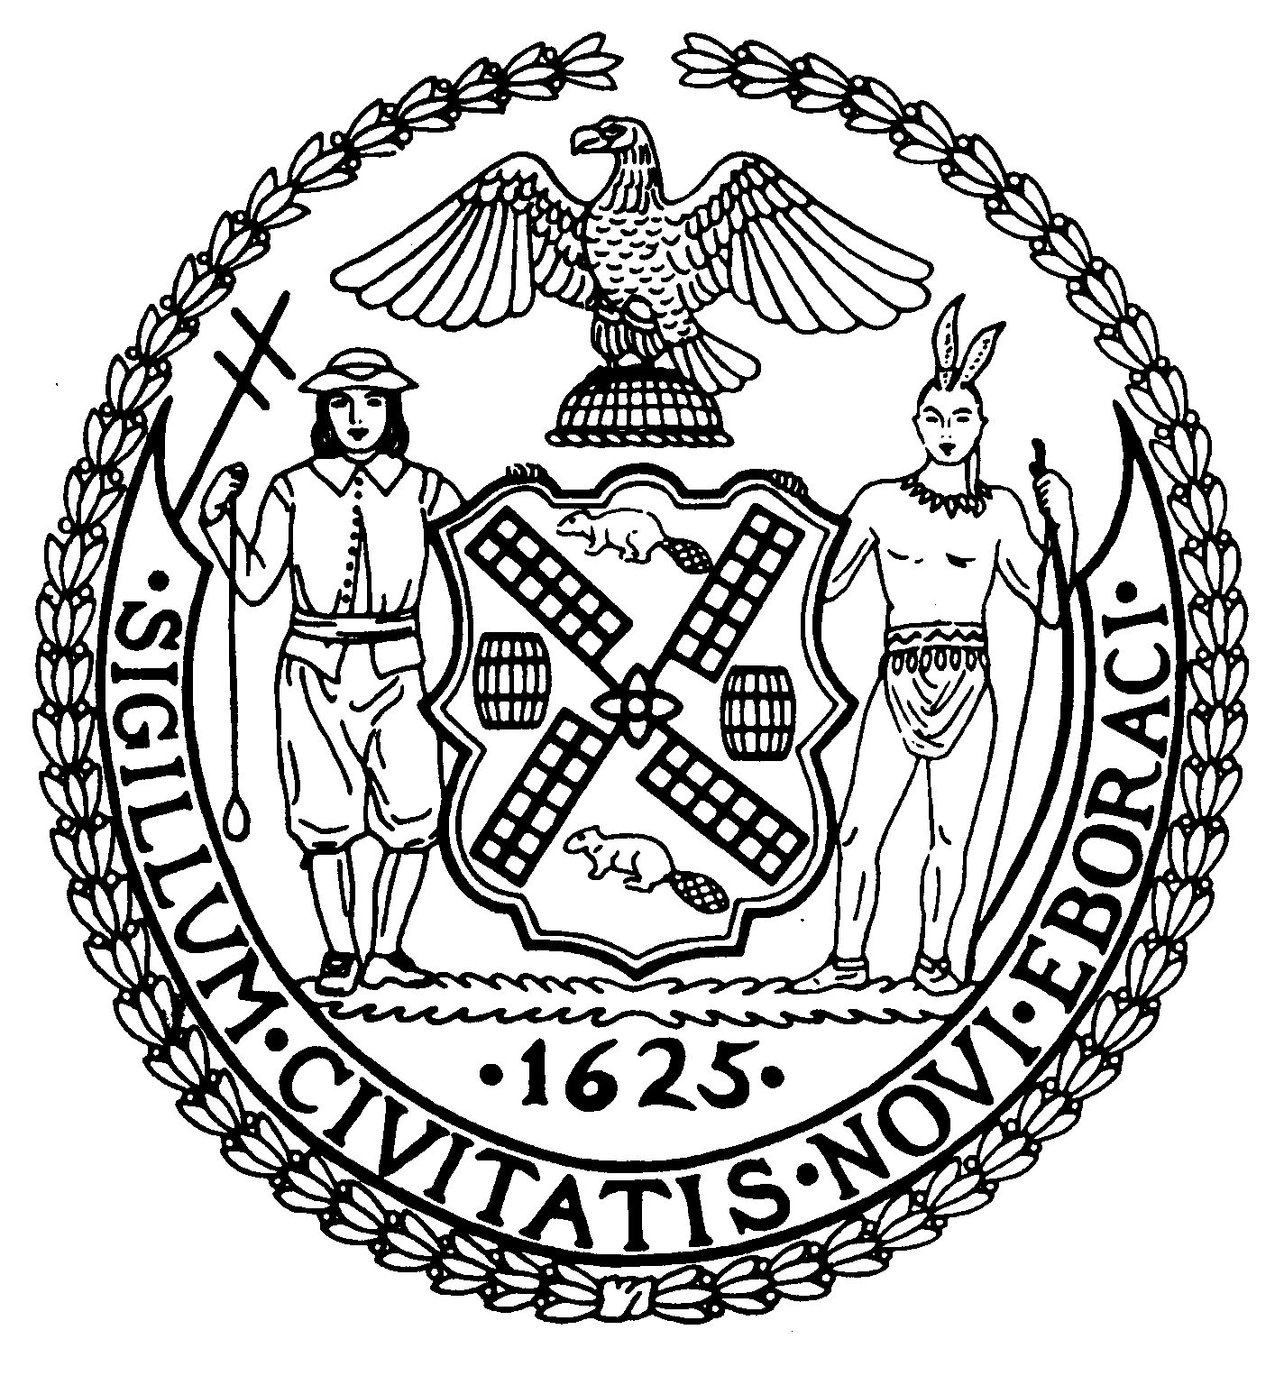
Chairman Suite 620
New York, N.Y. 10022

Latha Thompson (212) 758-4340
District Manager (212) 758-4616 (Fax)
www.cb8m.com Website
info@cb8m.com - E-Mail

The City of New York
Manhattan Community Board 8
Transportation Committee
Wednesday, February 2, 2011
New York Blood Center, 310 East 67th Street, Auditorium

Present: Michele Birnbaum, Scott Falk, Lorance Hockert, Jonathan Horn, Rita Popper, Alex Tisch, Charles Warren, Hedi White
Absent (excused): Helene Simon
Absent (unexcused): Michael Auerbach

The meeting was called to order by co-chair Jonathan Horn at 6:30 pm.
- Discussion of NYS Senate bill S00419 concerning bicycle violations by delivery riders

NY State Senator Liz Krueger spoke to the committee about the issues relating to bicycle delivery riders and enforcement of the laws related to these riders. There was a discussion on precisely what the bill will and should do. It was generally agreed by the committee members and the Senator that violations of the New York City delivery rider regulations (proper identification, safety equipment for bicycle and rider) should be enforced against the establishment. Violations of highway rules (running red lights, wrong way riding, riding on a sidewalk) should be enforced against both the establishment and the rider. The bill will be updated to reflect this. It was also suggested that agencies other than NYPD be allowed to write tickets for violations of the New York City delivery rider regulations. The Senator’s office will also check whether this requires action by the State Legislature or can be done by the City Council.

After the bill has been revised, the committee will review the updated version and consider taking a vote at that time.

- Discussion of Weill Cornell construction project on East 69th Street between First and York Avenue

Richard Thomas provided the committee with a detailed update on the traffic impacts of this project. They are complying with the existing DOT stipulations which include maintaining an 11ft. traffic lane and coordinating with the Sloan Kettering loading dock across the street. He admitted that there have been some issues with traffic flow during the past few weeks, but they are taking steps to avoid any repetition. They have increased the number of workers designated to traffic control and will, if necessary, hire a former NYPD officer they have worked with on previous projects.
Mr. Thomas also expressed the hospitals readiness to work with the committee to review the overall traffic situation on York Avenue around “Hospital Alley”. The co-chairs are planning to do another site visit with the representatives of the different hospitals and DOT in the early Spring to review the matter.

- Update from DOT on 86th Street Park Smart Pilot Study
David Stein and Willa Ng from DOT made a presentation on the results from the Park Smart pilot on East 86th Street and a portion of Madison Avenue started last June. Surprisingly, occupancy rates for meter spaces were virtually unchanged by the increased meter rates. In addition, average duration for vehicles parked actually went up. This is in contrast to results of earlier pilots in other areas where occupancy and duration went down. The DOT representatives expressed interest in expanding the pilot area to include more of Madison Avenue and several blocks north and south of 86th Street along the other avenues. They also proposed revising the peak rate hours and significantly increasing the peak rate premium.

The committee members felt that the results were disappointing , but conclusive and that the pilot should be discontinued. Accordingly, the following resolution was approved.

WHEREAS, the Department of Transportation performed a Park Smart Pilot project on East 86th Street and Madison Avenue starting in June 2010, and
WHEREAS, the results of this study were no change in the occupancy rates or average duration during the pilot period,
THERFORE BE IT RESOLVED that Manhattan Community Board 8 asks that DOT discontinue the Park Smart program on East 86th Street and Madison Avenue.
Approved 7-0-1
Yes: Birnbaum, Hockert, Horn, Popper, Tisch, Warren, White
Abstain: Falk

- Request for a bus shelter at the NW corner of East 72nd Street and 3rd Avenue
The member of the public who requested this shelter was unable to attend due to the weather conditions. The committee did listen to representatives of 165 East 72nd Street, the building in front of which the shelter would be placed. They expressed a number of concerns involving safety, sanitation and pedestrian traffic flow. This location had previously been considered for a shelter in 2001 and the board voted against installing one at that time. It was agreed that the committee co-chairs, a DOT representative, the requesting member of the public and representatives of the building will do a site inspection and report back next month.

- Discussion of pedestrian safety issues at the intersection of East 73rd Street and York Avenue

DOT is conducting a traffic and safety study at this intersection and expects to have answers by the end of February. It was agreed by the committee and members of the public present to hold off any discussion until our March meeting.

- Old Business

The issue of poor local service on the M15 was raised. The MTA will be invited back.

- New Business

There was no new business

The meeting was adjourned at 8:10 pm
Respectfully submitted,
Jonathan Horn and Charles Warren, Co-chairs

