Jacqueline Ludorf 505 Park Avenue, Suite 620
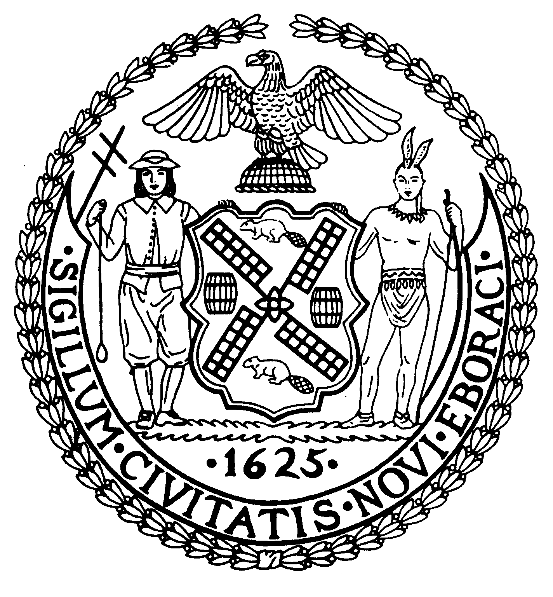
Chair New York, N.Y. 10022-1106
(212) 758-4340
Latha Thompson (212) 758-4616 (Fax)
District Manager www.cb8m.com - Website

info@cb8m.com - E-Mail

The City of New York
Manhattan Community Board 8

SECOND AVENUE SUBWAY TASK FORCE
Manhattan Community Board 8
Tuesday, February 15, 2011
New York Blood Center, 310 East 67th Street – Auditorium

Present: Barbara Chocky, Margaret Price, Rita Popper, Barry Schneider, Helene Simon, Cos Spagnoletti

Excused: David Rosenstein, Judith Schneider, H. Patrick Stewart

The meeting was called to order at 6:35 PM

- Construction Update

Note: The 36 page presentation is available at http://mta.info/capconstr/sas/documents/2011_Feb%2015_Final.pdf

A. Construction work zone progress – 96th Street Station, 86th Street Station, 72nd Street Station and Lexington/63rd Street Station. (See pages 3 - 33 of the PowerPoint presentation, noted above.)

B. To improve the pedestrian experience and conditions for local businesses, the MTA is implementing the following enhancements: Way finding signage for stores; replacement of bent/worn fencing; signage that advertises small businesses on the street side barriers, and improved crosswalks. The first block to receive these treatments is Second Avenue between E. 92 and E. 93rd Streets. (See pages 34 -35.)

C. 72nd Street Ancillary Facility facade color. MTA chief architect Judy Kunoff reviewed the 27 comments that the MTA received from the public regarding the facade color. She reported that 16 preferred the original terra cotta color, 7 preferred the light grey and 4 preferred the darker grey. And no respondent was in favor of the privacy screen. (See page 36.)

2. During and following the presentation, there was a spirited discussion of the sidewalk entrances at E. 86th Street and the within-the-building entrance at E. 69th Street as well as other issues of concern to the community members in the auditorium.

Respectfully submitted, M. Barry Schneider and Patrick Stewart, SAS TF Co-Chairs

