Jacqueline Ludorf 505 Park Avenue
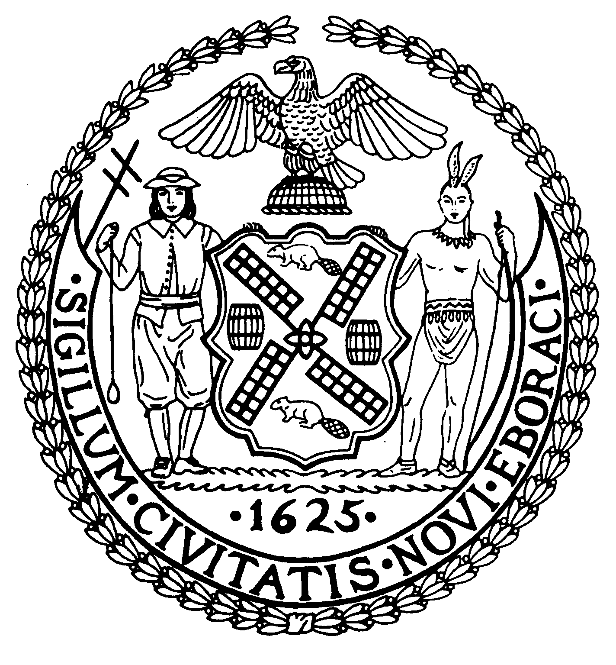
Chair Suite 620
New York, N.Y. 10022

Latha Thompson (212) 758-4340
District Manager (212) 758-4616 (Fax)
www.cb8m.com Website
info@cb8m.com - E-Mail

The City of New York
Manhattan Community Board 8
Transportation Committee
Wednesday, February 3, 2010
NY Blood Center
310 East 67th Street, Conference Room 1

Present: Michael Auerbach, Michele Birnbaum, Jim Clynes, Jonathan Horn, Edward Kramer, Barry Schneider, Judy Schneider, Helene Simon, Alex Tisch, Charles Warren, Hedi White, Scott Falk (Public Member)
Absent (excused): Richard Burg, Rita Popper, Betty Cooper Wallerstein, Larry Hockert (Public Member)

The meeting was called to order by co chair Jonathan Horn at 6:30 p.m. The committee was reminded that a public forum featuring a presentation on Select Bus Service will take place on February 25th. New committee member Alex Tisch and new Public Member Scott Falk were welcomed.

- Request by Memorial Sloan Kettering to replace 5 parking spots with a “No Parking, Mon-Sat, 6am to 6pm” zone on the south side of East 67th Street between York and First Avenues in front of Rockefeller Research Laboratory
This was a continuation of the discussion from January on the changes requested by MSK for this block. The south side changes are designed to facilitate better traffic management of trucks using the loading docks on both the north and south sides of the street. There were serious concerns expressed by the public and the committee over the loss of on-street parking for the public. Following a detailed discussion of the truck delivery needs of Memorial Hospital and Rockefeller Research Laboratory, it was proposed that a section of 5 spots currently assigned to MD parking only on the north side of East 67th Street be returned to the public in exchange for this request. There was additional discussion of the technical and logistical issues relating to the changes under discussion and the applicant agreed to the committee’s proposed revisions to their request.

WHEREAS, Memorial Hospital and Rockefeller Research Laboratory needed flexible access to their loading docks on East 67th Street between First and York Avenue, and
WHEREAS, traffic flow on this block, including the M66 bus route, would be improved by providing them this flexibility, and
WHEREAS, Memorial Sloan Kettering has agreed to return a number of parking spots currently assigned to MD parking to the public,
THERFORE BE IT RESOLVED that Community Board 8M approves the following parking sign changes on East 67th Street:
- On the South side, install a new sign reading “No Standing, 6AM - 6PM, Monday – Saturday” with a single arrow pointing West at a location approximately 172 feet West of York Avenue (just East of the entry to Rockefeller Research Laboratory.
- On the North side, remove the current sign reading “No Standing 7AM – 7PM Including Sunday except Authorized Vehicles, MD Plates Only” with a single arrow facing East located 229 feet West of York Avenue. These spots should be restored to regular parking.
Approved 12-0
Yes: Auerbach, Birnbaum, Clynes, Horn, Kramer, B. Schneider, J. Schneider, Simon, Tisch, Warren, White, Falk (Public Member)

- A discussion of delivery issues for Rite Aid store at the corner of East 68th Street and Second Avenue. (requested by Mr. Cohen, resident)
This item was withdrawn. According to Council Member Garodnick’s office, the issues have been resolved.

- Old Business
There was no old business.

- New Business
.A member of the public raised several possible issues with deliveries and garbage at the Rite Aid located at 81st Street and Second Avenue. It was suggested that she contact the board office and the Department of Sanitation to address her concerns.

Barry Schneider requested that we look into having the “No Standing” regulations revised to better accommodate drop-offs and pick-ups. The committee will research the matter further and consider it for a future agenda item.

Michele Birnbaum questioned the extensive posting of new Yellow Pedestrian Crossing signs throughout the district, especially on Park Avenue. They are part of DOT’s Safe Routes to School program. The committee will request a future presentation from DOT on this entire program.

Michele Birnbaum raised the issue of size of the Variable Message Signs being used for the Second Avenue Subway construction. A general discussion of the inconveniences posed by these signs followed. The Second Avenue Subway Task Force has already passed a resolution relating to this matter. We will follow up jointly with the Task Force.

Michael Auerbach raised the issue of a bike route cross-town through Central Park. This issue will be forwarded to the Parks Committee for a joint discussion.

A member of the public raised some concerns over the problem of recurring potholes. Josh Orzeck of DOT will address the matter.

The meeting was adjourned at 7:20 pm
Respectfully submitted,
Jonathan Horn and Charles Warren, Co-chairs

