Jacqueline Ludorf 505 Park Avenue, Suite 620
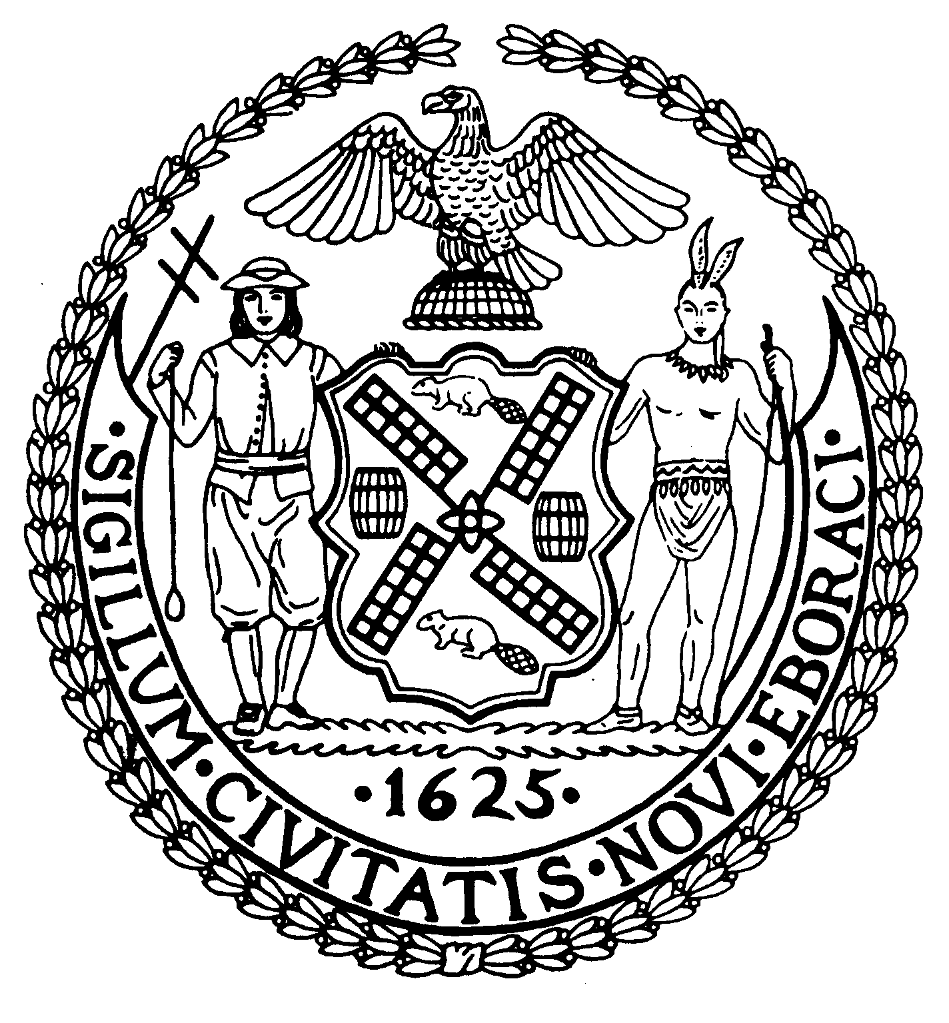
Chair New York, N.Y. 10022-1106
(212) 758-4340
Latha Thompson (212) 758-4616 (Fax)
District Manager www.cb8m.com - Website

info@cb8m.com - E-Mail

The City of New York
Manhattan Community Board 8

Landmarks Committee,

February 8, 2010 – 6:30PM
Hunter College School of Social Work, 129 East 79th Street – Room 1010

Present: Jane Parshall, David Liston, Teri Slater, Elizabeth Ashby, Joie Anderson, Marco Tamayo, David Helpern, Christina Davis, Susan Evans, Michele Birnbaum

- 8 East 75th Street (between 5th and Madison Avenues) – Upper East Side Historic District- Peter Pennoyer, Architect – Application is to restore the lower portion of 8 East 75th Street to its historic state and to add a layer of detail to better organize the original and non-original elements.

WHEREAS 8 East 75th Street is a Beaux-Arts style residence constructed in 1872.

WHEREAS the original architect is unknown.

WHEREAS the house originally had a mansard roof and two dormers; these were removed and a brick box-like penthouse was added.

WHEREAS at the base or ground level, the applicant proposes a restoration which will include bringing the railings and door back to what they were originally and resetting the granite base of the house.

WHEREAS work to the middle of the building will be minimal and include repointing work and waterproofing as well as some repairs to the existing balustrade.

WHEREAS at the fifth floor, the applicant proposes to restore some of the original elements to bring the top of the house back into harmony with the lower floors.

WHEREAS the resolution at the top or 5th floor presents a good solution to the loss of the mansard roof and the dormers and will include adding back a stone cornice with a stone balustrade, a string course, and curved console brackets and additional Beaux-Arts detailing.

WHEREAS the design and materials are appropriate to the architecture of the building.

THEREFORE BE IT RESOLVED that this application is approved as presented.

VOTE: 10 favor (Parshall, Liston, Slater, Ashby, Anderson, Tamayo, Helpern, Davis,
Evans, Birnbaum)

OLD BUSINESS: Continued discussion of Landmarks Committee Guidelines and procedures. Thank you to Teri Slater for circulating to us guidelines that the Landmarks Preservation Commission makes available to all applicants.

