Jacqueline Ludorf 505 Park Avenue, Suite 620
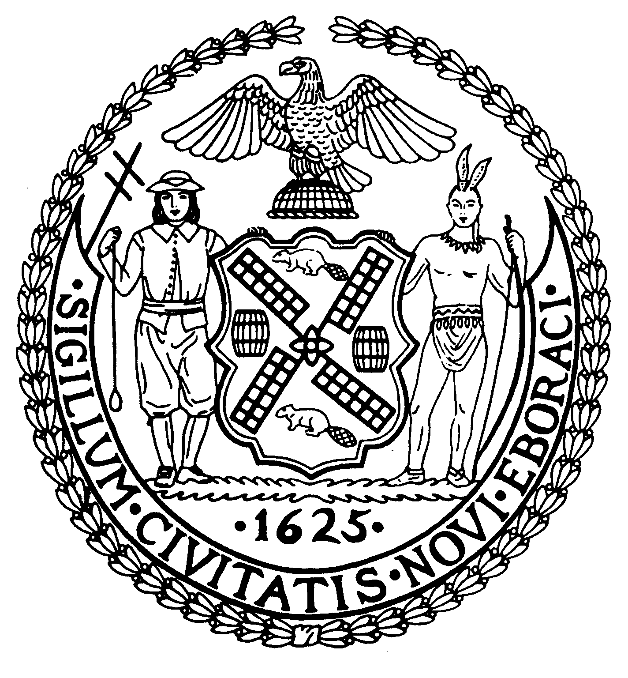
Chair New York, N.Y. 10022-1106
(212) 758-4340
Latha Thompson (212) 758-4616 (Fax)
District Manager www.cb8m.com - Website

info@cb8m.com - E-Mail

The City of New York
Manhattan Community Board 8

Housing Committee Minutes
Community Board 8 Office
505 Park Avenue
February 24, 2010
6:60PM

Father Mark Halliman, Coordinator of the East Side Congregations for Housing Justice, was to discuss east side housing issues. Father Halliman was not able to attend due to a scheduling conflict. He is scheduled to attend the April 28, 2010 CB 8 Housing Committee meeting.
Caroline Winston, President of the East Side Housing Coalition will discuss upper east side housing concerns at the next CB 8 Housing Committee meeting on Tuesday, March 23, 2010 at 6:30 P.M.
There was a brief discussion regarding what constitutes illegal hotels.
Respectfully submitted.
Sharon Pope

