Jacqueline Ludorf 505 Park Avenue
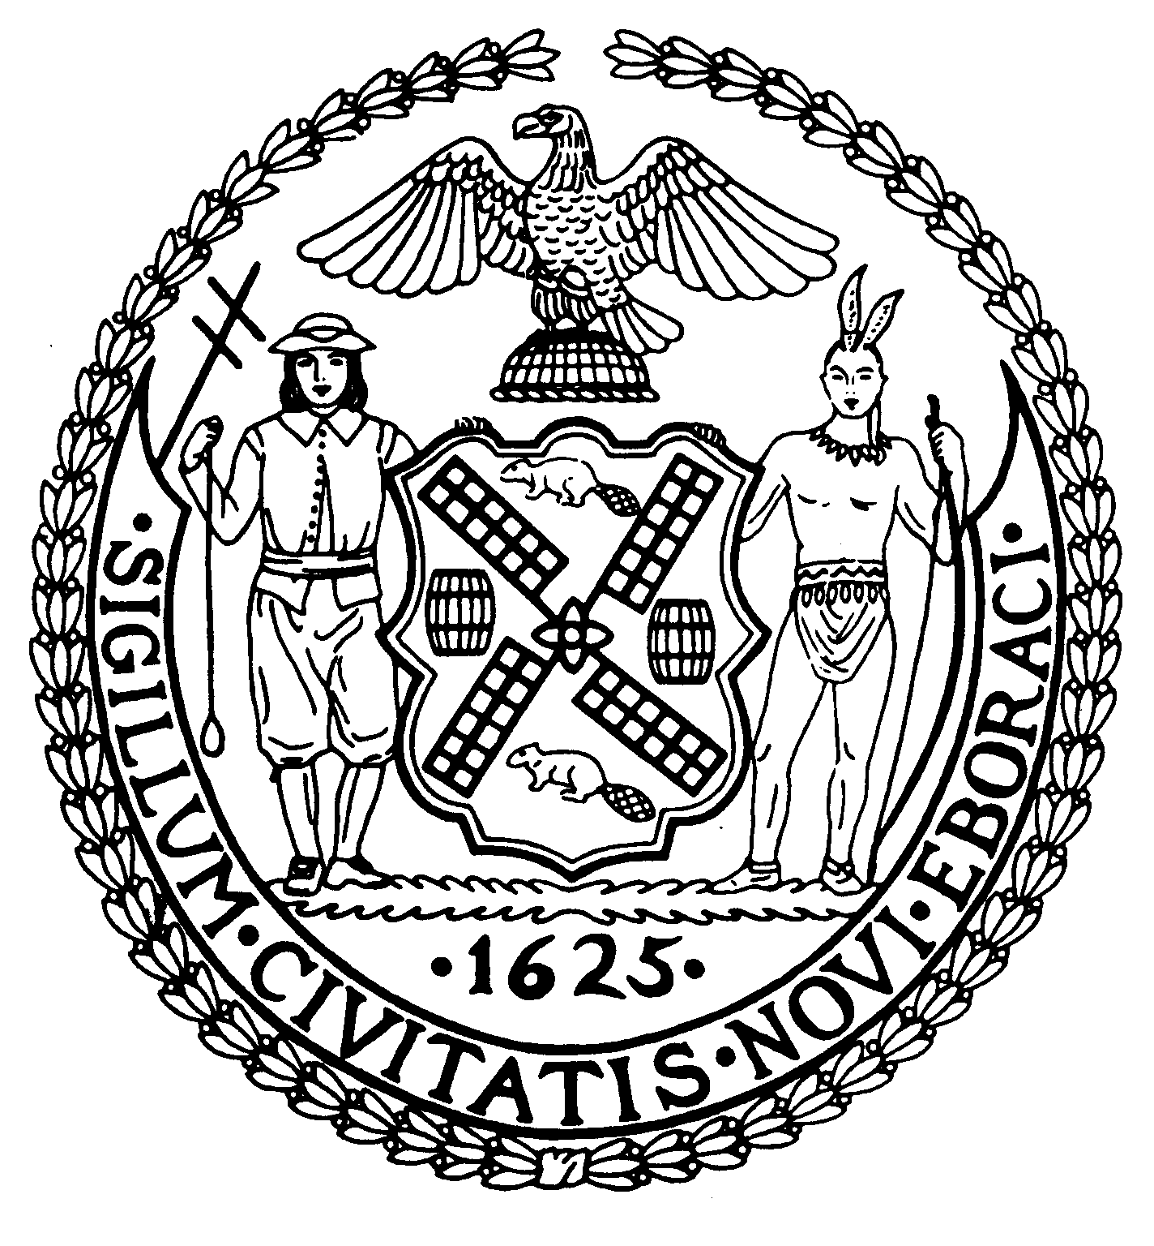
Chairman Suite 620
New York, N.Y. 10022

Latha Thompson (212) 758-4340
District Manager (212) 758-4616 (Fax)
www.cb8m.com Website
info@cb8m.com - E-Mail

The City of New York

Manhattan Community Board 8

Youth and Education Committee Meeting

The Blood Center
310 East 67th Street, Conference Room
February 22, 2010
7:00 pm

Agenda

- District Attorney’s Offices program for summer internships presented by Linda Janneh.

- Planned Parenthood presentation on efforts to increase access to sex education in NYC Public Schools

- CECD2 Report

Progress of the incubator school at PS 158 and selection of a principal

- Update on the progress of the second teacher/aid in the classroom

- Future Meetings

- New/Old Business

James Clynes and Judith E. Schneider Co-Chairs

