Jacqueline Ludorf 505 Park Avenue, Suite
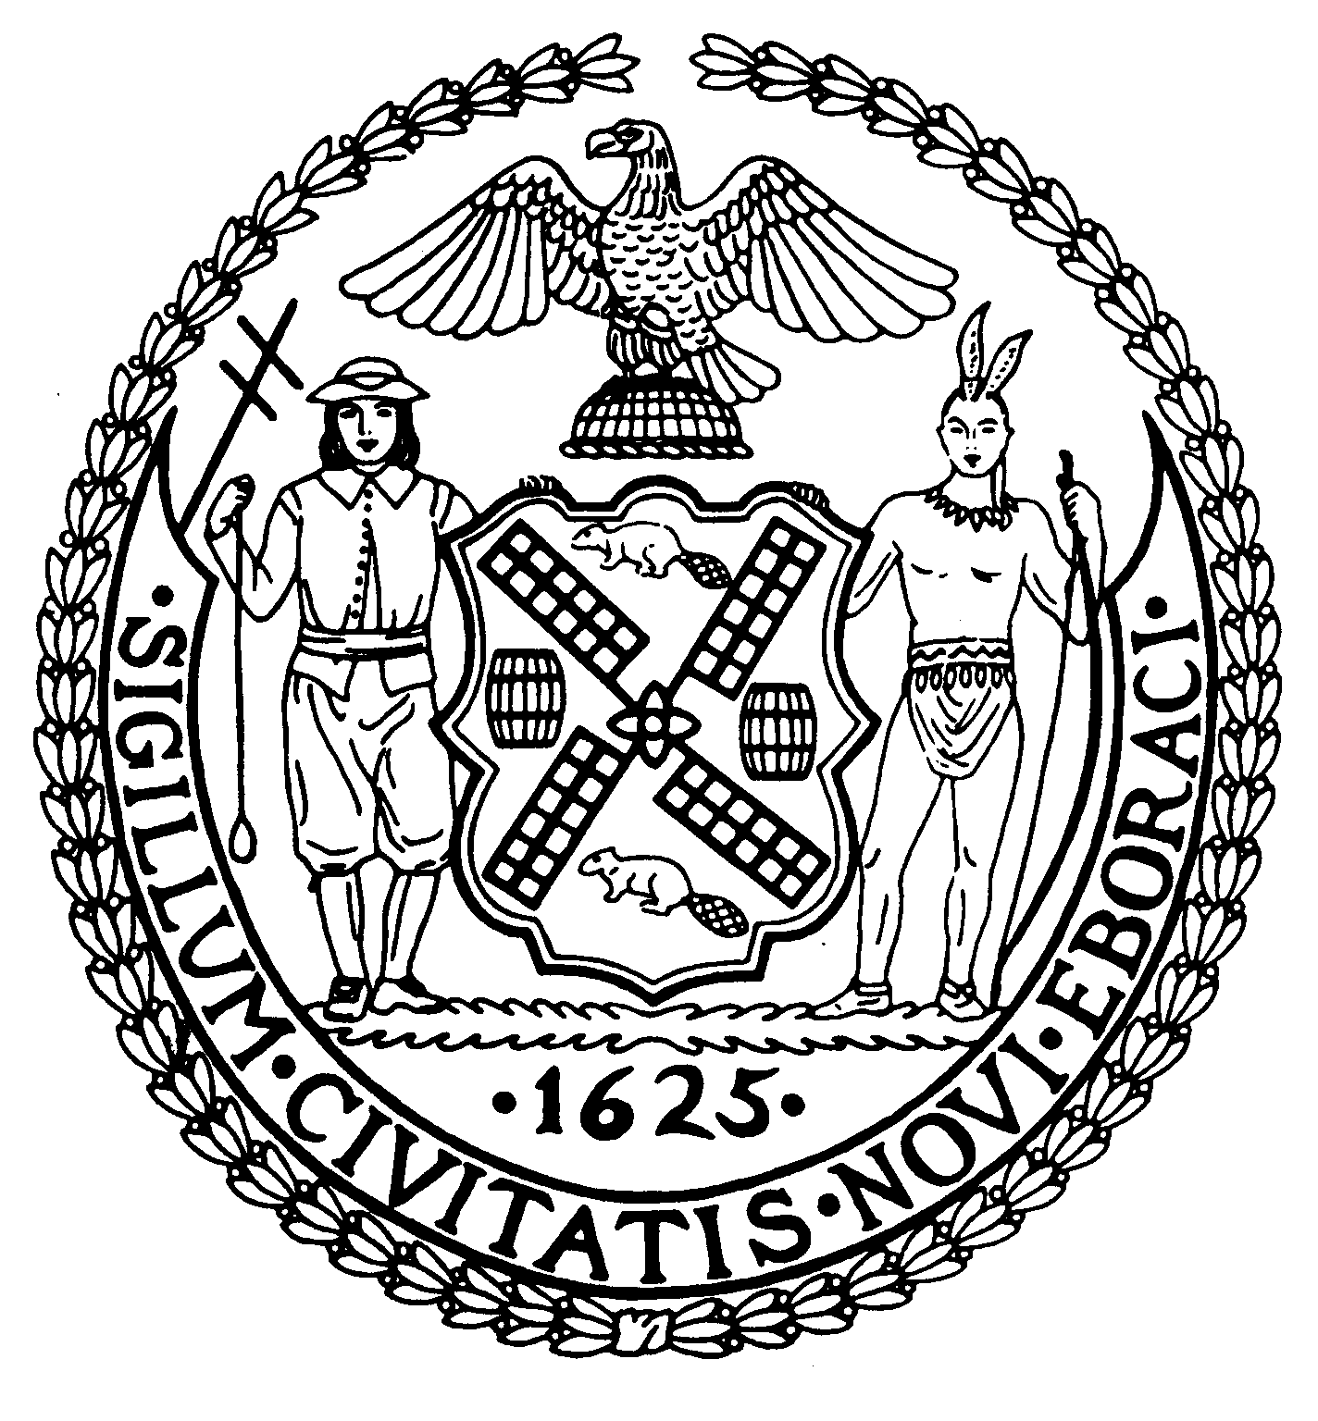

Chair New York, N.Y. 10022-1106

(212) 758-4340
Latha Thompson (212) 758-4616 (Fax)
District Manager www.cb8m.com - Website
info@cb8m.com - E-Mail

The City of New York
Manhattan Community Board 8

Environment and Sanitation Committee

Wednesday, February 9, 2010
New York Blood Center
310 East 67th Street
Conference Room 1
6:30PM

Agenda

1. Discussion of water tunnel Shaft-33B, including presentation by NYC Department of Design & Construction.
2. Possible discussion of proposed forum on UES air quality with focus on boilers and heating oil for residential buildings.
3. Old business
5. New business

David Kleckner and Debra Teitelbaum, Co-Chairs

