Jacqueline Ludorf 505 Park Avenue, Suite 620
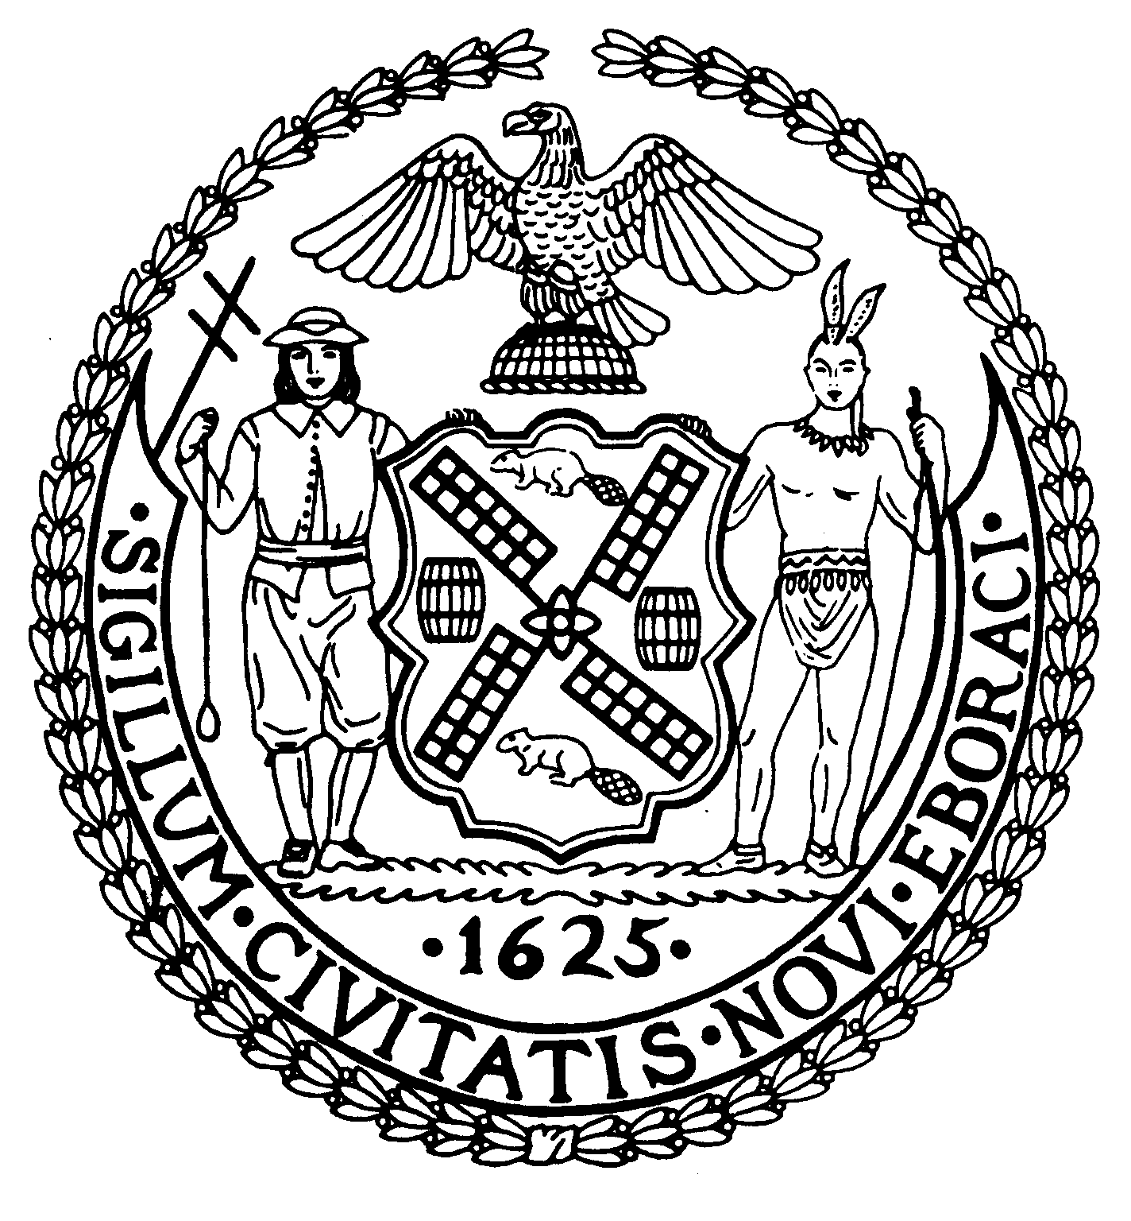
Chair New York, N.Y. 10022-1106

(212) 758-4340
Latha Thompson (212) 758-4616 (Fax)
District Manager www.cb8m.com - Website
info@cb8m.com - E-Mail

The City of New York
Manhattan Community Board 8

Parks Committee
Hunter College School of Social Work
129 East 79th Street, Hexter Lounge
Thursday, February 18, 2010 @ 6:30 PM

Agenda

1. Queensboro Oval: Update on the Parks Dept.'s plans to convert this dual tennis-softball
facility to an all-tennis center.
2. Old Business
3. New Business

Margaret Price and Barbara Rudder, Parks Committee Co-Chairs

