Jacqueline Ludorf 505 Park Avenue
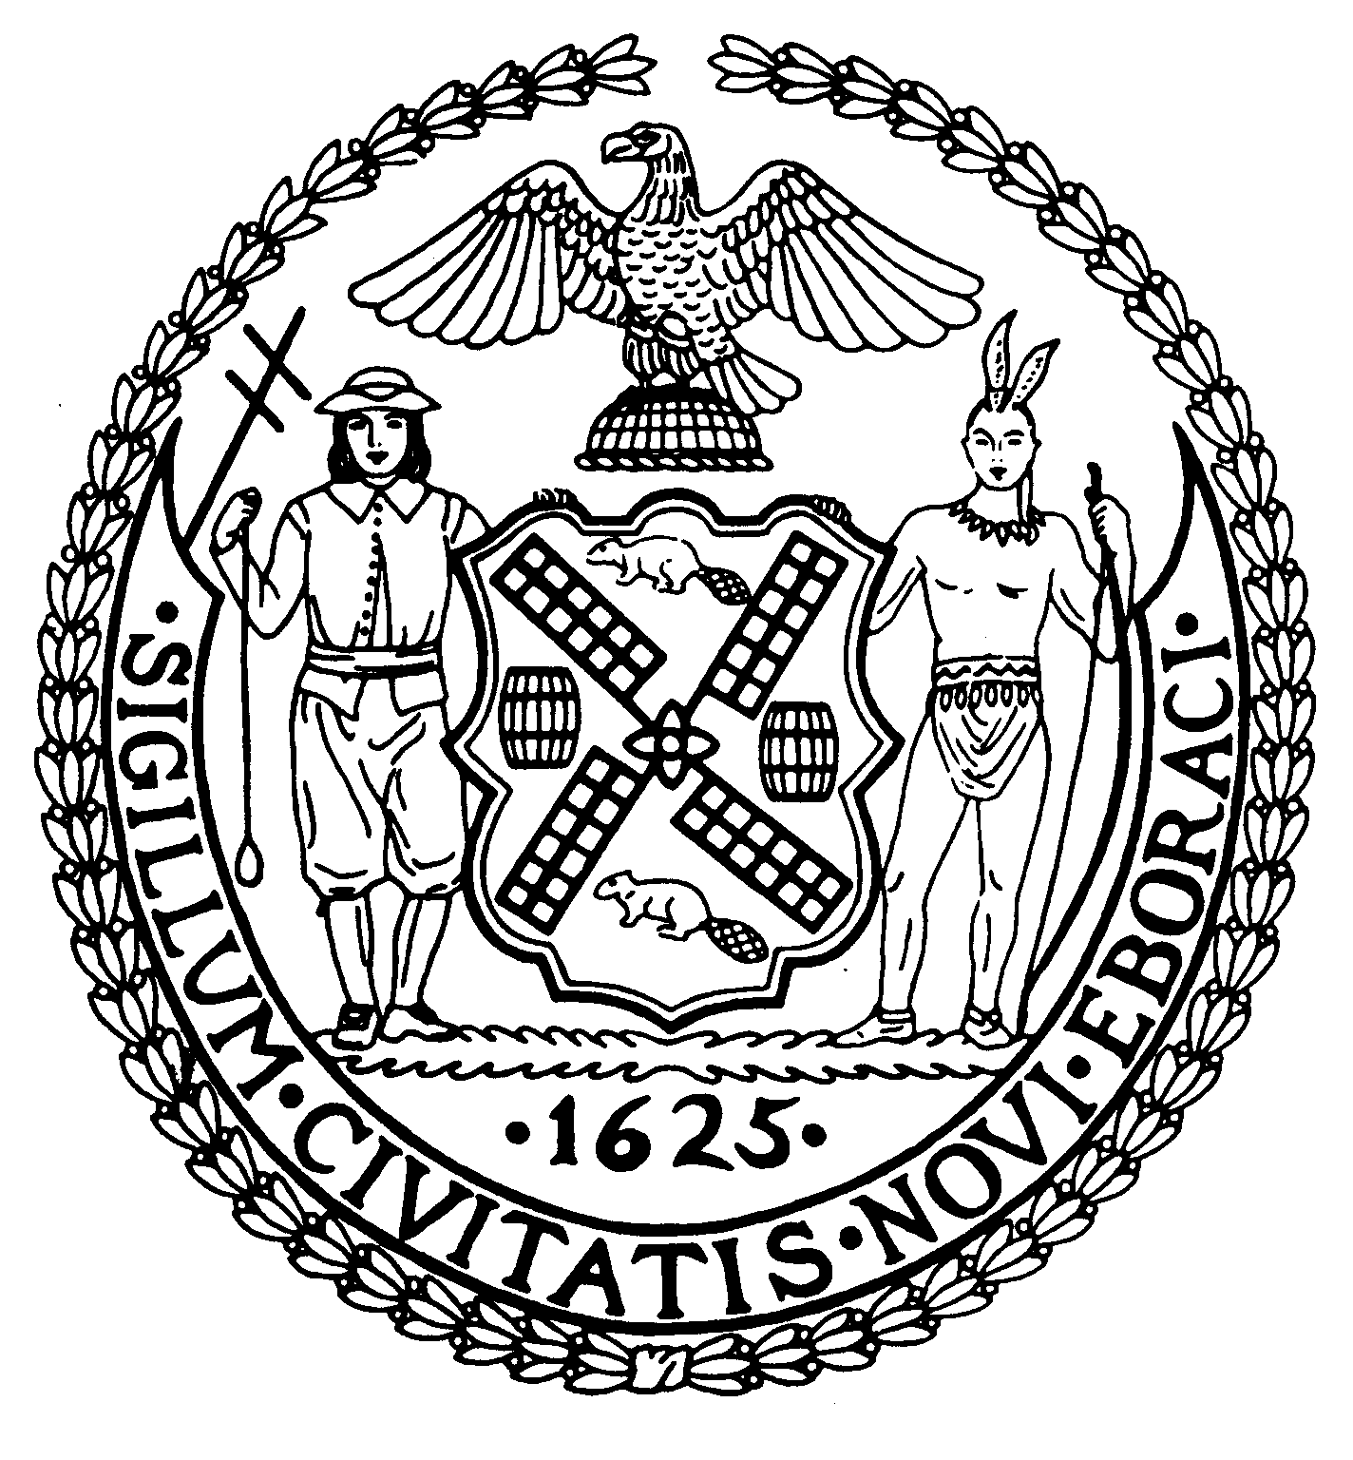
Chair Suite 620
New York, N.Y. 10022

Latha Thompson (212) 758-4340
District Manager (212) 758-4616 (Fax)
www.cb8m.com Website
info@cb8m.com - E-Mail

The City of New York

Manhattan Community Board 8

Transportation Committee Meeting
New York Blood Center
310 East 67th Street, Conference Room 1

Wednesday, February 3, 2010
6:30PM

Agenda

- Request by Memorial Sloan Kettering to replace 5 parking spots with a “No Parking, Mon-Sat, 6am to 6pm” zone on the south side of East 67th Street between York and First Avenues in front of Rockefeller Research Laboratory.

- A discussion of delivery issues for Rite Aid store at corner of East 68th Street and Second Avenue. (Requested by Mr. Cohen, resident)

- Old Business

- New Business

Jonathan Horn and Charles Warren, Co-Chairs

